

**School of Electronics Engineering (SENSE)**

**B. Tech Electronics and Communication Engineering**

**BECE401P – Computer Communications and Networks Lab**

**Submitted By**

21BEC1851 – Rahul Karthik S

**Submitted To**

Dr. Nitish Katal

**Table of Contents**

Experiment 1: Client-Server Network Topology using Cisco Packet Tracer 3

Experiment 2: Setup a Wide Area Network with a router Using Cisco Packet Tracer 10

Experiment 3: Email Server using Cisco Packet Tracer 14

Experiment 4: File Transfer Protocol Using Cisco Packet Tracer 20

Experiment 5: Static Routing Using Cisco Packet Tracer 29

Experiment 6: Dynamic Routing Using Cisco Packet Tracer 34

Experiment 7: Performance of TCP and UDP Protocol using NetSim 40

Experiment 8: Impact of Link Failure on Network’s Performance Using NetSim 43

Experiment 9: Working of RIP and OSPF Routing Protocol using NetSim 46

Experiment 10: Subnetting Using Cisco Packet Tracer 50

Experiment 11: Perform Cyclic Redundancy Check Using MATLAB 56

Experiment 1: Client-Server Network Topology using Cisco Packet Tracer

**Objective 1:**

**Aim:**

To set up a simple point-to-point network between two hosts.

**Procedure:**

1. Open Cisco Packet Tracer. Take two PCs from the End Devices section as given in Figure 1.1.1.

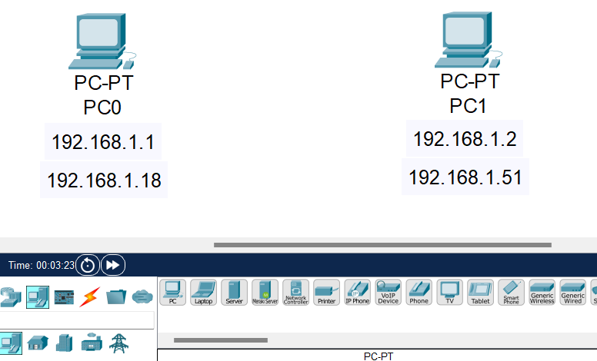

Figure 1.1.1 – Taking two PCs from End Devices

1. Connect the PCs by selecting Automatically Choose Connection Type in Connections section as given in Figure 1.1.2.

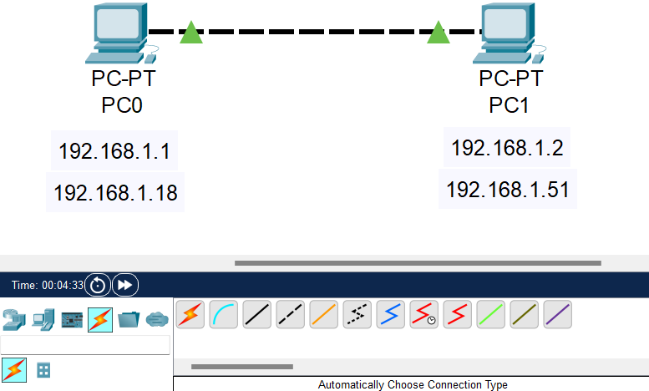

Figure 1.1.2 – Connect two PCs

1. Click on the PC0, go to Desktop Tab $→$ IP Configuration, then enter the IP Address as 192.168.1.1 as given in Figure 1.1.3.

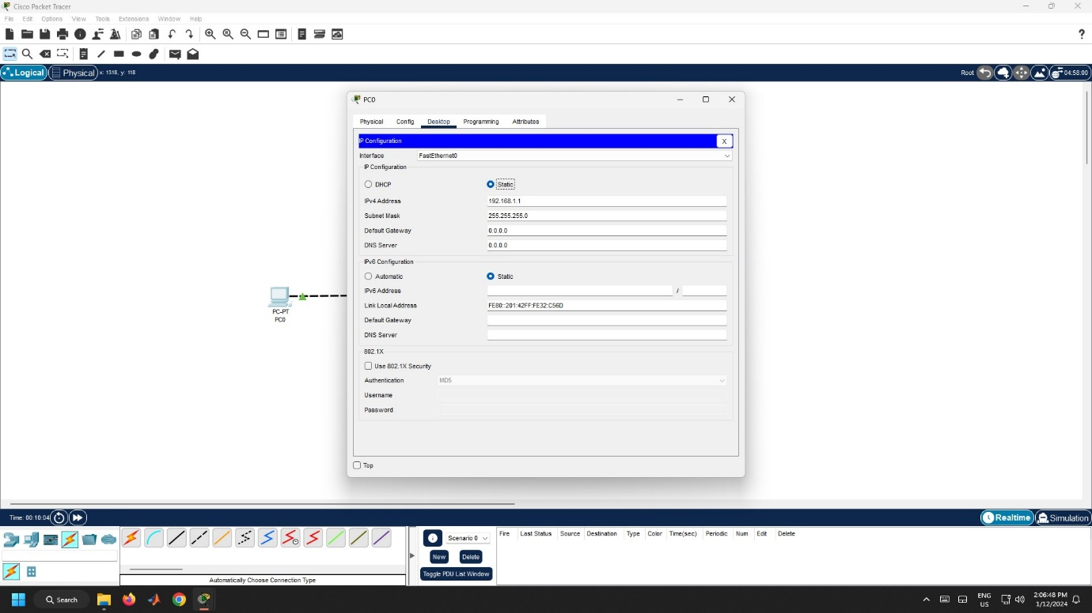

Figure 1.1.3 – IP Configuration for PC0

1. Similarly, click on the PC0, go to Desktop Tab $→$ IP Configuration, then enter the IP Address as 192.168.1.1.2 as given in Figure 1.1.4.

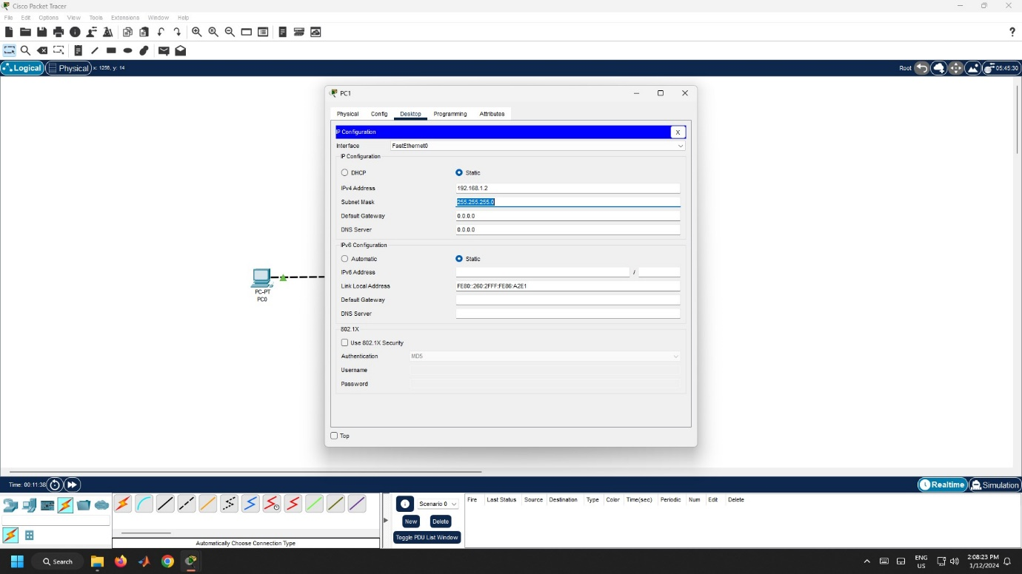

Figure 1.1.4 – IP Configuration for PC1

1. Now, verify the connection between the PCs by going to Desktop $→$ Command Prompt of PC0. Then type, ping 192.168.1.2 as given in Figure 1.1.5.

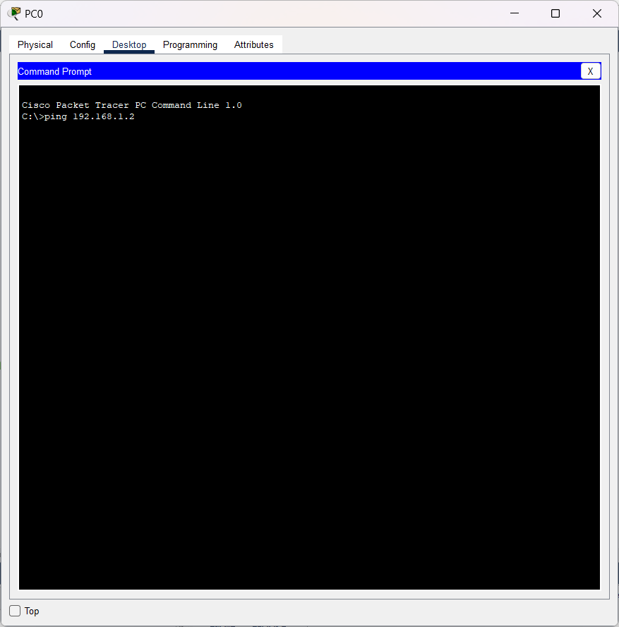

Figure 1.1.5 – Ping Command

**Result:**

Hence, a simple point-to-point network between two hosts has been established successfully.

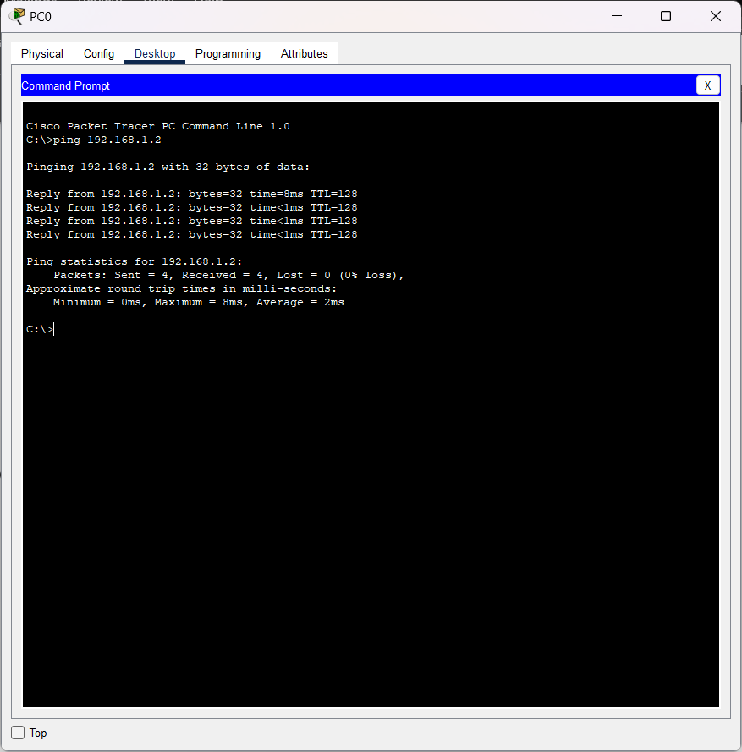

Figure 1.1.6 – Ping Successful

**Conclusion:**

1. The IP address must be unique for each and every PC.
2. Here, two PCs are connected to each other and configured in the same IP Address Family.
3. The connection is established only if both PCs are configured in the same IP Address. Otherwise, the connections won’t be established, and packets won’t be transferred.
4. The ping command is utilized to assess and confirm the accessibility of a host over an Internet Protocol (IP) network.

**Objective 2:**

**Aim:**

To set up a local area network using star topology using a Data Link Layer Switch.

**Procedure:**

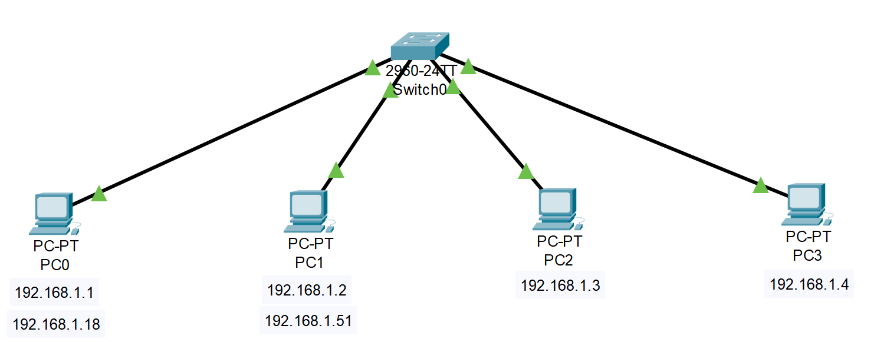

Figure 1.2.1 – Star Topology Connection

1. Click the PC, go to Desktop Tab $→$ IP Configuration and configure the IP Addresses for each PC as given in Figure 1.2.2.
   1. PC0: 192.168.1.1
   2. PC1: 192.168.1.2
   3. PC2: 192.168.1.3
   4. PC3: 192.168.1.4



Figure 1.2.2 – IP Configuration for PC0

1. Now, verify the connection between the PCs by going to Desktop $→$ Command Prompt of PC0. Then type, ping 192.168.1.3 as given in Figure 1.2.3.

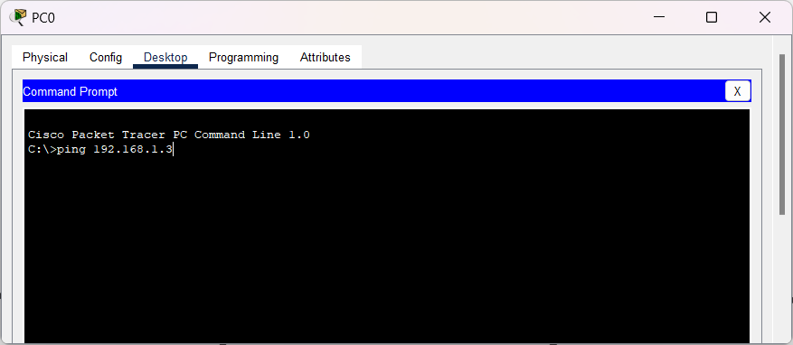

Figure 1.2.3 – Ping Command

**Result:**

Hence, a local area network using star topology using a Data Link Layer Switch is established successfully.

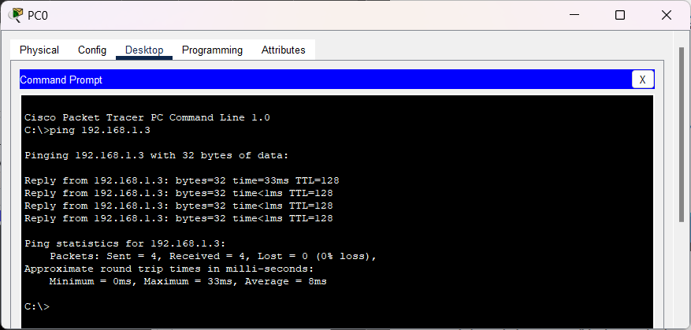

Figure 1.2.4 – Ping Successful

**Conclusion:**

1. Here, four PCs are connected to a switch forming a star topology.
2. All four PCs are configured with the same IP Address family, i.e. 192.168.1.X.
3. If the PCs are configured with a different IP Address family, then the packets won’t be sent.
4. When PC1 wants to send a packet to PC4, the packet will be sent to the switch. Then, the switch will broadcast the packet to all the PCs connected in the Local Area Network.
5. Then, based on the IP Address of the receiver PC the packets will be sent.

**Objective 3:**

**Aim:**

To set up a Server Client Topology.

**Procedure:**

1. Open Cisco Packet Tracer. Then, get the following components and connect the components using the connection cables as given in Figure 1.3.1
   1. Four PCs from End Devices Section
   2. One Server from End Devices Section
   3. One 2960 Switch from Switches Section

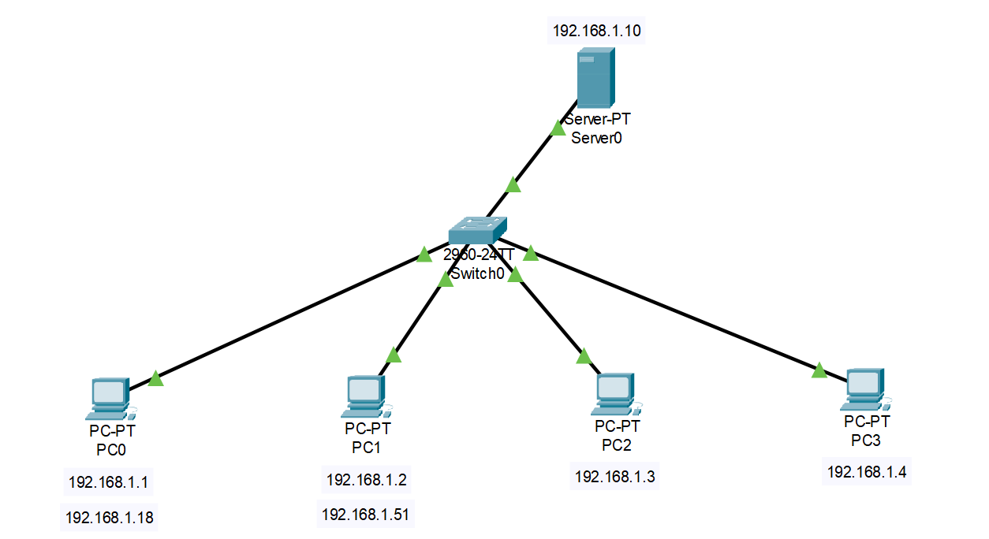

Figure 1.3.1 – Client Server Connection

1. Click the PC, go to Desktop Tab, IP Configuration and configure the IP Addresses for each PC as given in Figure 1.3.2.
   1. PC0: 192.168.1.1
   2. PC1: 192.168.1.2
   3. PC2: 192.168.1.3
   4. PC3: 192.168.1.4



Figure 1.3.2 – IP Configuration for PC0

1. Click the Server0, go to Desktop Tab $→$ IP Configuration and configure the following as per Figure 1.3.3.
   1. IP Address: 192.168.1.10
   2. DNS Server: 192.168.1.10

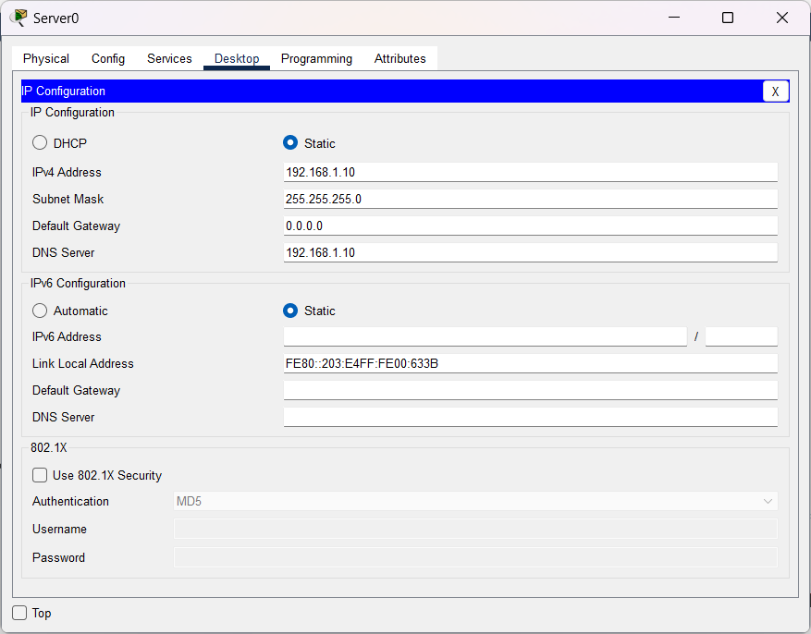

Figure 1.3.3 – Server0 Configuration

1. Verify the connection between the PCs by going to Desktop $→$ Command Prompt of PC0. Then type, ping 192.168.1.3 as given in Figure 1.3.4.



Figure 1.3.4 – Ping Command

1. Verify the connection between the PC and the server by going to Desktop $→$ Web Browser of any PC (e.g.: PC0). Then, type 192.168.1.10/index.html as given in Figure 1.3.5.

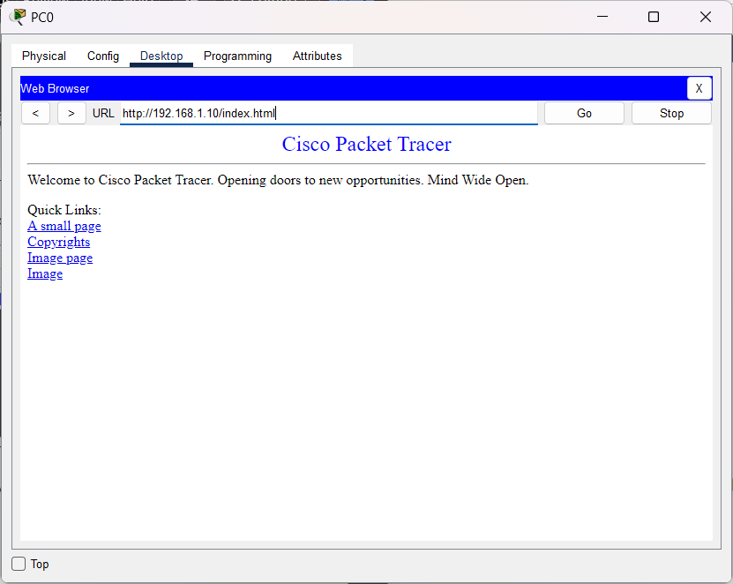

Figure 1.3.5 – Server Web Page in Web Browser

**Result:**

Hence, a local area network using star topology using a Data Link Layer Switch is established successfully.



Figure 1.3.6 – Ping Successful

**Conclusion:**

1. Here, a server is also connected to a local area network.
2. So, the server can be accessed by any PCs which are connected to the same local area network.
3. PCs use the DNS Server of the server to access the contents of the server.
4. By entering the DNS Server of the server in the web browser of the PCs, we can access the contents of the server.

Experiment 2: Setup a Wide Area Network with a router Using Cisco Packet Tracer

**Aim:**

To set up a wide area network using a router, configure a server in LAN – 2 and access the server from LAN – 1.

**Procedure:**

1. Open Cisco Packet Tracer. Then, get the following components and connect the components using the connection cables as given in Figure 2.1.
   1. Four PCs from End devices Section.
   2. One Server from End devices Section.
   3. Two 2960 Switch from Switches Section.
   4. One ISR4331 Router from Router Section.

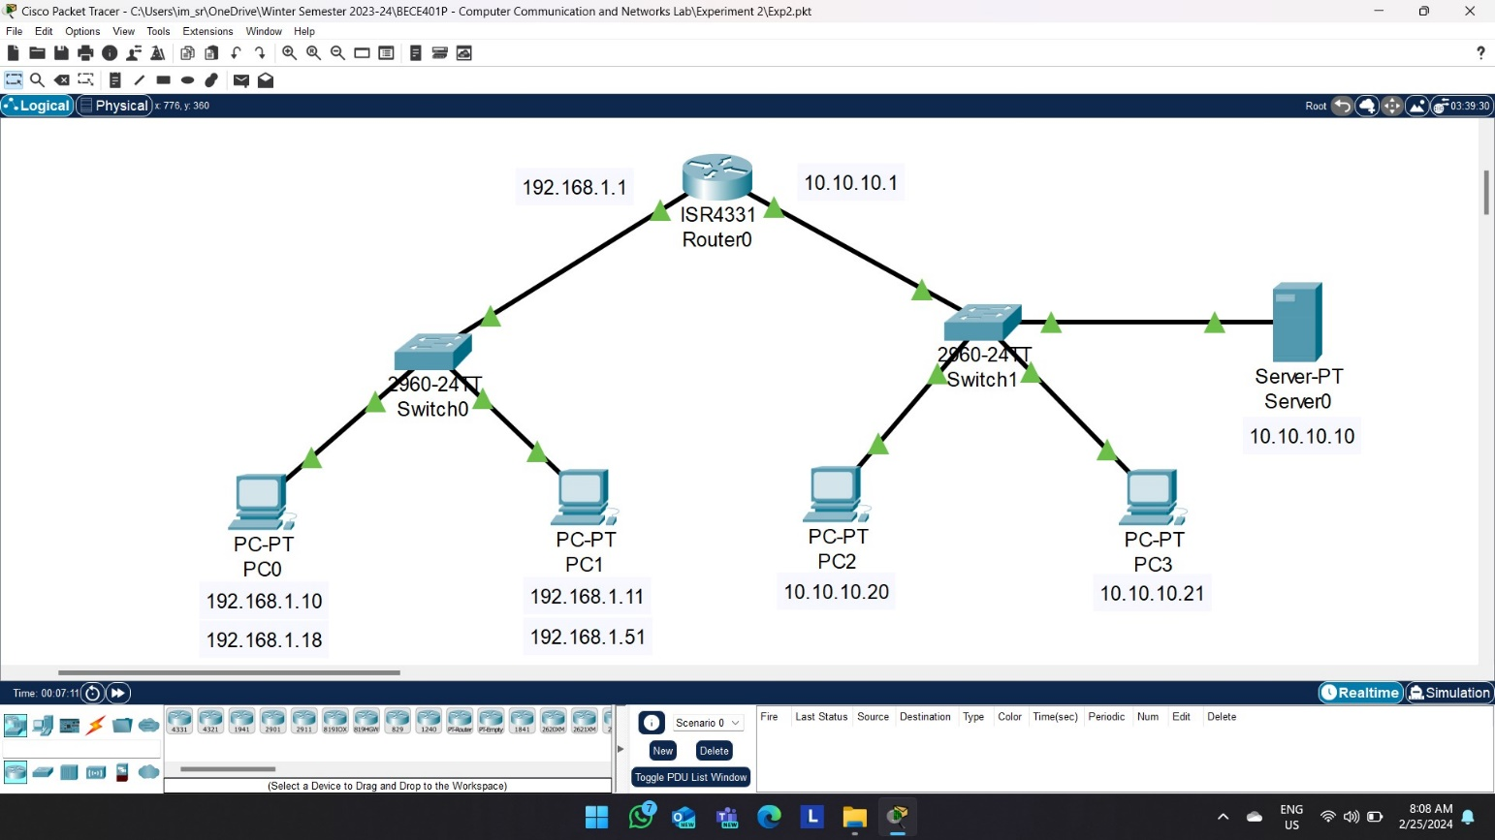

Figure 2.1 – Wide Area Network Connection

1. Click the PC, go to Desktop Tab $→$ IP Configuration and configure the IP Addresses and Default Gateway for each PC as given in Figure 2.2.
   1. Configure the IP Addresses of PC0 and PC1 as 192.168.1.10 and 192.168.1.11 respectively as they belong to the same local area network.
   2. Configure the Default Gateway of PC0 and PC1 as 192.168.1.1.
   3. Configure the IP Addresses of PC2 and PC3 as 10.10.10.20 and 10.10.10.21 respectively as they belong to another local area network.
   4. Configure the Default Gateway of PC0 and PC1 as 10.10.10.1.

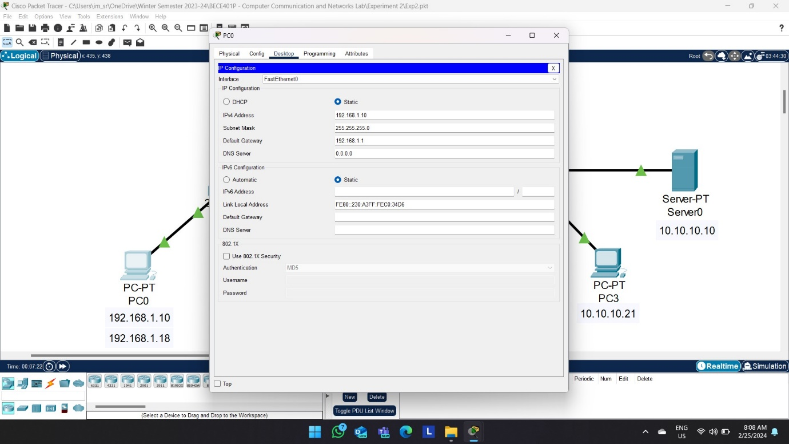

Figure 2.2 – IP Address and Default Gateway Configuration of PC0

1. Click Server0, go to Desktop Tab $→$ IP Configuration and configure the IP Addresses and DNS Server as 10.10.10.10 as given in Figure 2.3.

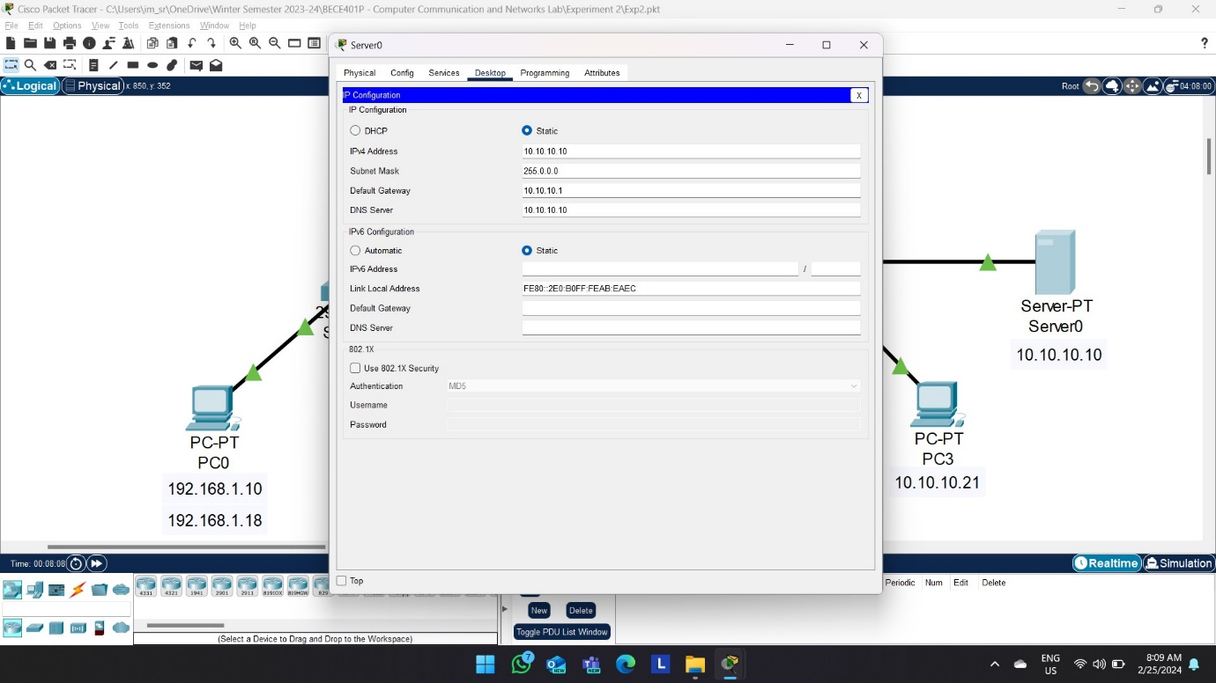

Figure 2.3 – IP Address, Default Gateway and DNS Server Configuration of Server

1. Click Router0, turn on the Port Status and configure the following as given in Figure 2.4.
   1. Configure the GigabitEthernet/0/0/0, IPv4 address as 192.168.1.1.
   2. Configure the GigabitEthernet/0/0/1, IPv4 address as 10.10.10.1.

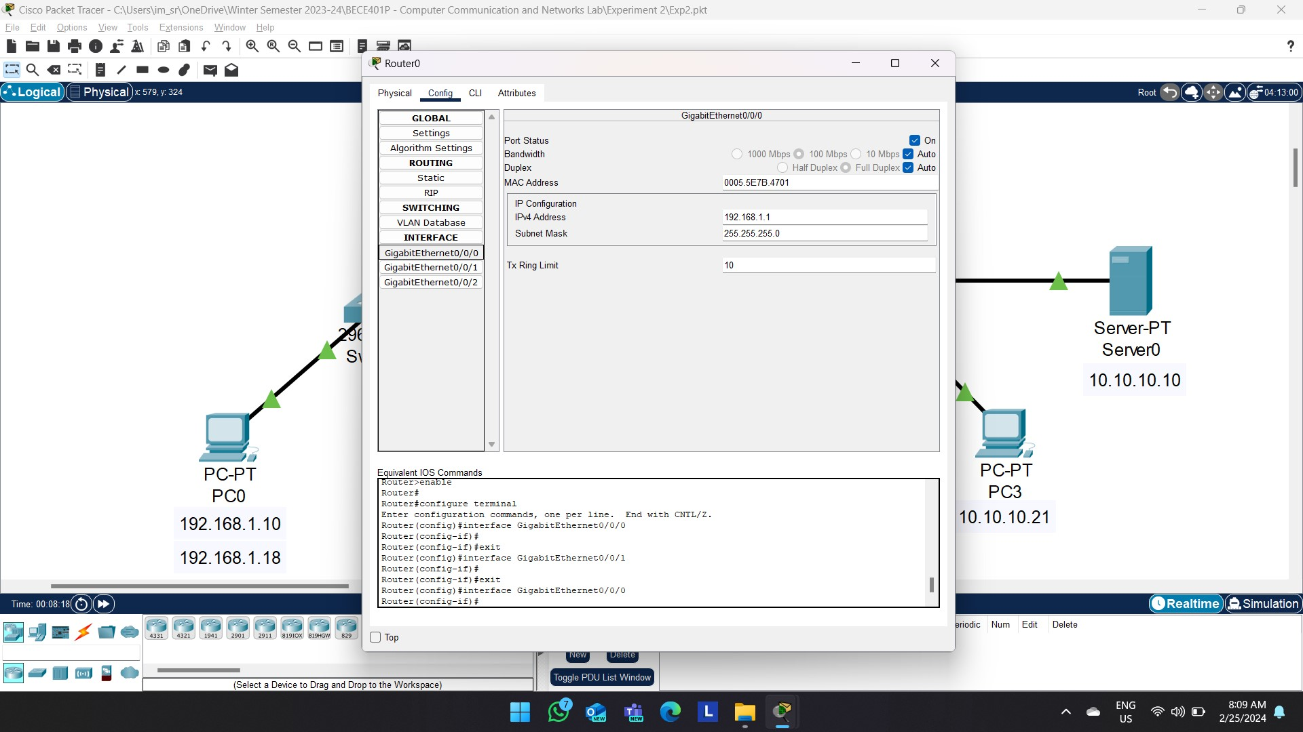

Figure 2.4 – Router Configuration

1. Verify the connection between the PCs by going to Desktop $→$ Command Prompt of PC0. Then type, ping 10.10.10.21 as given in Figure 2.5.

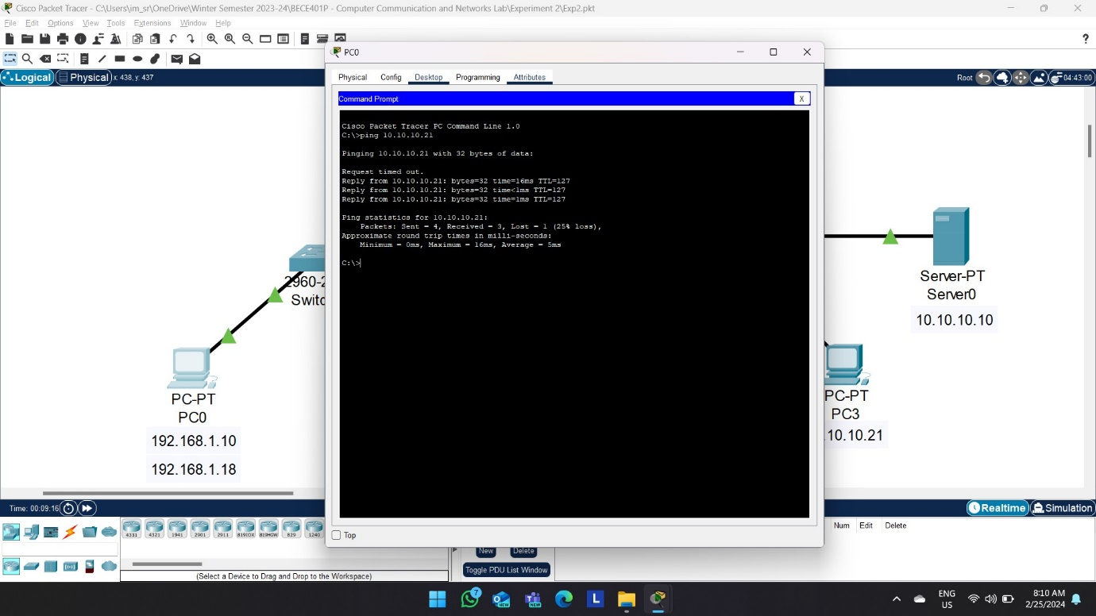

Figure 2.5 – Ping Command

1. Verify the connection between the PC and the server by going to Desktop $→$ Web Browser of any PC (e.g.: PC0). Then, type 192.168.1.10/index.html as given in Figure 2.6.

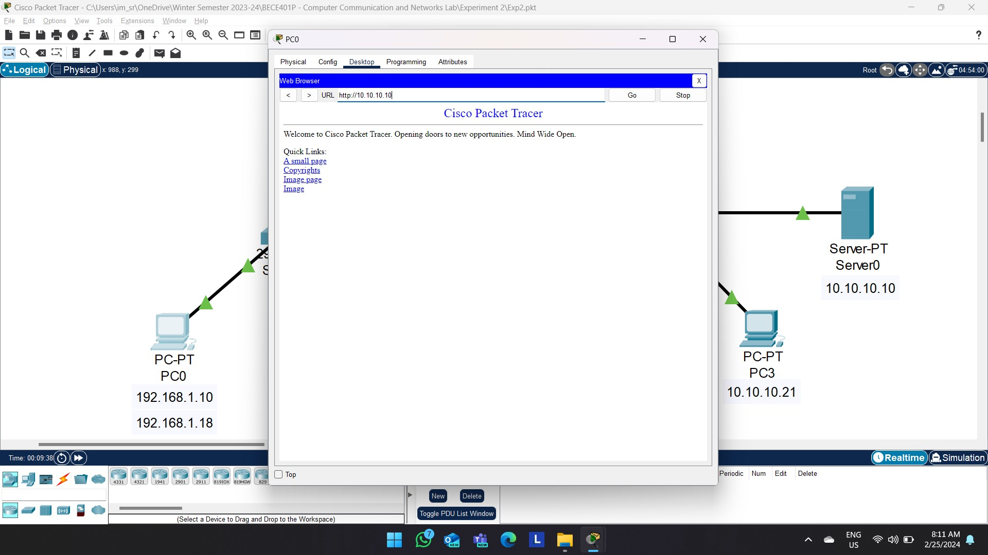

Figure 2.6 – Server Web Page in Web Browser

**Result:**

Hence, a wide area network is set up using a router, and PC in a LAN can communicate with server of another LAN successfully.



Figure 2.7 – Ping Successful

**Conclusion:**

1. In this diagram, two different local area networks are connected to the router.
2. The devices in LAN – 1 are configured with one IP Address Family (i.e. 192.168.1.X), whereas devices in LAN – 2 are configured with a different IP Address Family (i.e. 10.10.10.X).
3. The Router is used to communicate between different Local Area Networks by making a WAN.
4. PC0 in LAN – 1 can able to access the webpages of server which is in the LAN – 2 using the DNS Server.
5. By entering the DNS Server Address in the web browser, we can access the webpages of the server.
6. Here, Default Gateway is used to identify the different Local Area Networks connected to the router.
7. The PCs and Routers are connected in Physical Layer by the GigabitEthernet port.
8. When PC0 in LAN – 1 wants to send a packet to PC2 in LAN – 2, this packet is transferred to the router, then using the default gateway we can identify and send the packets to that respective Local Area Networks and then the packets are broadcasted by the switch.

Experiment 3: Email Server using Cisco Packet Tracer

**Aim:**

To setup an email server using Cisco Packet Tracer.

**Procedure:**

1. Open Cisco Packet Tracer. Then, get the following components and connect them using connection cables as given in Figure 3.1.
   1. Two PCs from End devices section
   2. One Server from End devices section
   3. One 2960 Switch from Switches Section
   4. One ISR4331 Router from Router Section

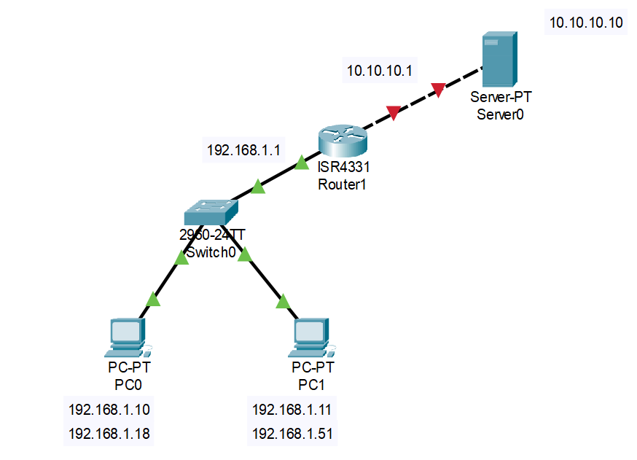Figure 3.1 – Email Server Connections

1. Click the PC, go to Desktop Tab → IP Configuration and configure the IP Addresses and default gateway for each PC as given in Figure 3.2.
   1. Configure the IP address of PC0 as 192.168.1.10 and IP Address of PC1 as 192.168.1.11.
   2. Configure the Default Gateway for both PC0 and PC1 as 192.168.1.1.

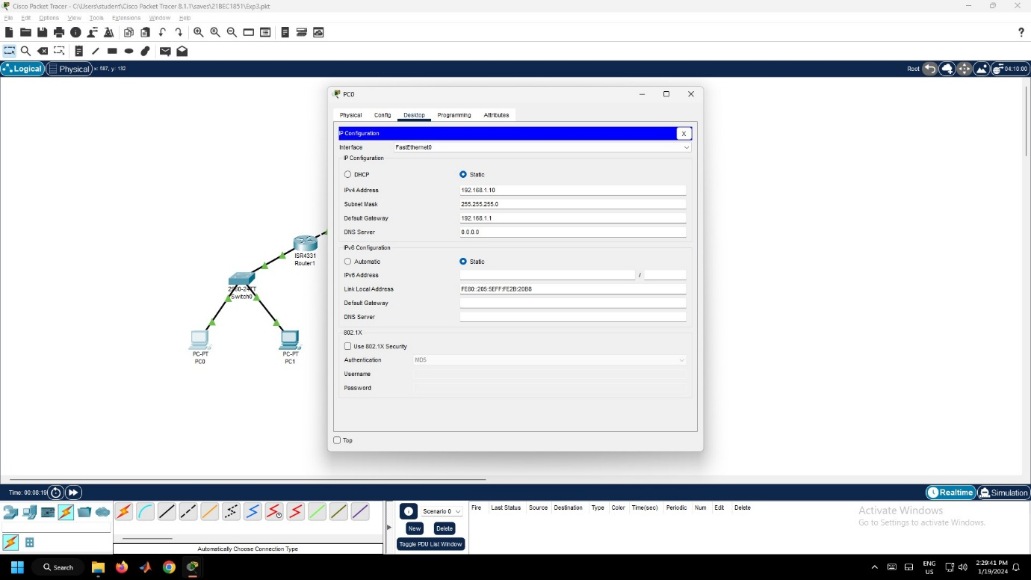

Figure 3.2 – PC0 Configuration

1. Click the Server0, go to Desktop Tab → IP Configuration and configure the IP Address and DNS Server as 10.10.10.10 and Default Gateway as 10.10.10.1 as given in Figure 3.3.

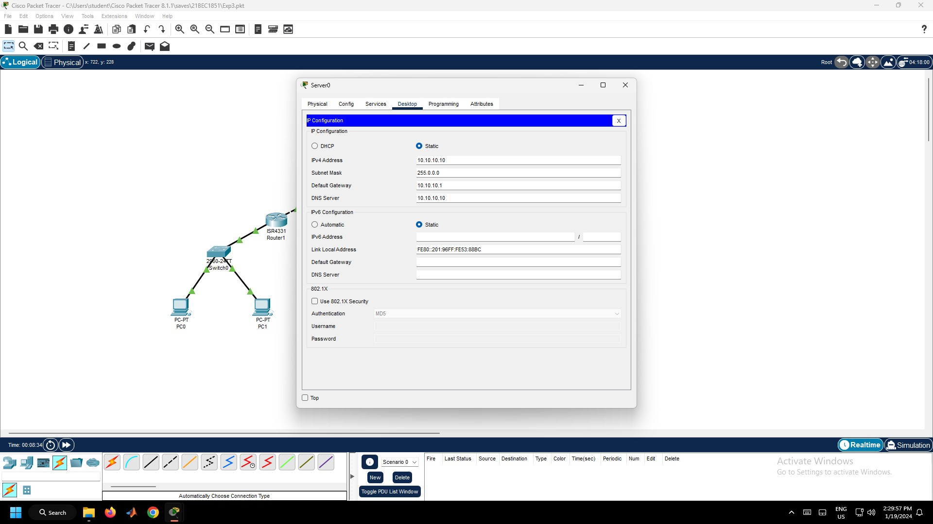

Figure 3.3 – IP Configuration in Server0 Configuration

1. Click the Router0, Go to Config tab. configure the Router by turning on the Port Status and enter the IP Address as 192.168.1.1 and 10.10.10.1 for GigabitEthernet0/0/0 and GigabitEthernet0/0/1 respectively as given in Figure 3.4.

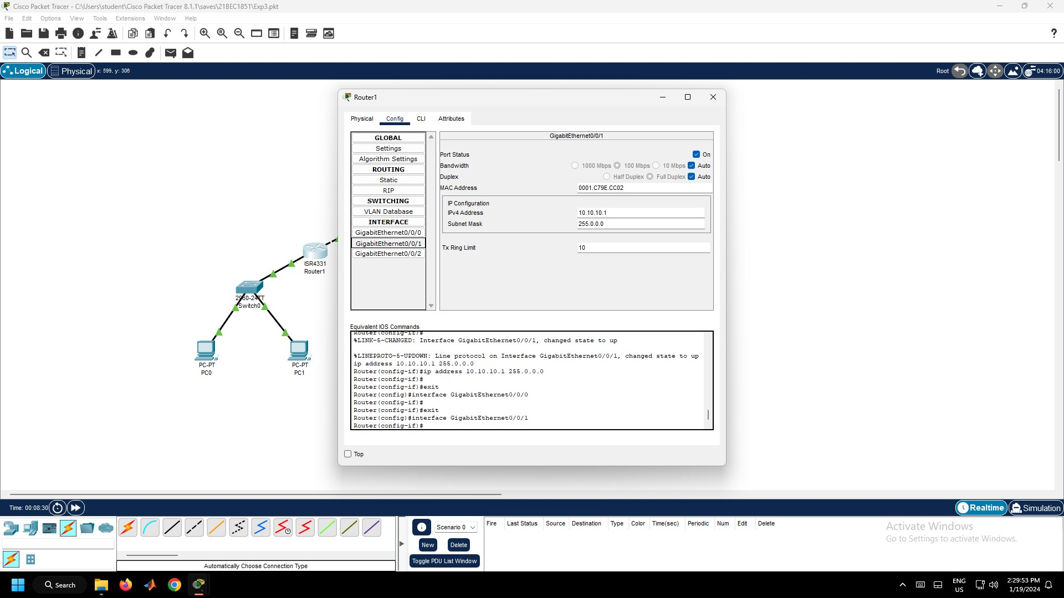

Figure 3.4 – Router0 Configuration

1. Now, verify whether connections are successfully established between two different Local Area Networks. Click the PC0, go to Desktop Tab and then to Web Browser. Now type the “10.10.10.10/index.html” as given in Figure 3.5.

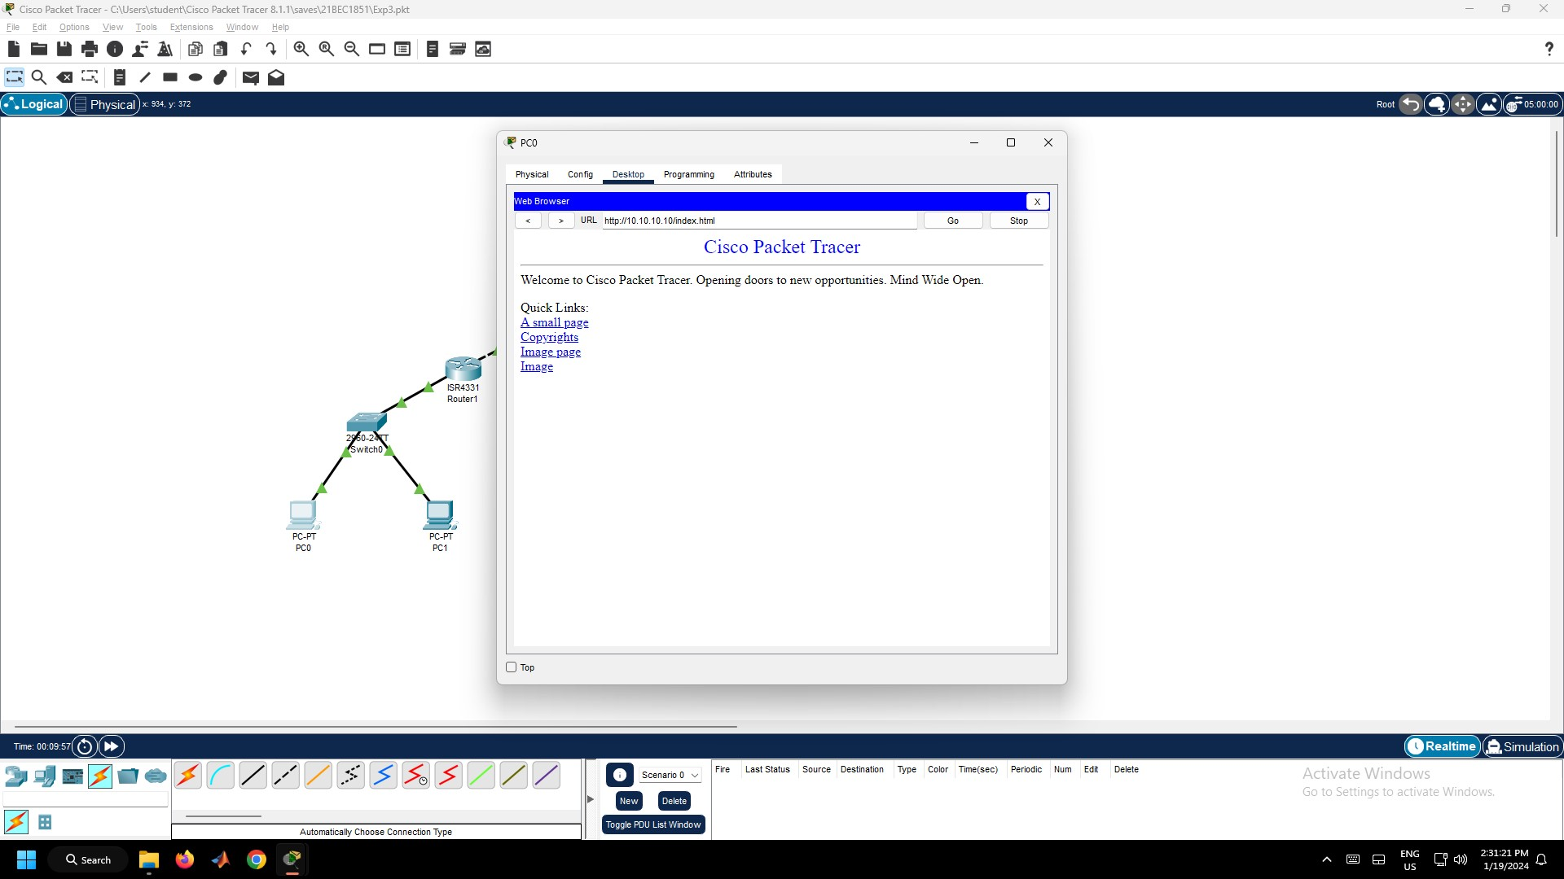

Figure 3.5 – Server Web Page in Web Browser

1. Click the Server0, go to Services Tab, under that click the Email Services. Now, set the Domain Name and setup the users by entering the username and password and click the “+” Symbol as given in Figure 3.6.

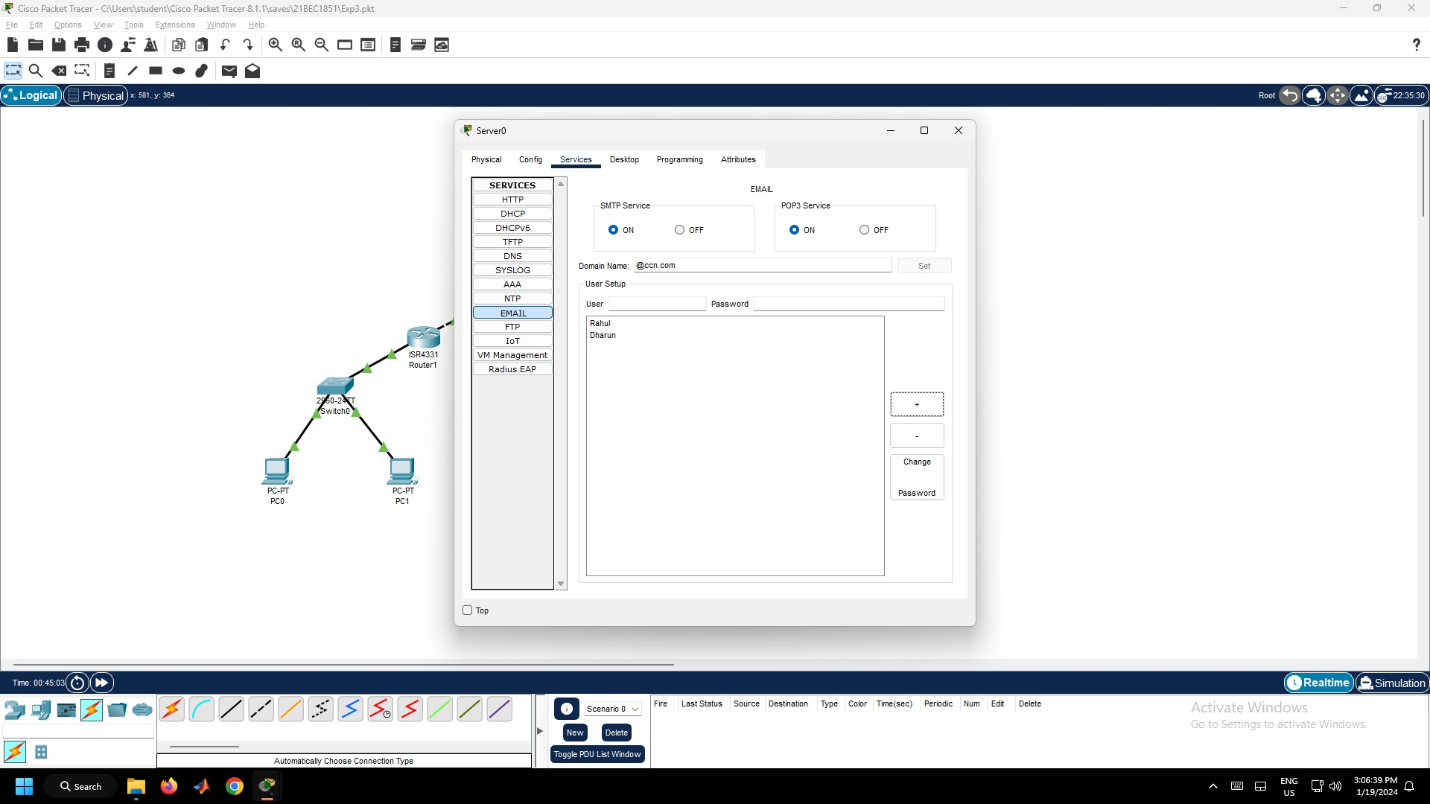

Figure 3.6 – Email Configuration in Server0

1. Click the PC0, go to Desktop Tab, click Email, configure the email client by filling in the user, server and login information. Then, click Save button as given in Figure 3.7. Follow the same procedure for PC1.

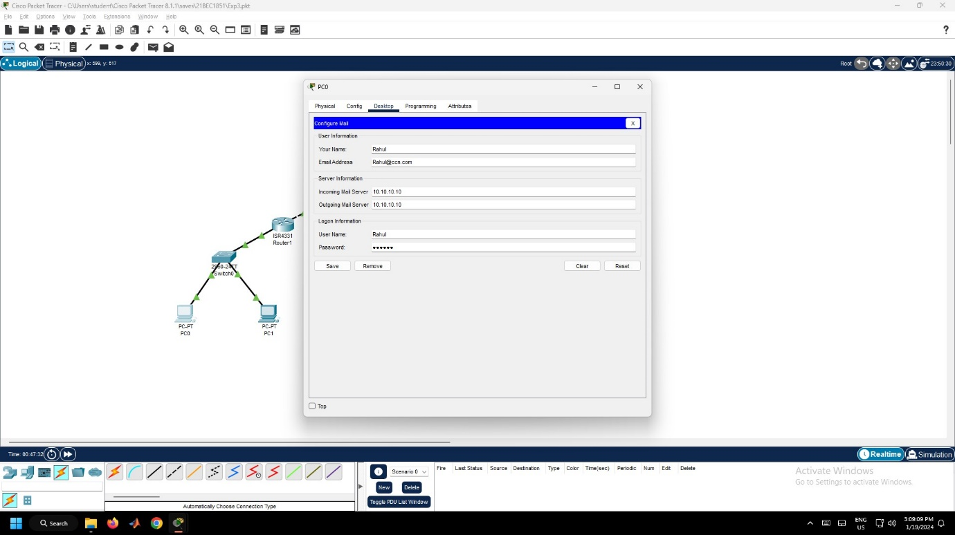

Figure 3.7 – Email Configuration in PC0

1. To test the email service, go to PC0 email client, compose an email and send its to PC1 email address ([Dharun@ccn.com](mailto:Dharun@ccn.com)) as given in Figure 3.8.

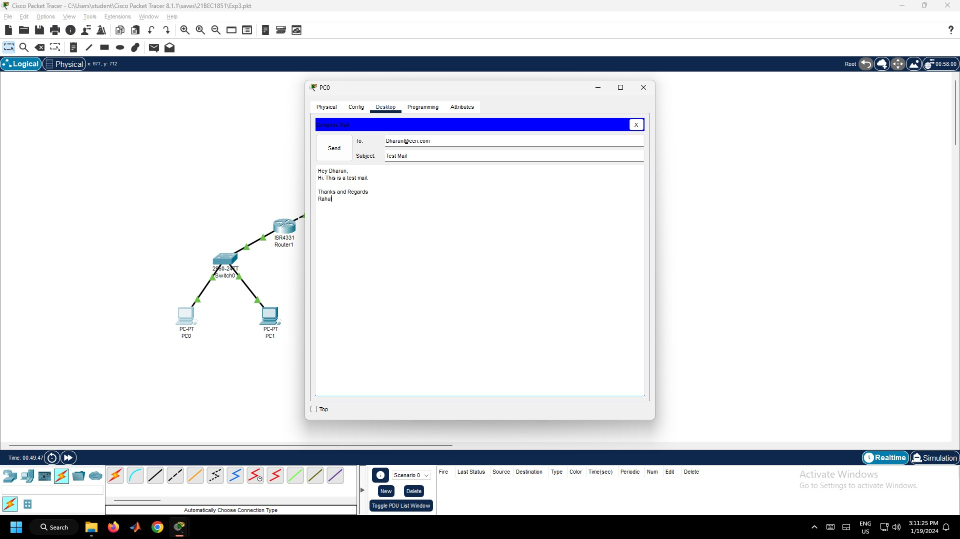

Figure 3.8 – Composing Email

1. Now, check whether the email from PC0 is received on PC1. On the email client of PC1, click on Receive as given in Figure 3.9.

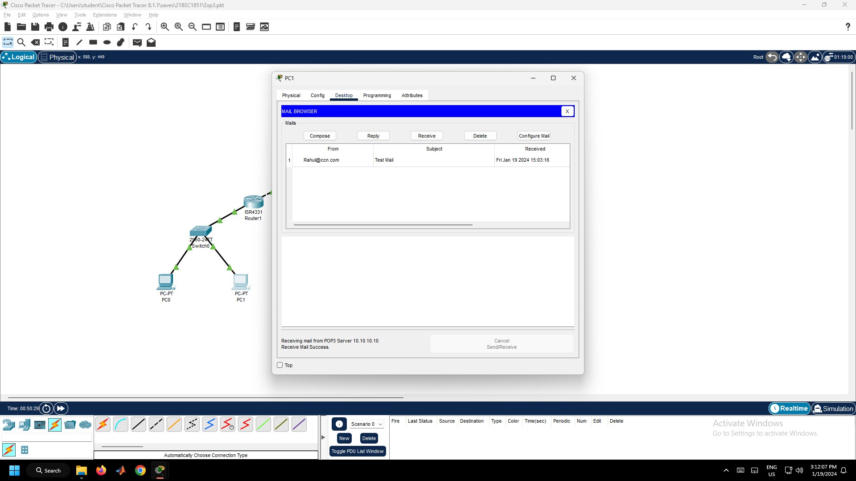

Figure 3.9 – Mail Received in PC1

**Result:**

Hence, an email server is configured and the email received in PC1 successfully.

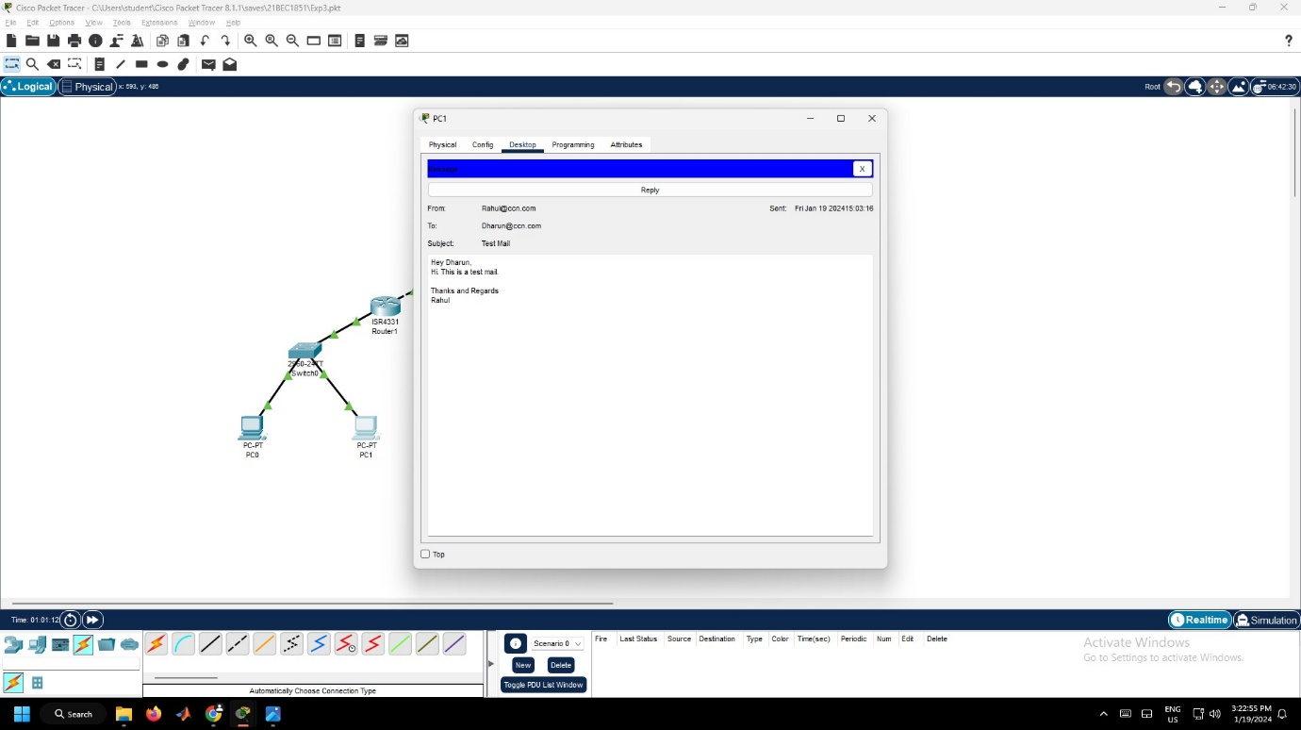

Figure 3.10 – Mail Received Successfully

**Conclusion:**

1. Here, two different Local Area Networks are connected to the router.
2. Here, PC0 and PC1 uses the Email Services of the Server0.
3. The users to be added in the server, before using the email services. Only then, the PCs can able to send the mail.
4. The email is sent from one PC to the other PC through the server.
5. The username and passwords of the users are stored in the server.
6. When PC0 wants to send the mail to PC1, the mail will be sent to the server. Then from server it will be sent to the PC1.

Experiment 4: File Transfer Protocol Using Cisco Packet Tracer

**Aim:**

To setup a file transfer protocol environment using Cisco Packet Tracer.

**Procedure:**

1. Open Cisco Packet Tracer. Then, get the following components and connect them using connection cables as given in Figure 4.1.
   1. Four PCs from End devices section
   2. One Server from End devices section
   3. Two 2960 Switch from Switches Section
   4. One ISR4331 Router from Router Section

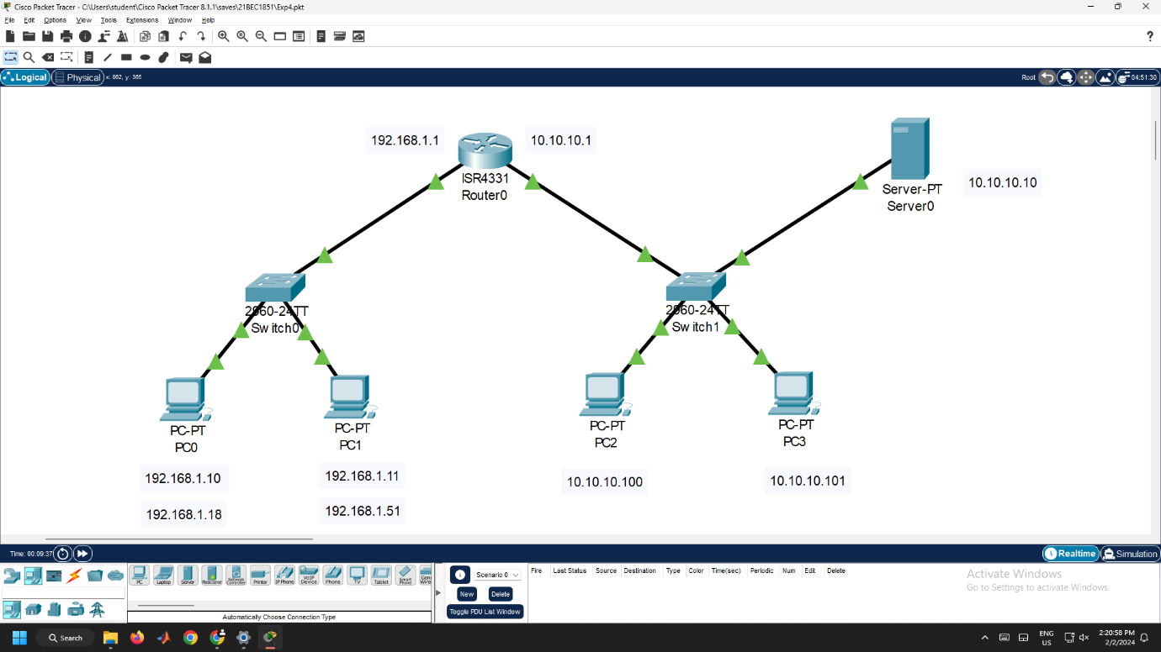

Figure 4.1 –File Transfer Protocol Server Connections

1. Click the PC, go to Desktop Tab → IP Configuration and configure the IP Addresses and default gateway for each PC as given in Figure 4.2.
   1. Configure the IP Address of PC0 as 192.168.1.10 and IP Address of PC1 as 192.168.1.11.
   2. Configure the Default Gateway for both PC0 and PC1 as 192.168.1.1.
   3. Configure the IP Address of PC2 as 10.10.10.100 and IP Address of PC1 as 10.10.10.101.
   4. Configure the Default Gateway for both PC2 and PC3 as 10.10.10.1.



Figure 4.2 – PC0 Configuration

1. Click the Server0, go to Desktop Tab → IP Configuration and configure the IP Address and DNS Server as 10.10.10.10 and Default Gateway as 10.10.10.1 as given in Figure 4.3.



Figure 4.3 – IP Configuration in Server0 Configuration

1. Click the Router0, Go to Config tab. Configure the Router by turning on the Port Status and enter the IP Address as 192.168.1.1 and 10.10.10.1 for GigabitEthernet0/0/0 and GigabitEthernet0/0/1 respectively as given in Figure 4.4.



Figure 4.4 – Router0 Configuration

1. Verify whether connections are successfully established between two different Local Area Networks. Click the PC0, go to Desktop Tab and then to Command Prompt. Now type the ping 10.10.10.100 as given in Figure 4.5.

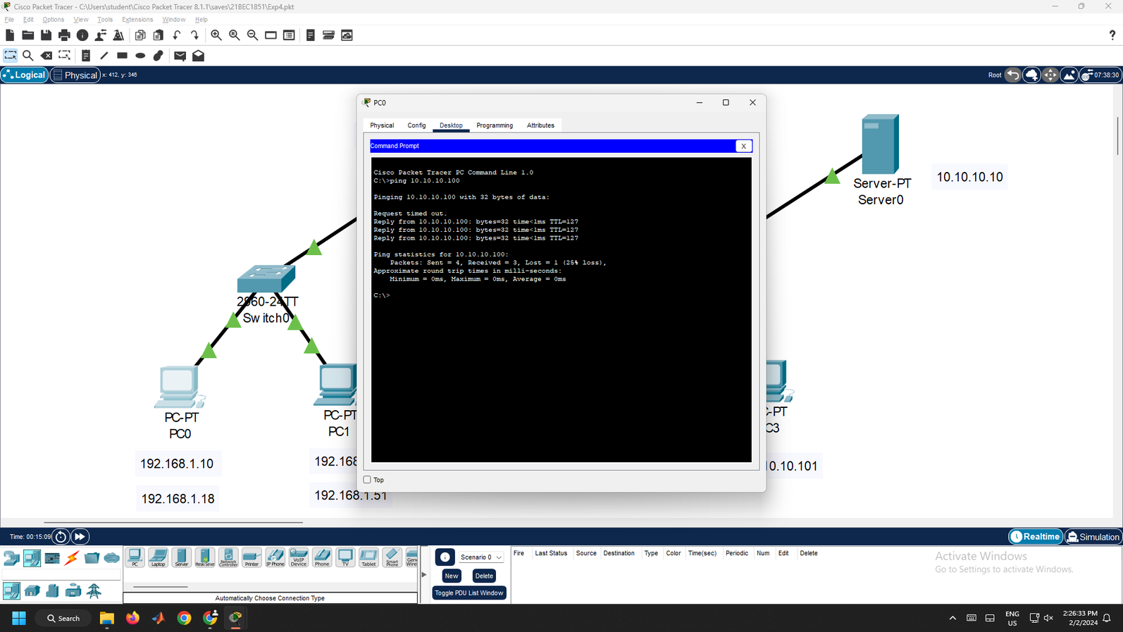

Figure 4.5 – Ping Command

1. Now, verify whether connections are successfully established between two different Local Area Networks. Click the PC0, go to Desktop Tab and then to Web Browser. Now type the “10.10.10.10/index.html” as given in Figure 3.5.



Figure 4.6 – Server Web Page in Web Browser

1. Click Server0, go to Services Tab, under that click the FTP Service. Now, set up the users by entering the username, password, permissions and click the “Add” button as given in Figure 4.7. While creating, give different permission access to different users.

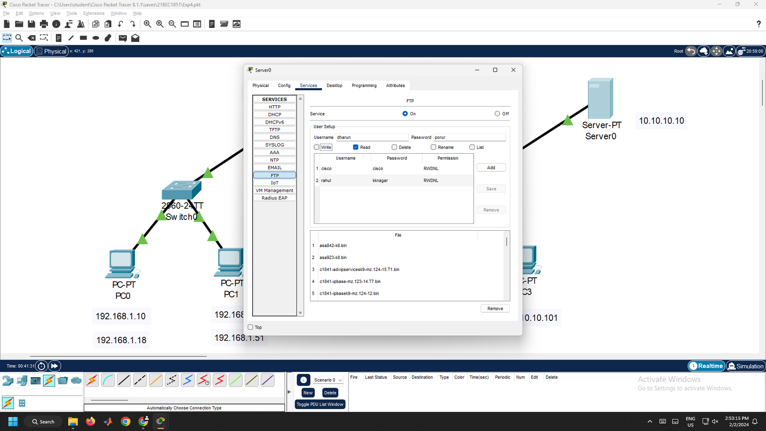

Figure 4.7 – FTP Users Configuration in Server0

1. Create a text file in any PC (say PC0). For that, Click the PC1, go to Desktop Tab, click Text Editor. Then, type something and save the document as given in Figure 4.9.

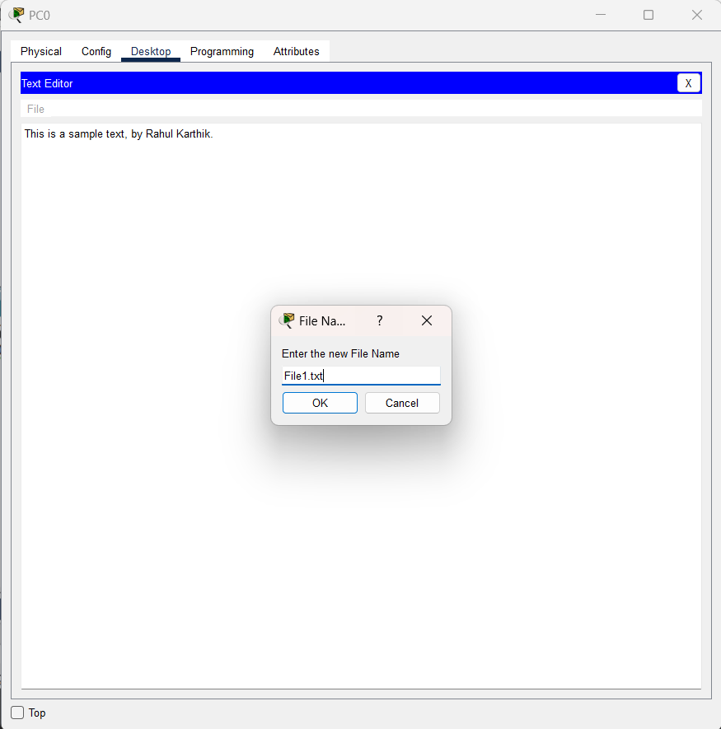

Figure 4.8 – Creating Text File in PC0

1. To verify whether the file was created in PC, Go to Desktop Tab, Open Command Prompt and type dir, to know whether the file was created or not as given in Figure 4.9.

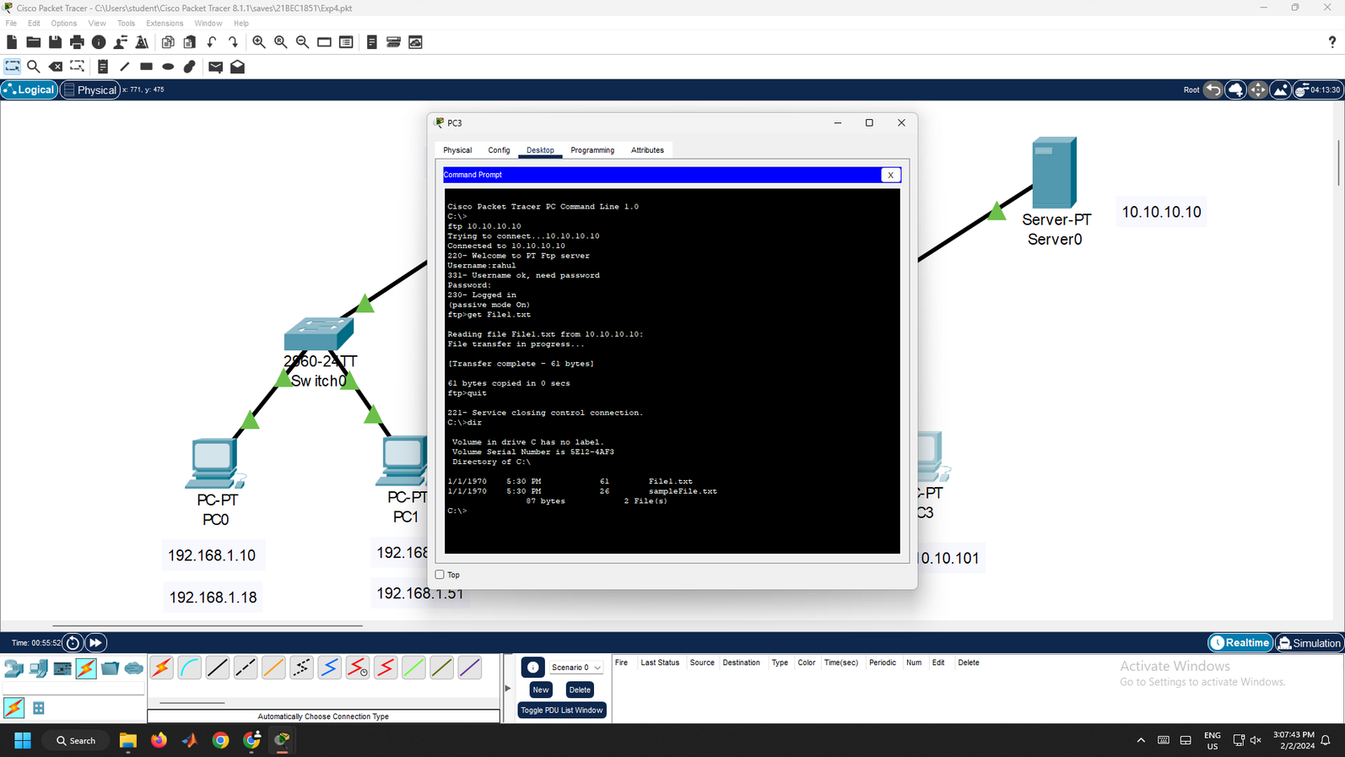

Figure 4.9 - Files in PC using dir command

1. To verify, go to Desktop Tab, click Command Prompt, then type ftp 10.10.10.10 to connect to the server. Login to the server by entering username and password. Type “?” for help, “quit” for exiting the ftp mode as given in Figure 4.10.

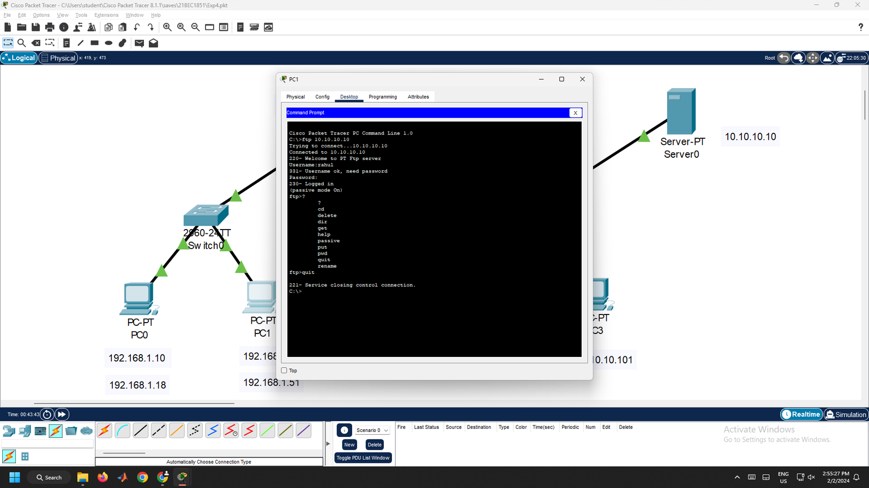

Figure 4.10 – FTP in PC0 Command Prompt

1. Now, type ftp 10.10.10.10 to enter into FTP mode, then login using the username and password. Then, type, put File1.txt to upload the text file from the PC to FTP Server as given in Figure 4.11.

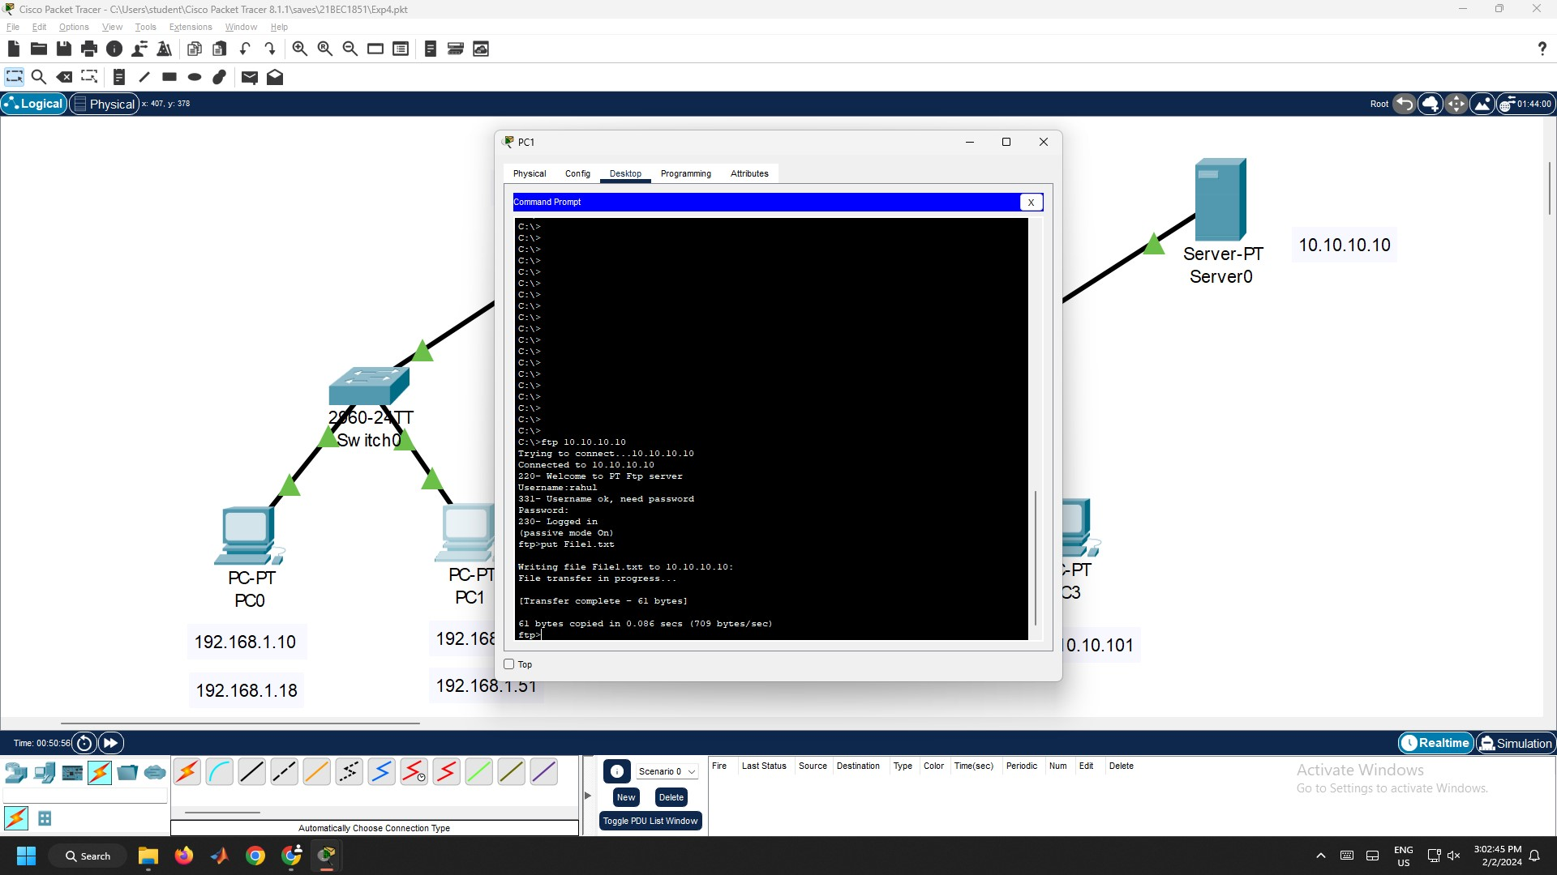

Figure 4.11 – File Transfer to Server using put command

1. To verify whether our file was uploaded to the server, type dir as given in Figure 4.12. This command is used to know the list of files in our server as given in Figure 4.12.

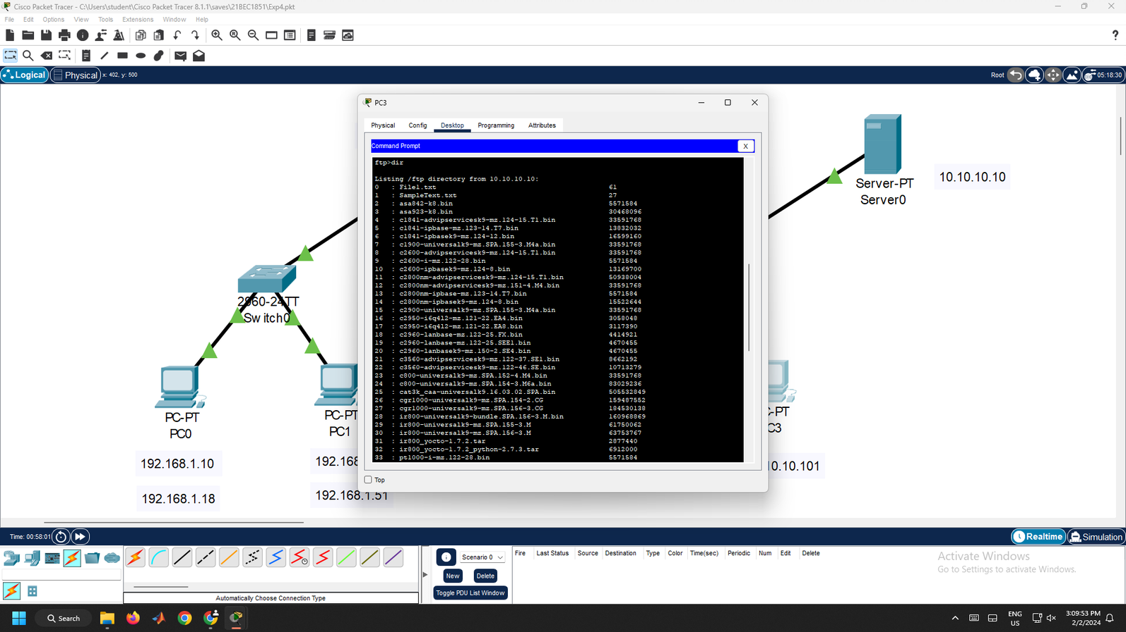

Figure 4.12 - Files in FTP Server using dir command

1. Click PC3, Click Desktop Tab, Go to Command Prompt. To get a file from FTP server, type get File1.txt as given in Figure 4.13.

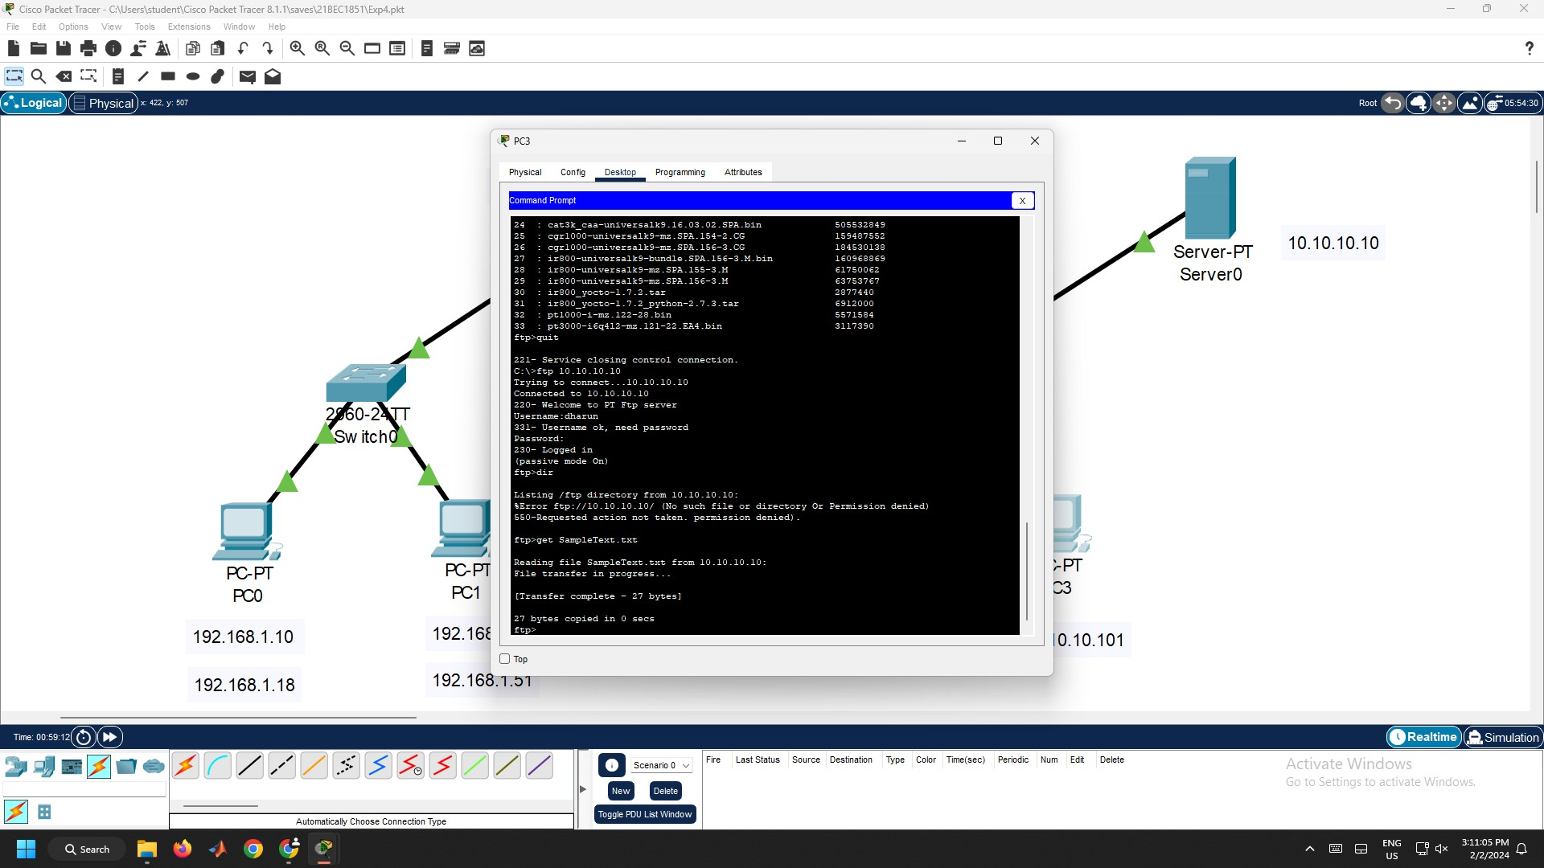

Figure 4.13 – File Transfer from Server using get command

1. To delete the file from the FTP server, type delete File1.txt and follow the Step (12) to verify whether the file is deleted or not as given in Figure 4.14.

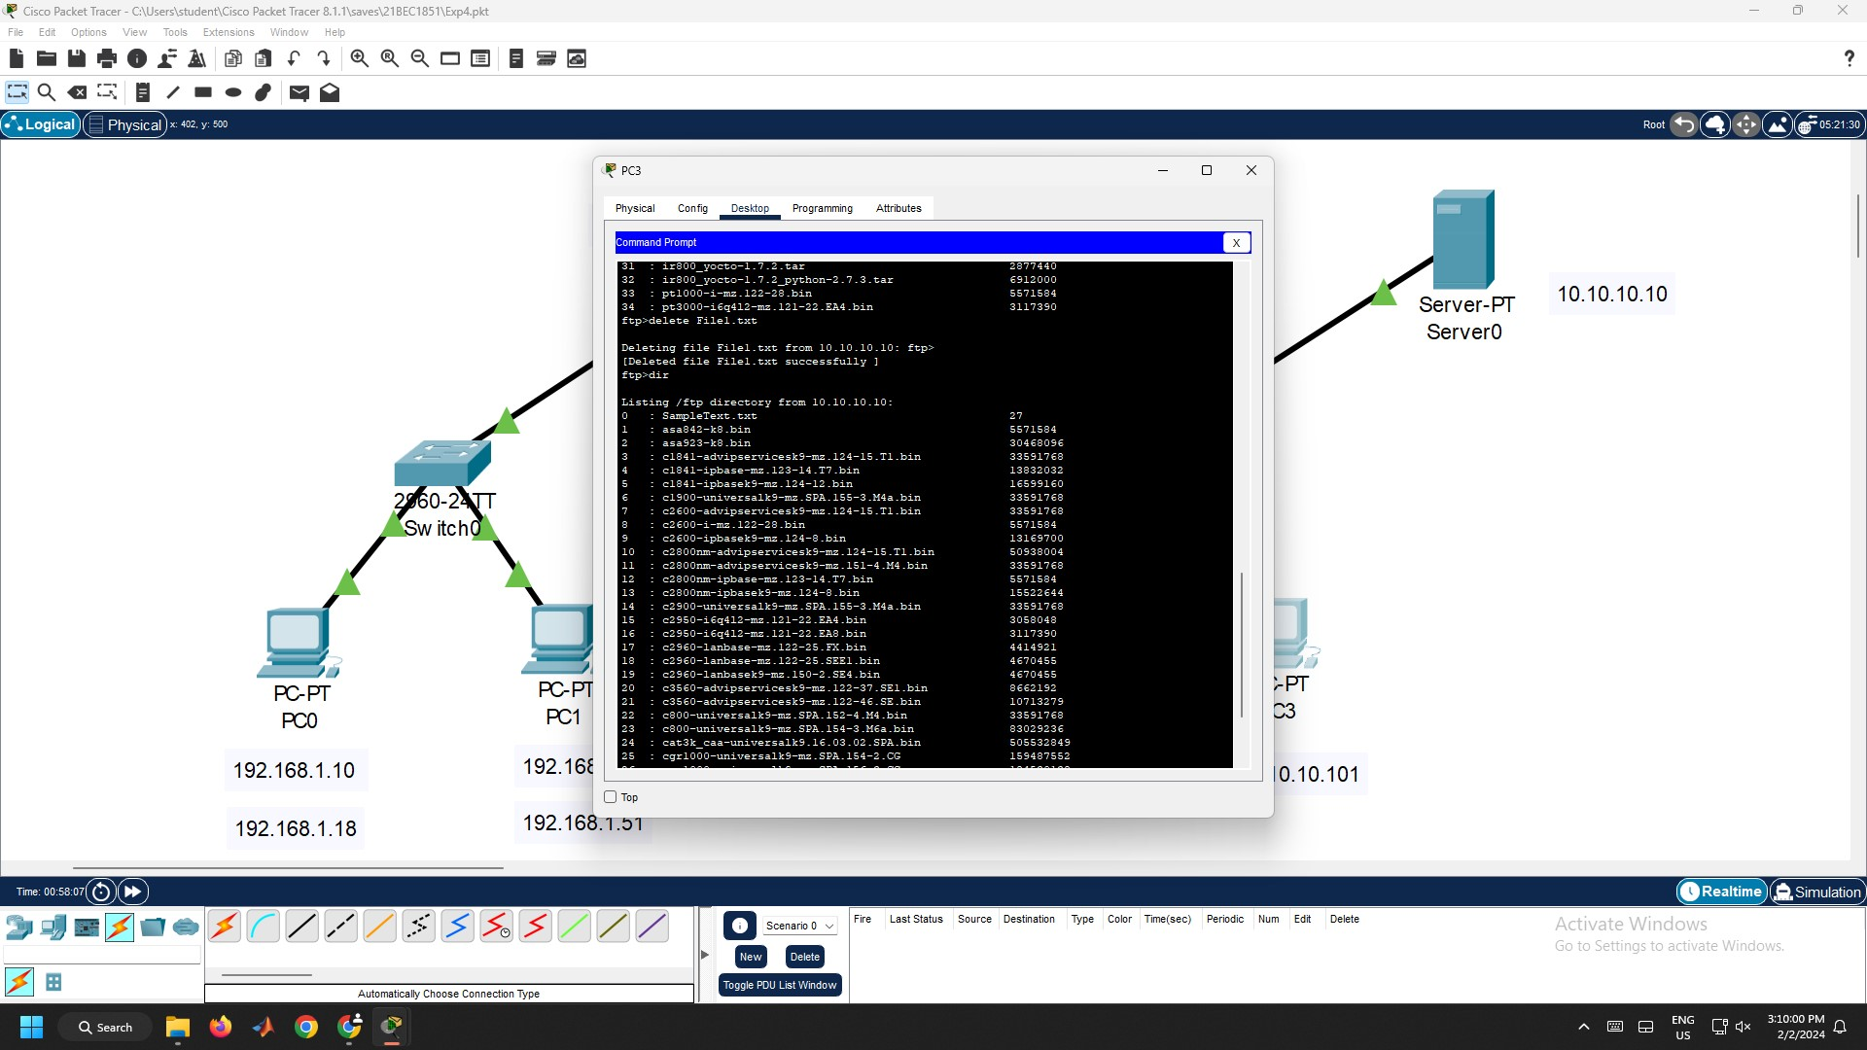

Figure 4.14 – Deleting Files from Server using delete command

1. Now, try to do another operation with a different user to check whether the server allows you to perform that operation as given in Figure 4.15.

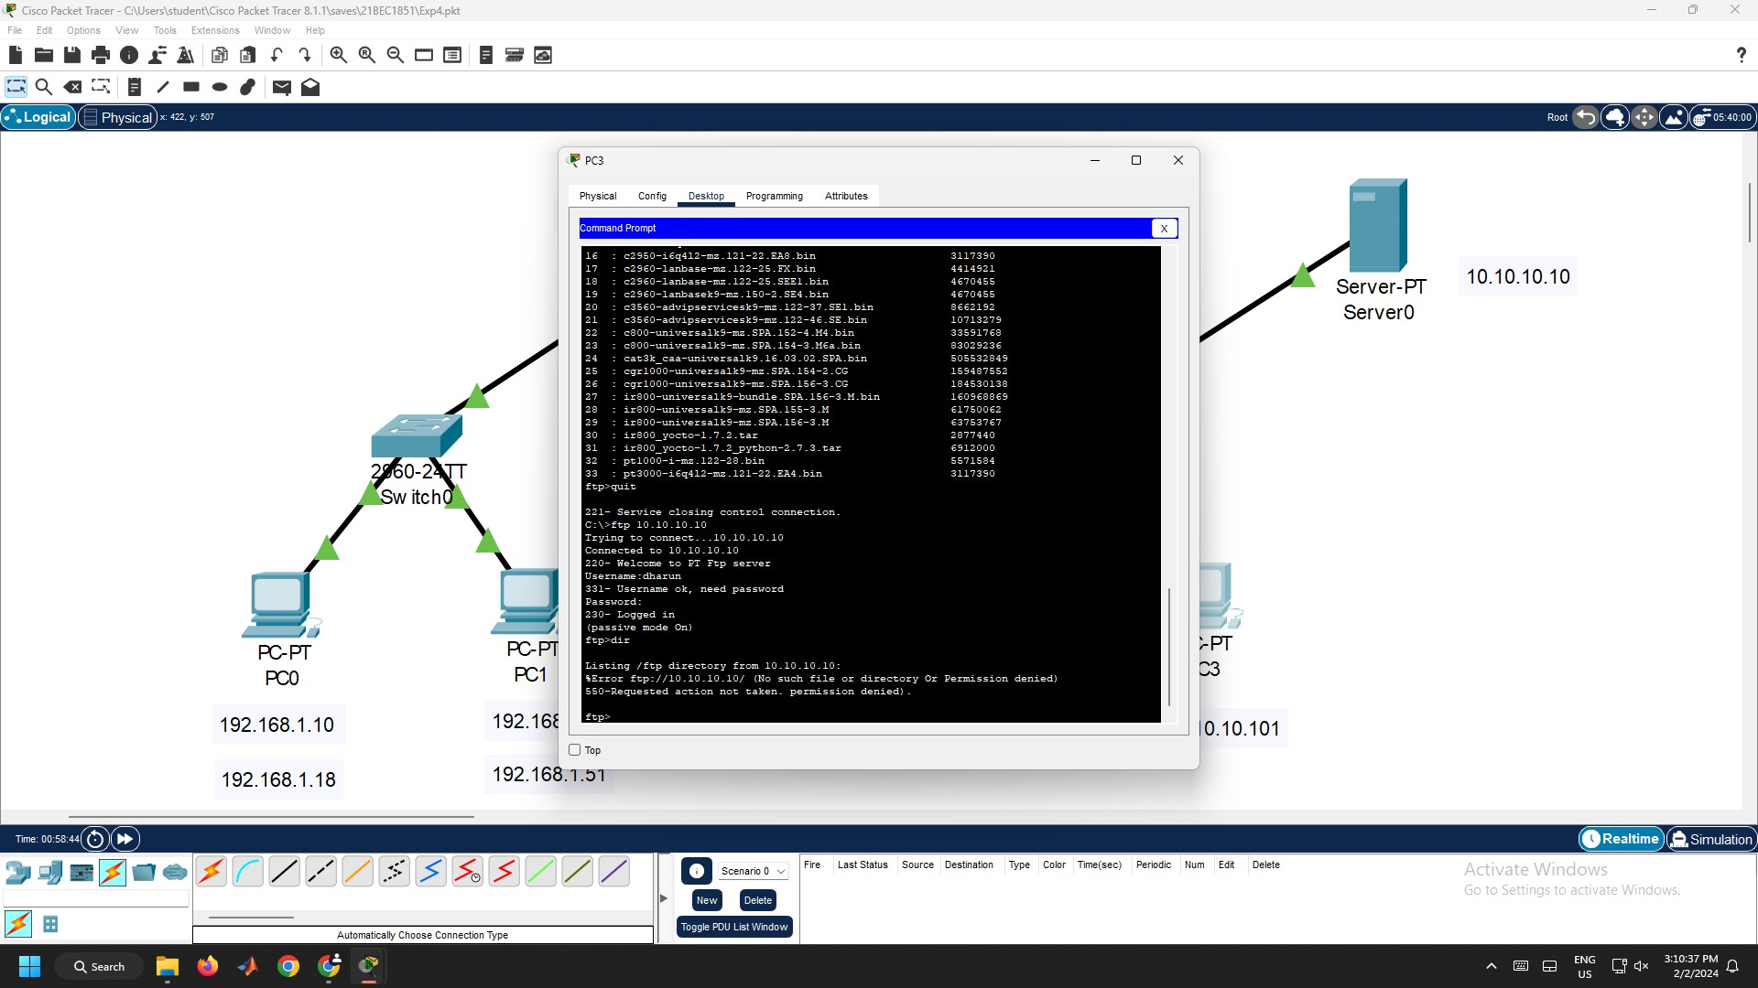

Figure 4.15 – Permission Denied for the user

**Result:**

Hence, a file transfer protocol is configured, and the file is transferred successfully.

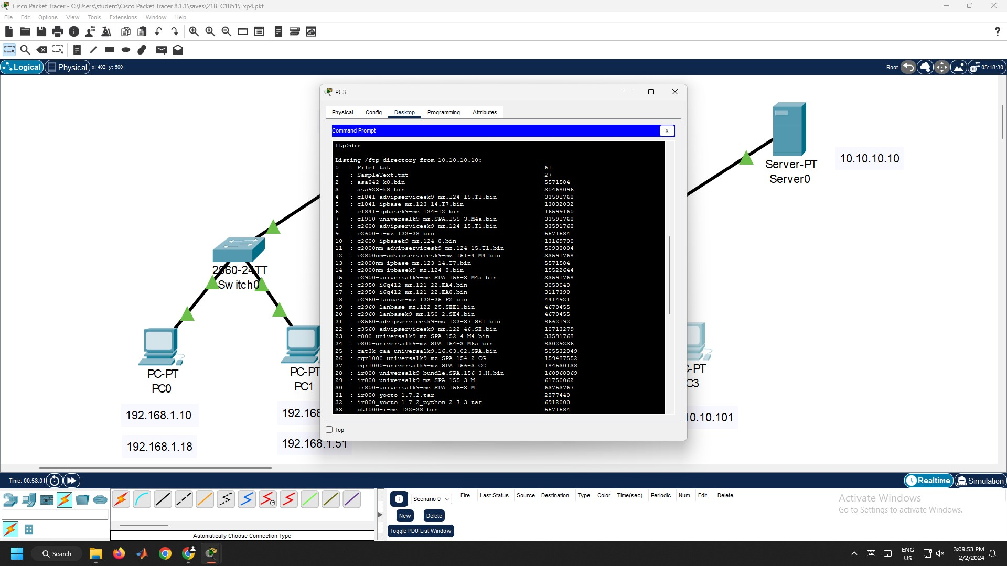

Figure 4.16 – File Transferred Successfully

**Conclusion:**

1. Here, two different Local Area Networks are connected to the router.
2. Here, PC0 and PC1 use the FTP Services of the Server0.
3. We can use dir command to list the files in our directory.
4. The users can be added to the server by creating username, password and different permissions can be assigned to different users like Read, Write, Delete, Rename and List.
5. We can use “?” for help and it shows various commands that can be used.
6. Users can perform any operation, if they are allowed to do that operation.
7. Any users can access the FTP server with username and password in any PCs as long as they are connected to the network.
8. We can upload the files from the PC to the server using put command
9. We can download the files from the server to the PC using get command.
10. We can delete the files in the server using delete command.

Experiment 5: Static Routing Using Cisco Packet Tracer

**Aim:**

To configure and implement the static routing using Cisco Packet Tracer.

**Procedure:**

1. Open Cisco Packet Tracer. Then, get the following components and connect them using connection cables as given in Figure 5.1.
   1. Four PCs from End Devices Section.
   2. One Server from End Devices Section.
   3. Two 2960 Switches from Switches Section.
   4. Two ISR4331 Routers from Routers Section.

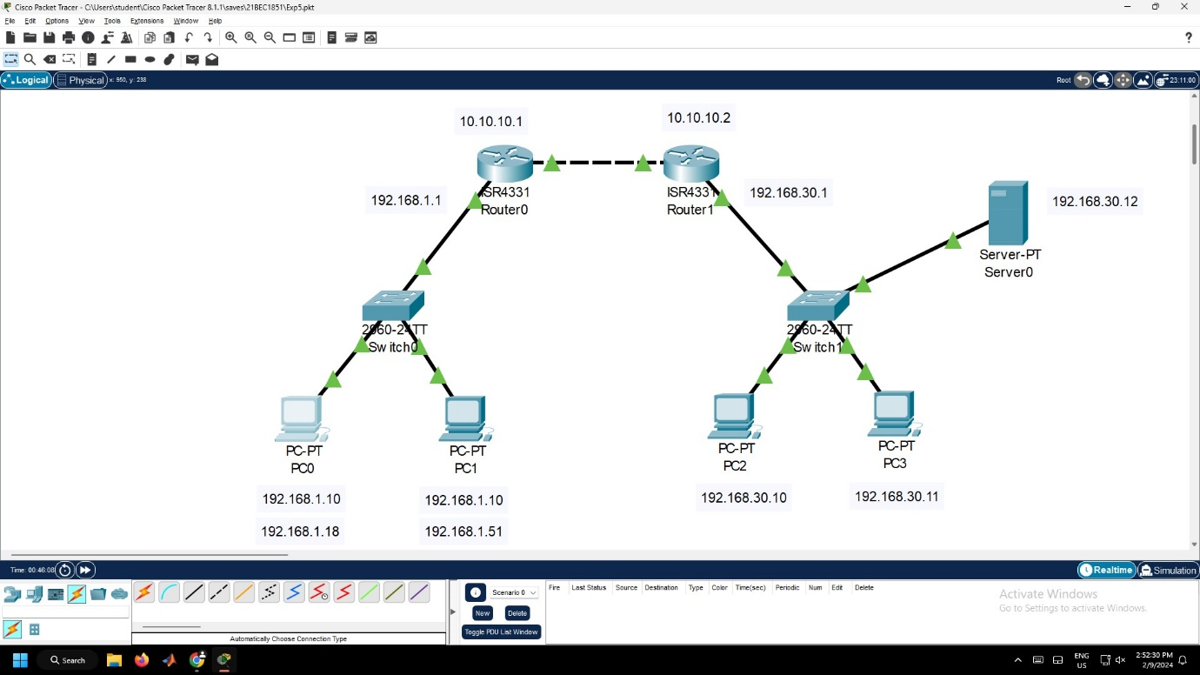

Figure 5.1 – Static Routing Connection

1. Click the PCs, go to Desktop Tab → IP Configuration and configure the IP Addresses and default gateway for each PC as given in Figure 5.2.
   1. Configure the IP Address of PC0 as 192.168.1.10 and IP Address of PC1 as 192.168.1.11.
   2. Configure the Default Gateway for both PC0 and PC1 as 192.168.1.1.
   3. Configure the IP Address of PC2 as 192.168.30.10 and IP Address of PC1 as 192.168.30.11.
   4. Configure the Default Gateway for both PC2 and PC3 as 192.168.30.1.

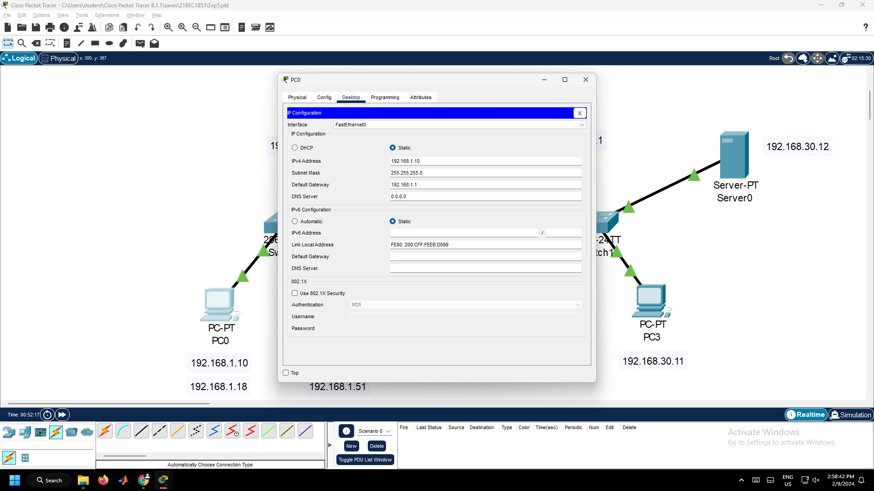

Figure 5.2 – PC0 Configuration

1. Click the Server0, go to Desktop Tab → IP Configuration and configure the IP Address and DNS Server as 192.168.30.12 and Default Gateway as 192.168.30.1 as given in Figure 5.3.

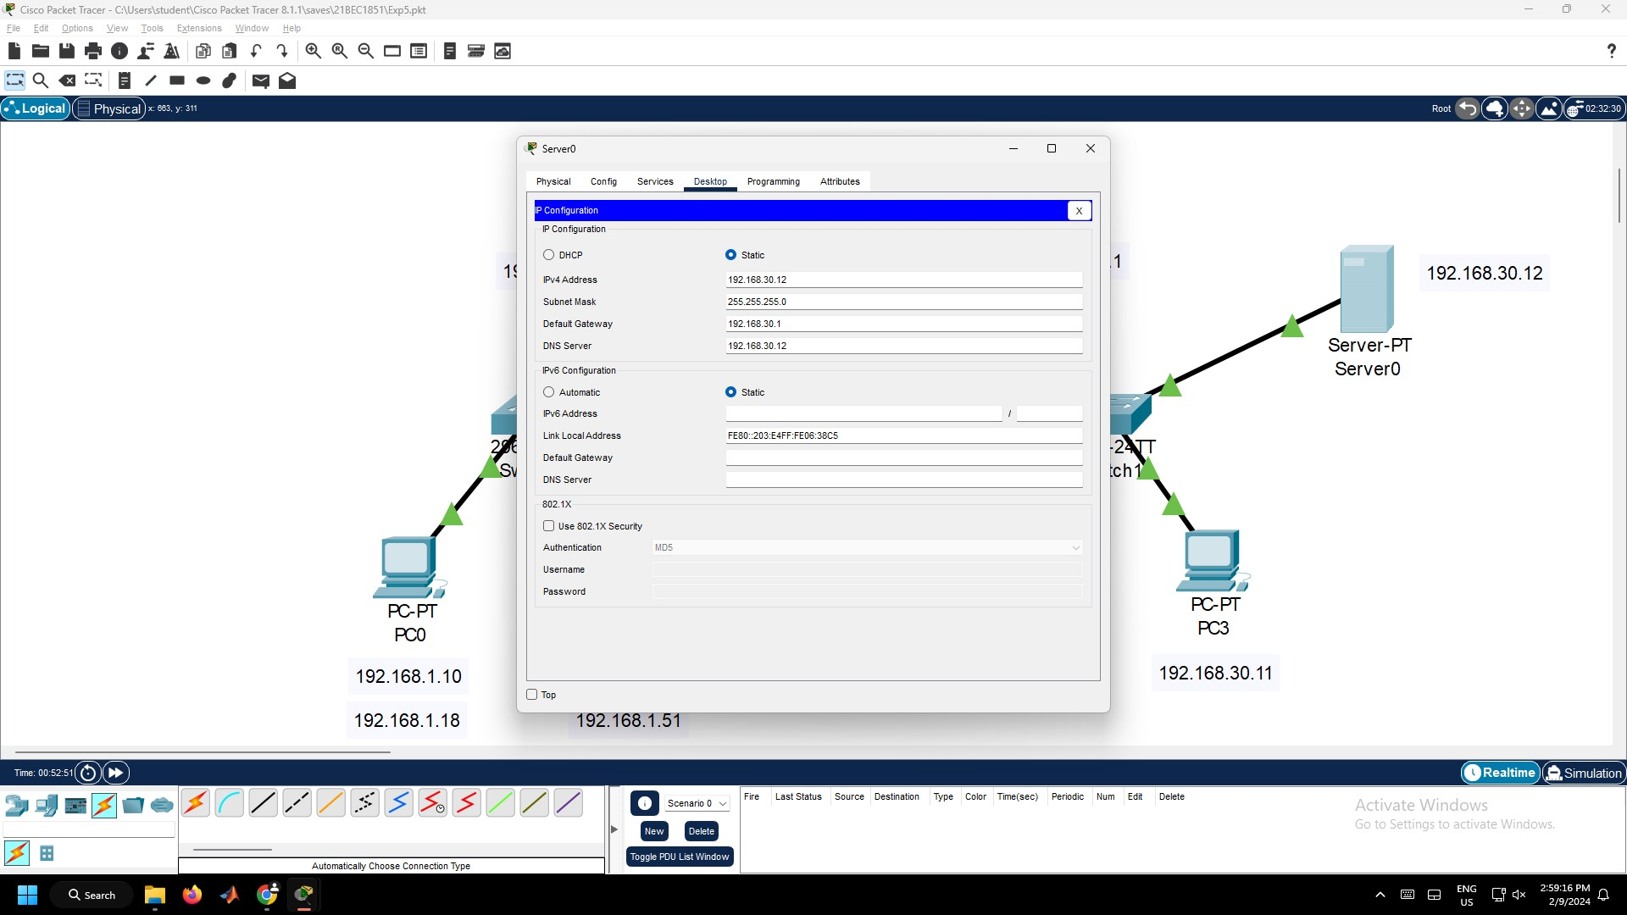

Figure 5.3 – Server0 Configuration

1. Click the Router0, Go to Config tab. Configure the Router by turning on the Port Status and enter the IP Address as 192.168.1.1 and 10.10.10.1 (this IP Address is used to route the packets to the different router) for GigabitEthernet0/0/0 and GigabitEthernet0/0/1 respectively as given in Figure 5.4.

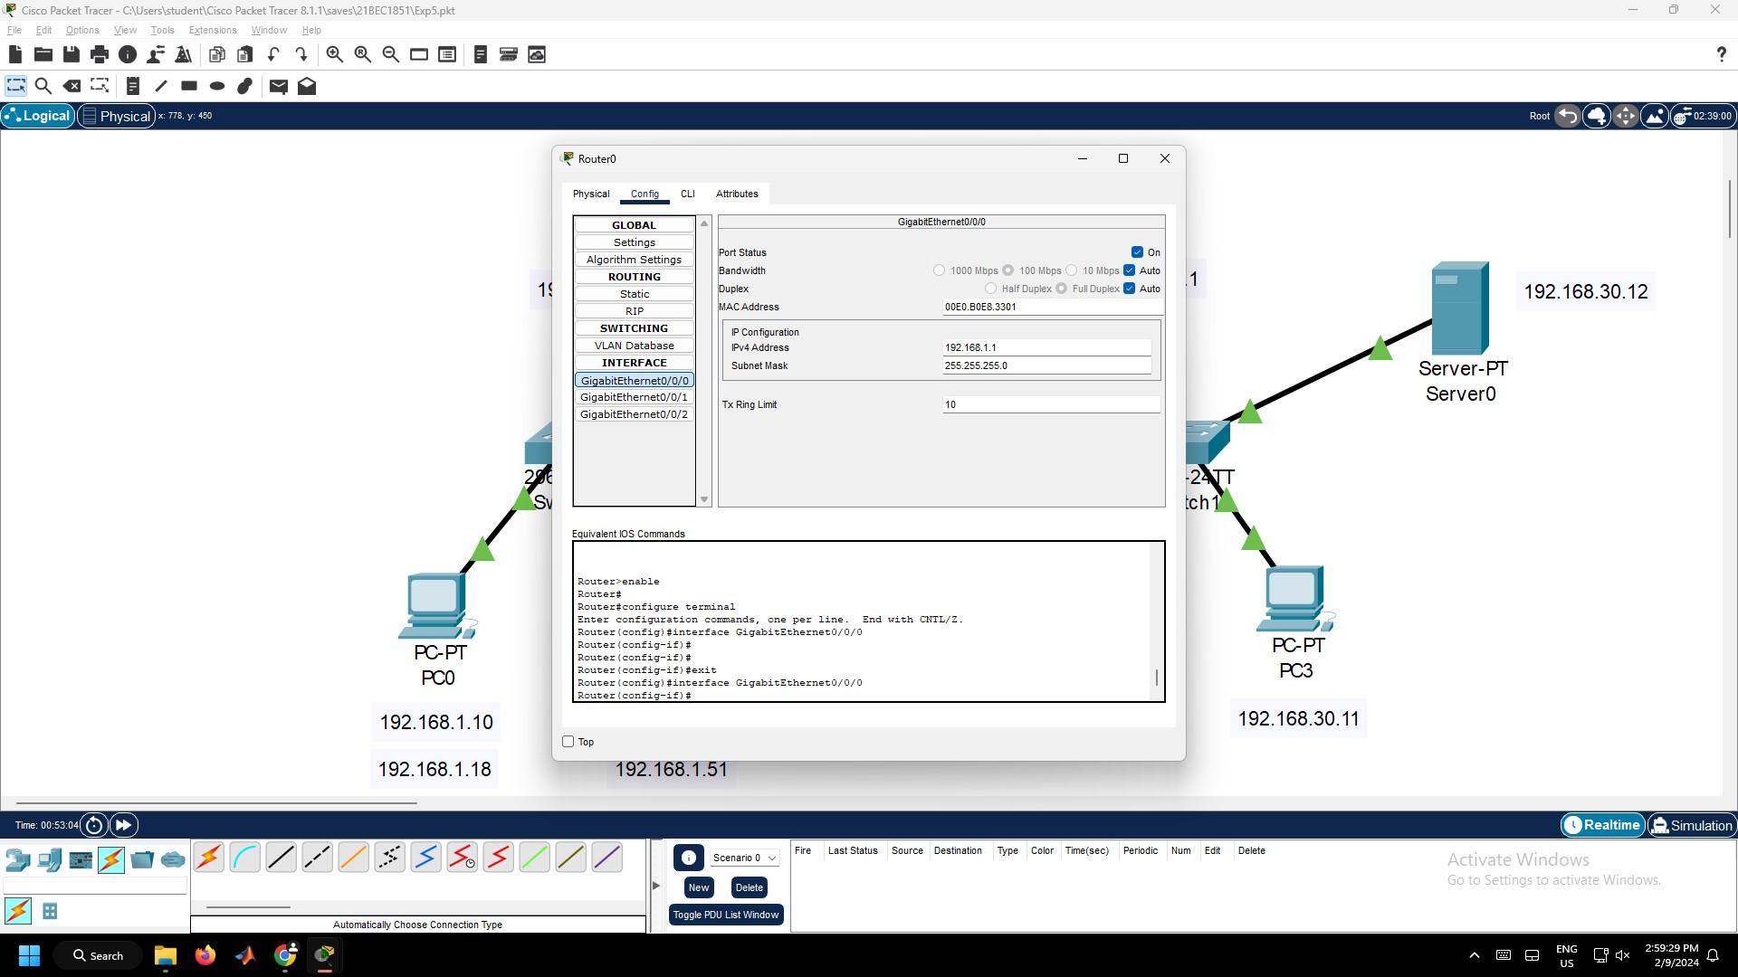 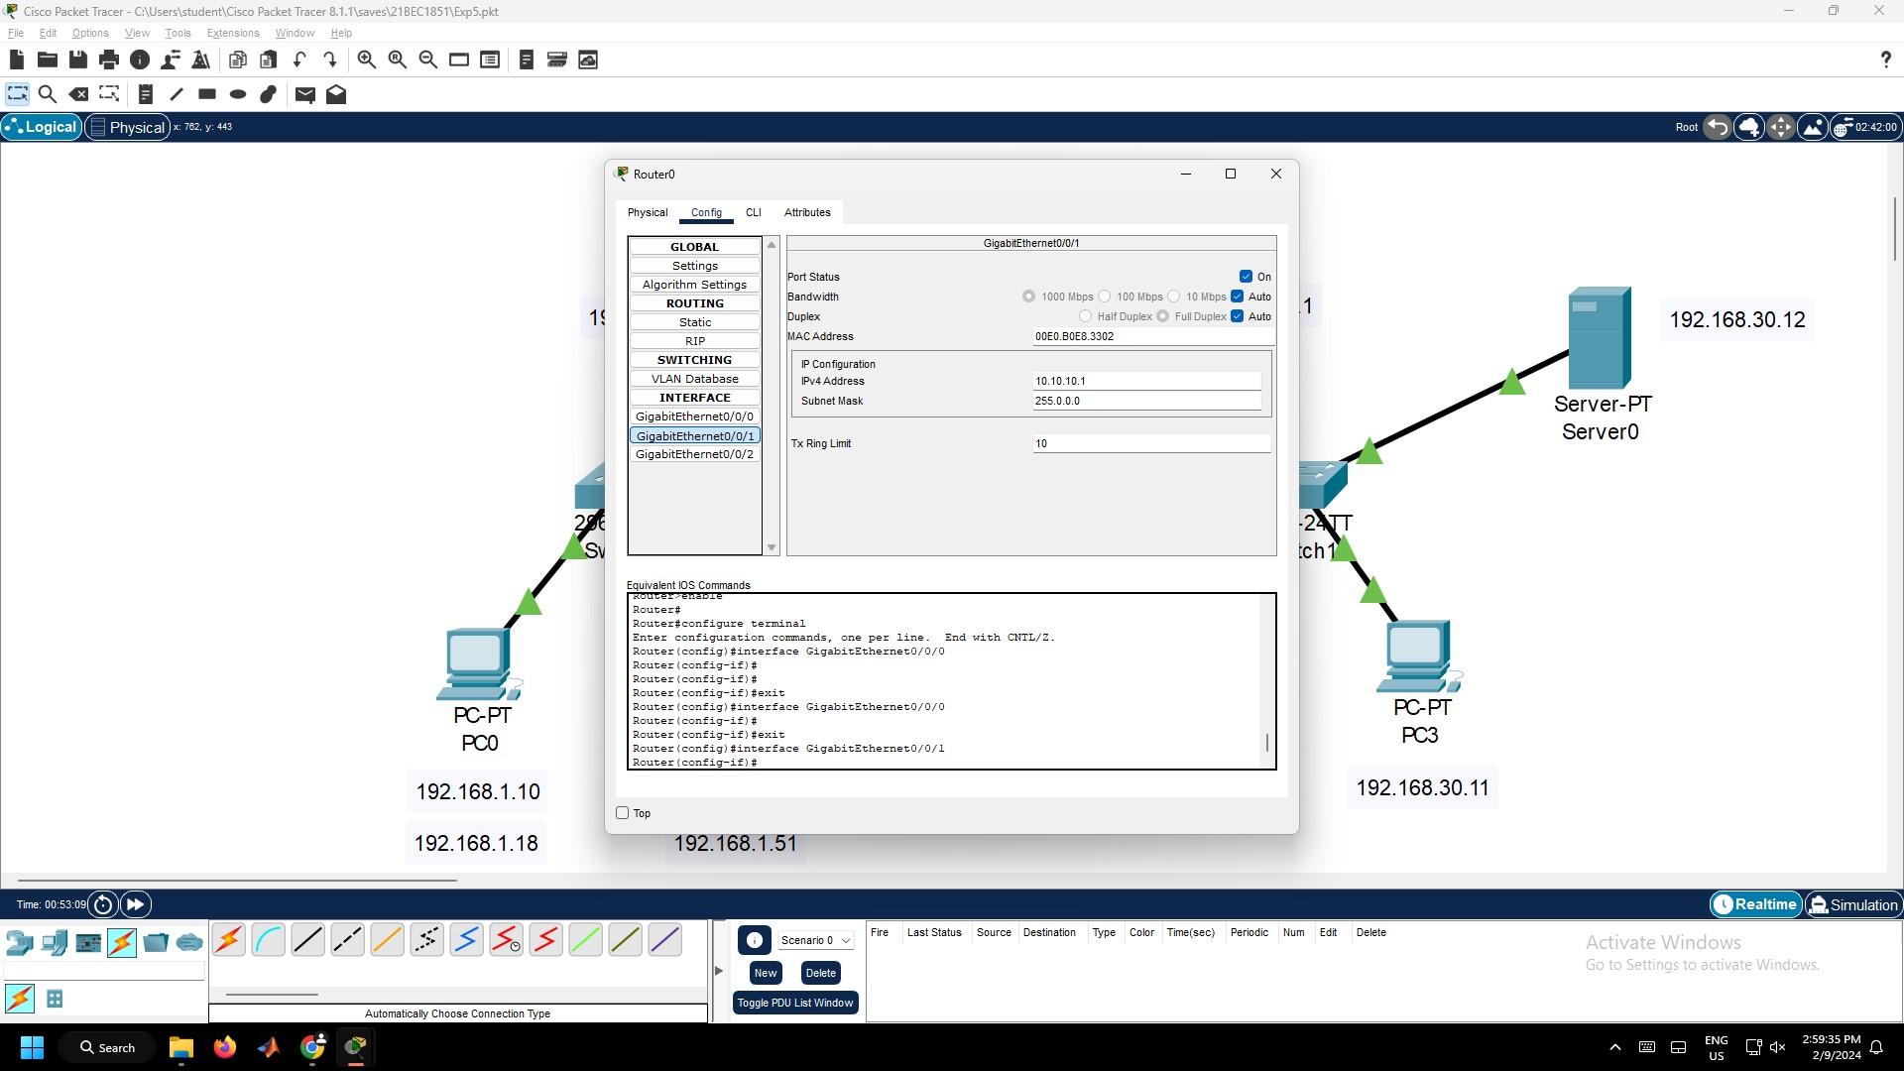

Figure 5.4 – Router0 Configurations

1. Similarly, click the Router1, Go to Config tab. Configure the Router by turning on the Port Status and enter the IP Address as 192.168.30.1 and 10.10.10.2 (this IP Address is used to route the packets to the different router) for GigabitEthernet0/0/0 and GigabitEthernet0/0/1 respectively as given in Figure 5.5.

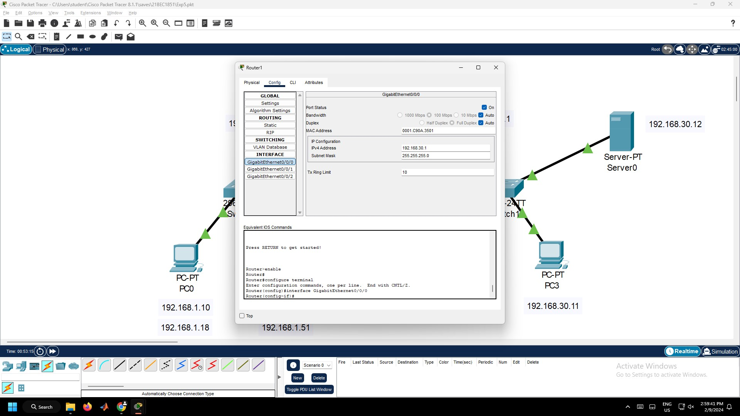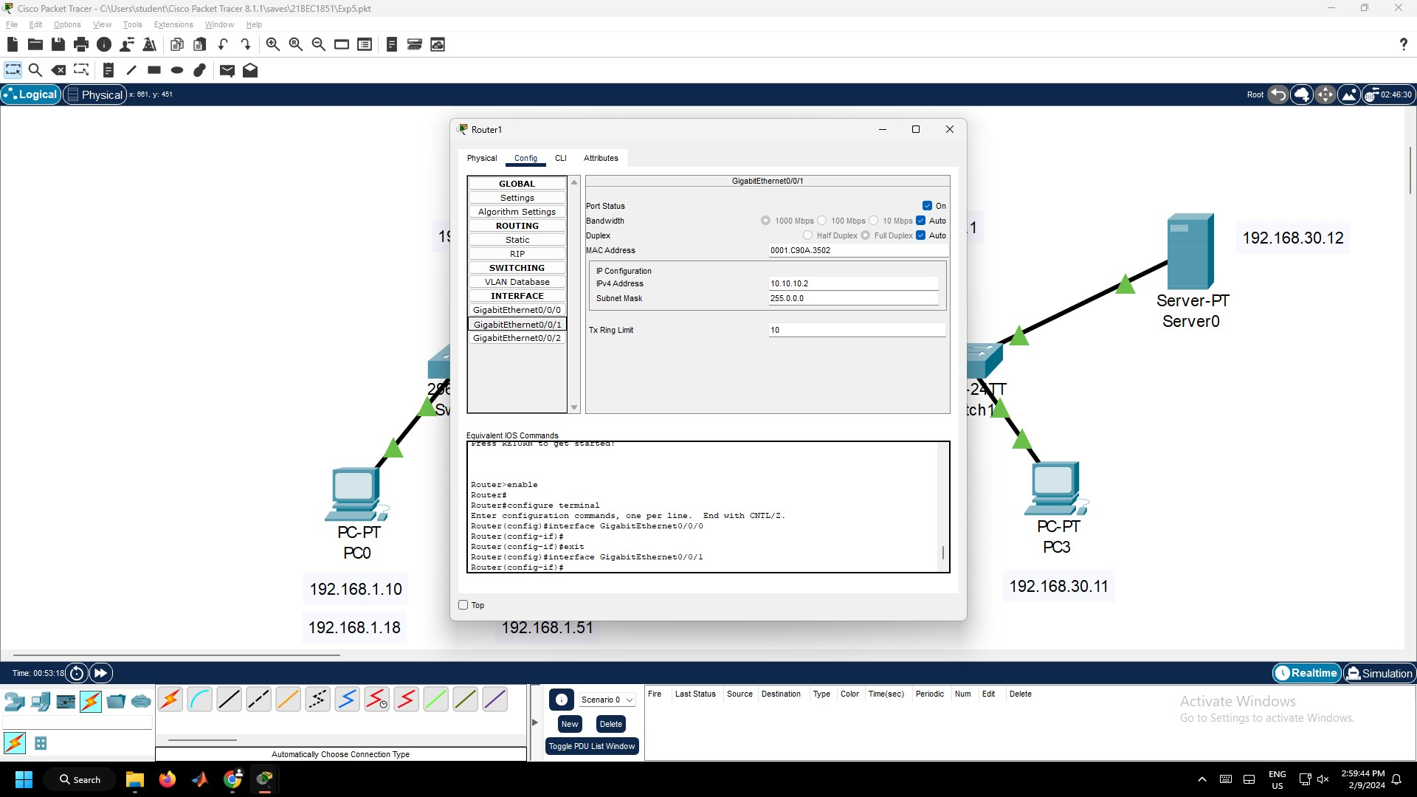

Figure 5.5 – Router1 Configurations

1. Now, Click the Router, Go to Config tab. Go to Static under Routing section. Under the Network, enter the IP Address of the different LAN connected to the different router, it’s Mask and Next Hop Address and click Add button as given in Figure 5.6.
   1. Router0:
      1. Network: 192.168.30.0
      2. Mask: 255.255.255.0
      3. Next Hop: 10.10.10.2
   2. Router1:
      1. Network: 192.168.1.0
      2. Mask: 255.255.255.0
      3. Next Hop: 10.10.10.1

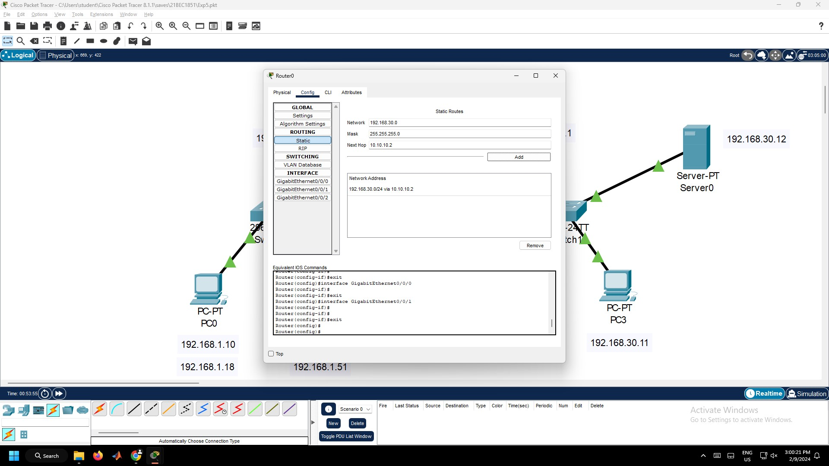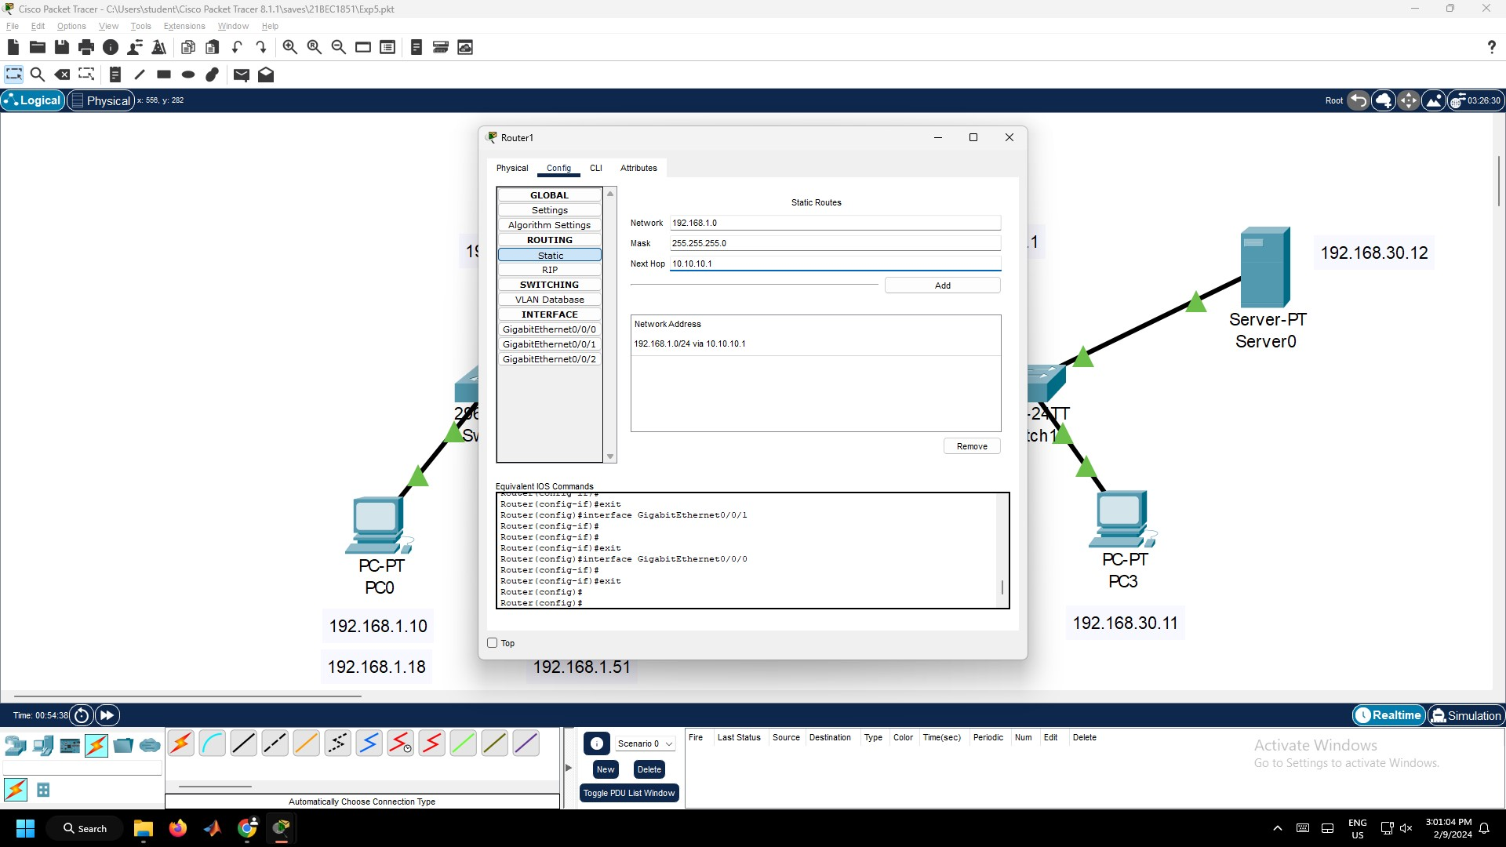

Figure 5.6 – Static Routing Configuration in Router0 and Router1

1. Verify whether connections are successfully established between two different Local Area Networks connected to two different routers. Click the PC1, go to Desktop Tab and then to Command Prompt. Now type the ping 192.168.30.11 as given in Figure 5.7.

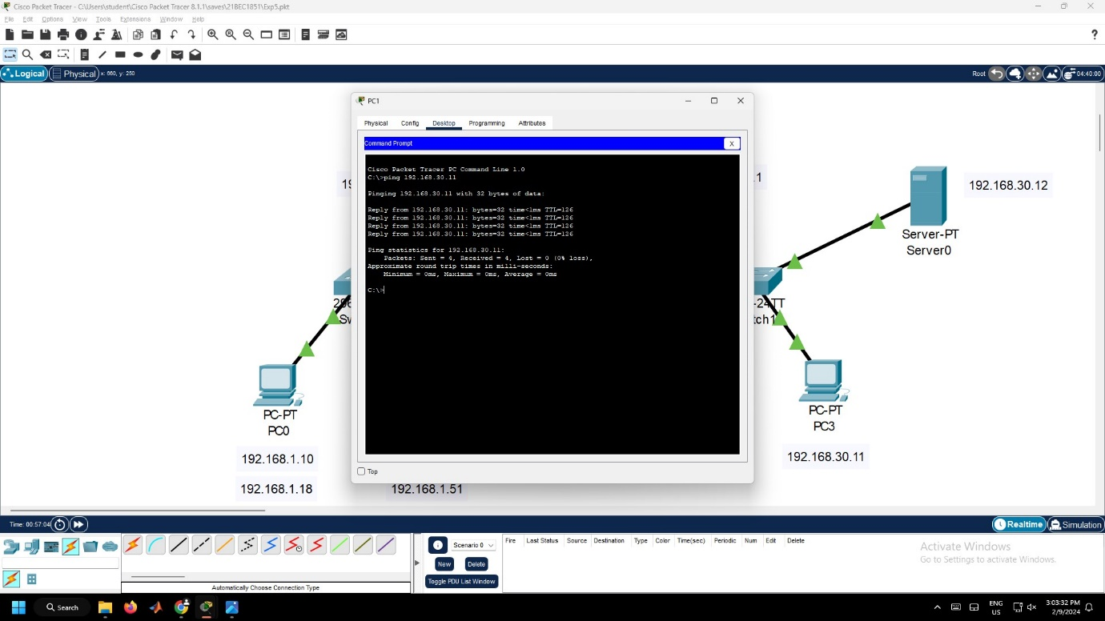

Figure 5.7 – Ping Command in PC1

1. Also verify, whether the connection to the server in LAN – 2 is established. Click the PC1, go to Desktop Tab and then to Web Browser. Now type the “192.168.30.12/index.html” as given in Figure 5.8.

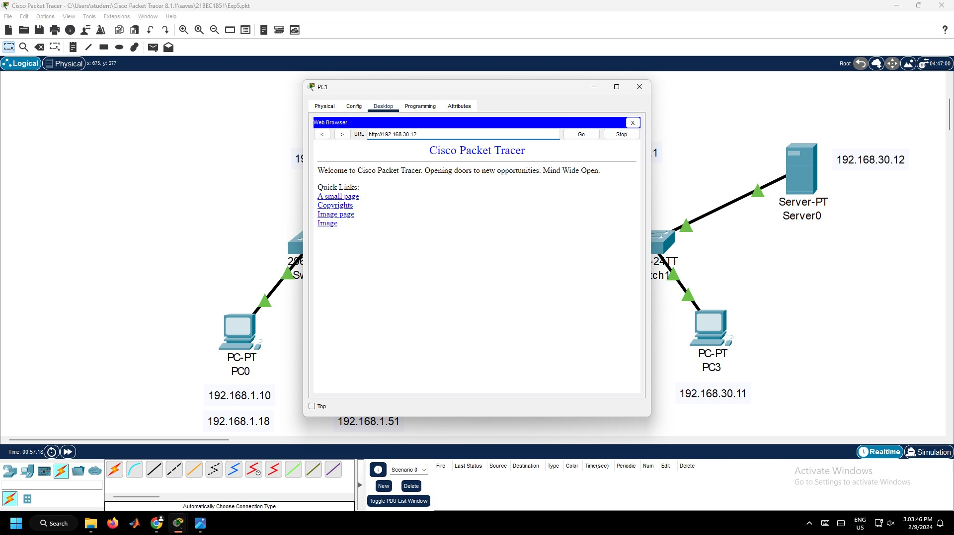

Figure 5.8 – Web Browser in PC1

**Result:**

Hence, the static routing between two routers is configured and the devices can able to communicate between other devices connected in the network.



Figure 5.9 – Ping Successful

**Inference:**

1. In this network, two different local area networks are connected to different routers.
2. The devices in LAN – 1 are configured with one IP Address Family (i.e. 192.168.1.X), whereas devices in LAN – 2 are configured with a different IP Address Family (i.e. 192.168.30.X).
3. Static routing enables the router to forward data between the LANs, providing a seamless network experience.
4. Default Gateway is used to identify the different Local Area Networks connected to the router and Next Hop address is used to route the packet to the different router.
5. In the Static Routing Configuration, the Host ID part of the Network Address and Next Hop Address is given as 0 (192.168.1.*0*) to make sure the ID after 0, i.e. from 1 will work.
6. When, a PC0 wants to send some packets to PC3, the packet will be sent to the Router0 and using the Next Hop address it will be routed to Router1 and then it’ll be sent to PC3.

Experiment 6: Dynamic Routing Using Cisco Packet Tracer

**Aim:**

To configure and implement the dynamic routing using Cisco Packet Tracer.

**Procedure:**

1. Open Cisco Packet Tracer. Then, get the following components and connect them using connection cables as given in Figure 5.1.
   1. Five PCs from End Devices Section.
   2. One Server from End Devices Section.
   3. Three 2960 Switches from Switches Section.
   4. Three 1841 Routers from Routers Section.

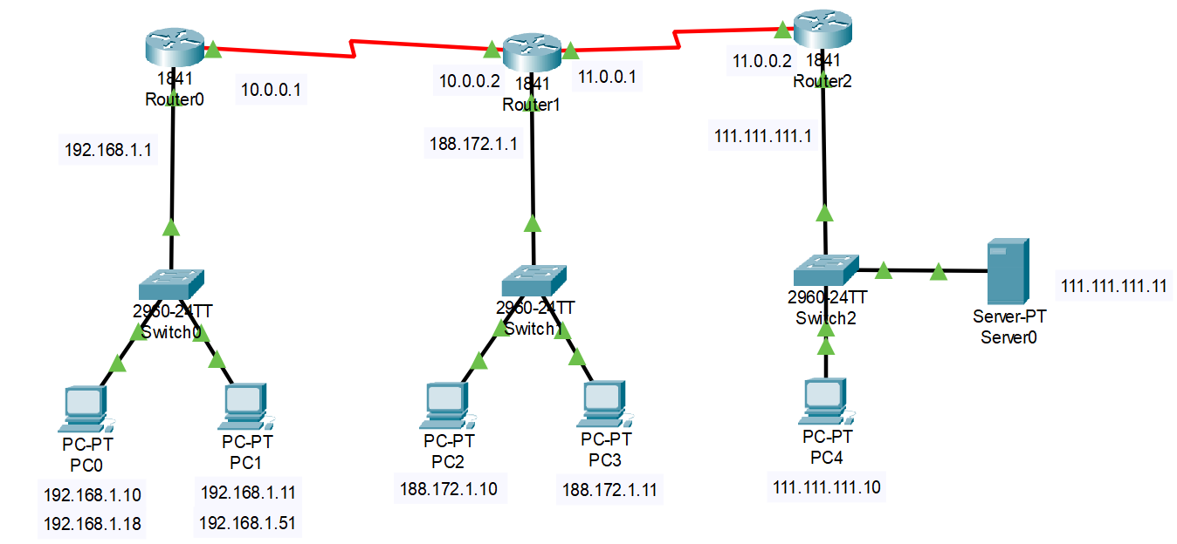

Figure 6.1 – Dynamic Routing Connection

1. Click the PCs, go to Desktop Tab → IP Configuration and configure the IP Addresses and default gateway for each PC as given in Figure 5.2.
   1. LAN – 1:
      1. PC0 IP Address: 192.168.1.10
      2. PC1 IP Address: 192.168.1.11
      3. Default Gateway: 192.168.1.1
   2. LAN – 2:
      1. PC2 IP Address: 188.172.1.10
      2. PC3 IP Address: 188.172.1.11
      3. Default Gateway: 188.172.1.1
   3. LAN – 3:
      1. PC0 IP Address: 111.111.111.10
      2. Server0 IP Address: 111.111.111.11
      3. Server0 DNS Server: 111.111.111.11
      4. Default Gateway: 111.111.111.1

 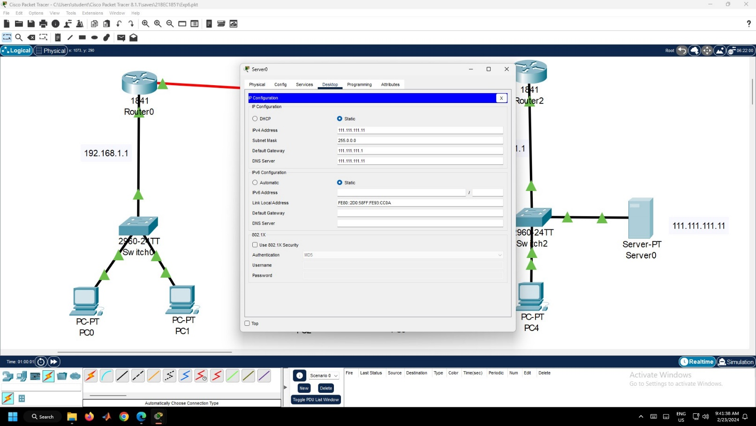

Figure 6.2 – PC0 and Server0 Configuration

1. Go to Router0, Go to Physical tab. Turn on the Router. Drag the WIC-2T Card to the Slot 0 of the Router. Then turn on the Router as given in Figure 6.3. Similarly, follow this procedure for Router1 and Router2.

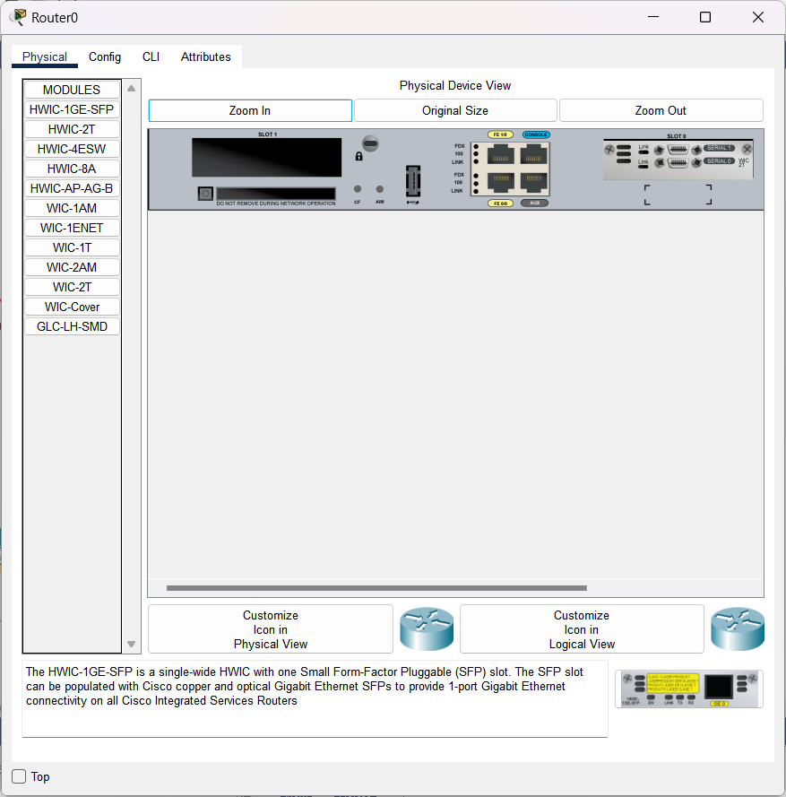

Figure 6.3 – WIC-2T slot added to Router0

1. Now, Go to Config tab. Configure the Router by turning on the Port Status and enter the below IP Address as given in Figure 6.4.
   1. Router0:
      1. FastEthernet0/1 – 192.168.1.1
      2. Serial0/0/0 – 10.0.0.1
   2. Router1:
      1. FastEthernet0/1 – 188.172.1.1
      2. Serial0/0/0 – 10.0.0.2
      3. Serial0/0/1 – 11.0.0.1
   3. Router2:
      1. FastEthernet0/1 – 111.111.111.1
      2. Serial0/0/0 – 11.0.0.2

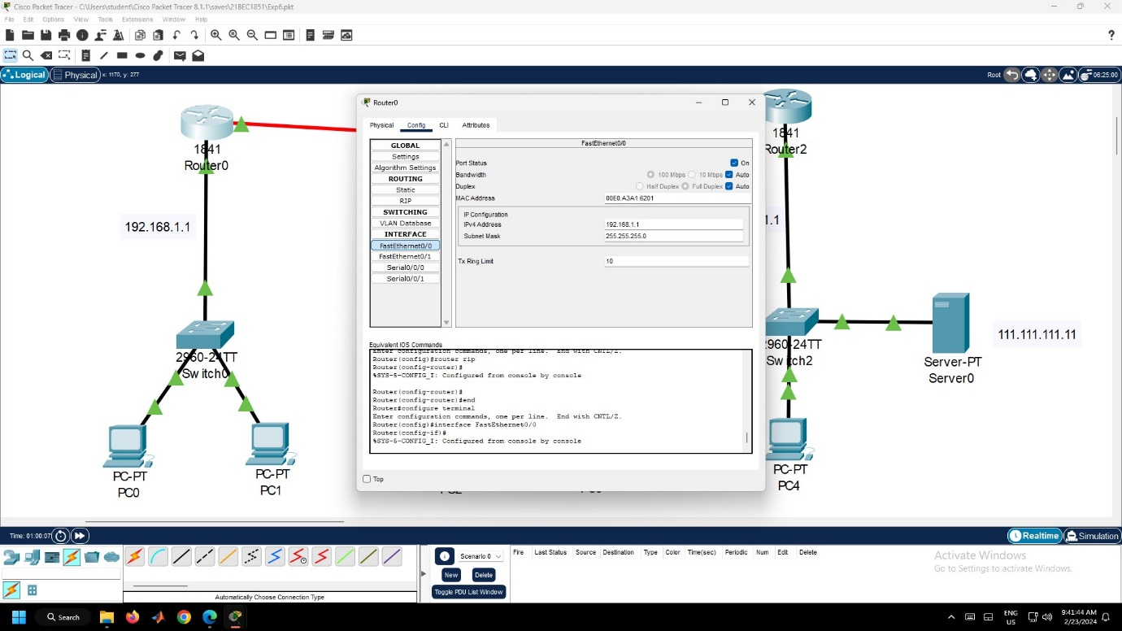 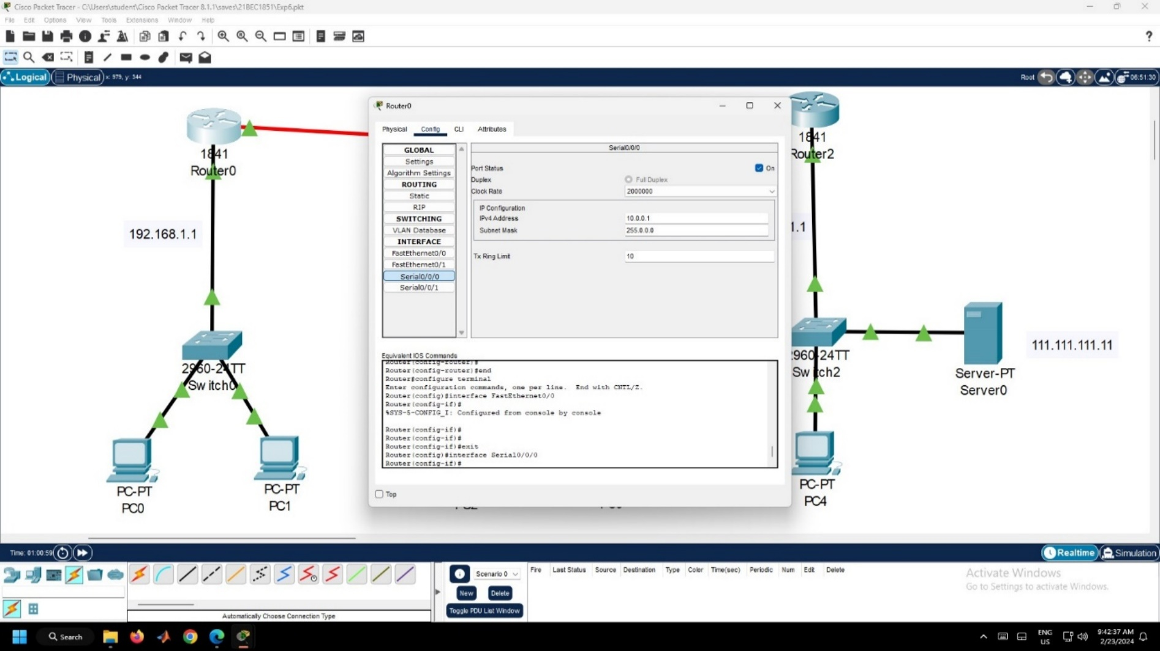

Figure 6.4 – Router0 Configurations

1. Now, Click the Router0, Go to Config tab. Go to RIP under Routing section. Under the Network, enter the below IP Addresses and click Add button as given in Figure 6.5. Similarly, follow this procedure for Router1 and Router2.
   1. 10.0.0.0
   2. 11.0.0.0
   3. 111.0.0.0
   4. 188.172.1.0
   5. 192.168.1.1

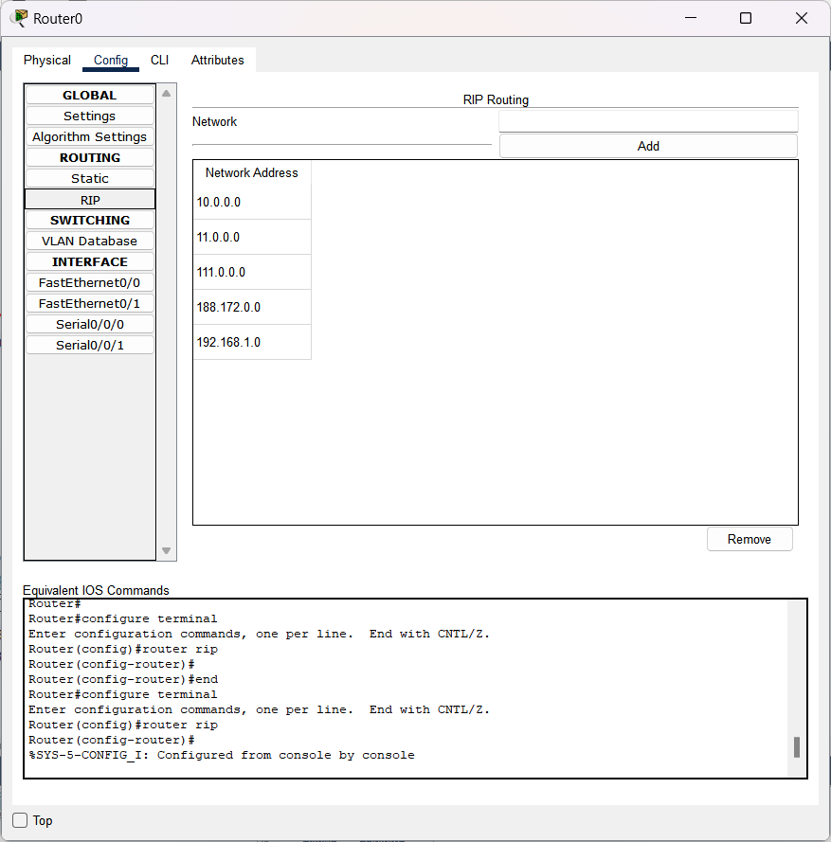

Figure 6.5 – RIP Configuration in Router0

1. Go to Settings of Router0, and in NVRAM, click Save Button as given in Figure 6.6. Similarly, follow this procedure for Router1 and Router2.

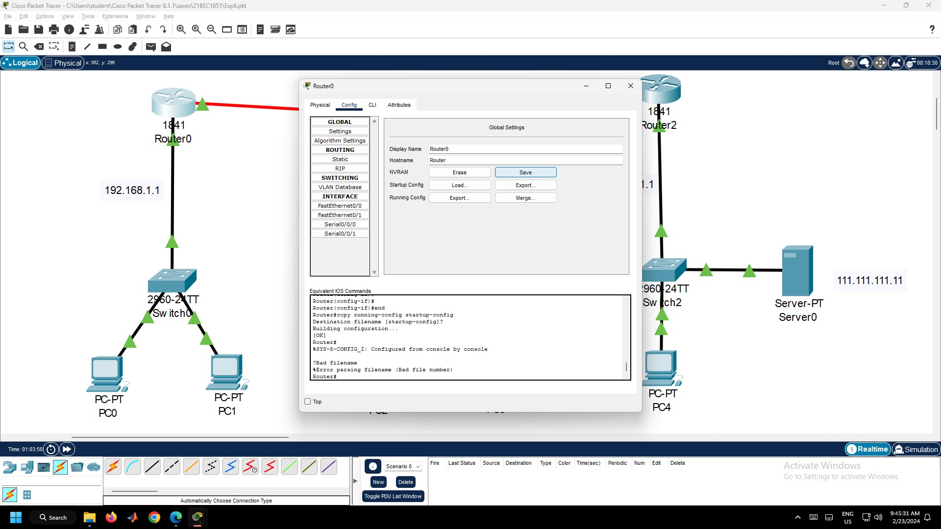

Figure 6.6 – NVRAM Settings in Router0

1. Verify whether connections are successfully established between two different Local Area Networks connected to two different routers. Click the PC0, go to Desktop Tab and then to Command Prompt. Now type the ping 188.172.30.11 as given in Figure 6.7.

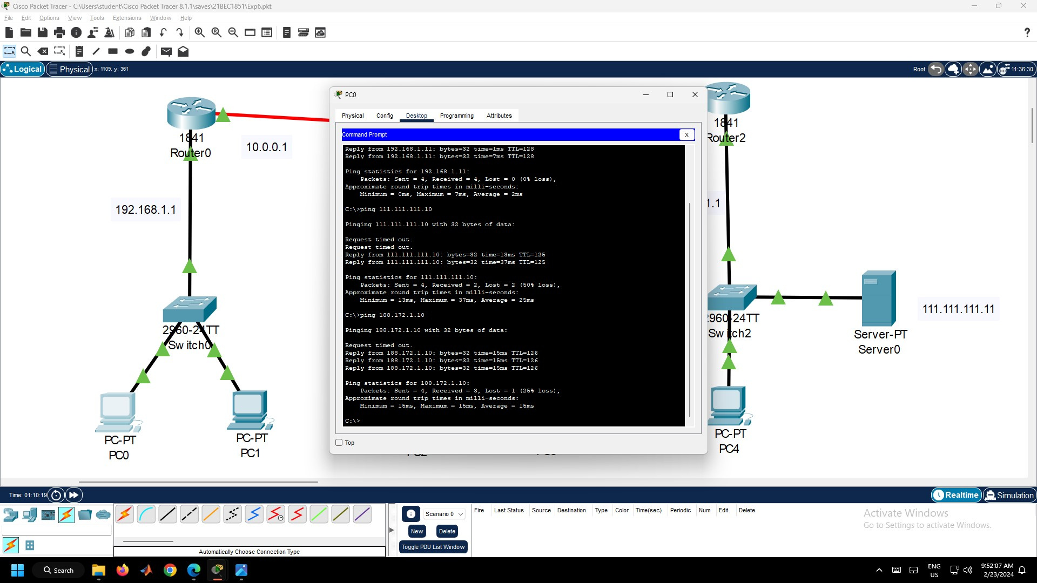

Figure 6.7 – Ping Command in PC0

1. Also verify, whether the connection to the server in LAN – 2 is established. Click the PC0, go to Desktop Tab and then to Web Browser. Now type the “111.111.111.11/index.html” as given in Figure 6.8.

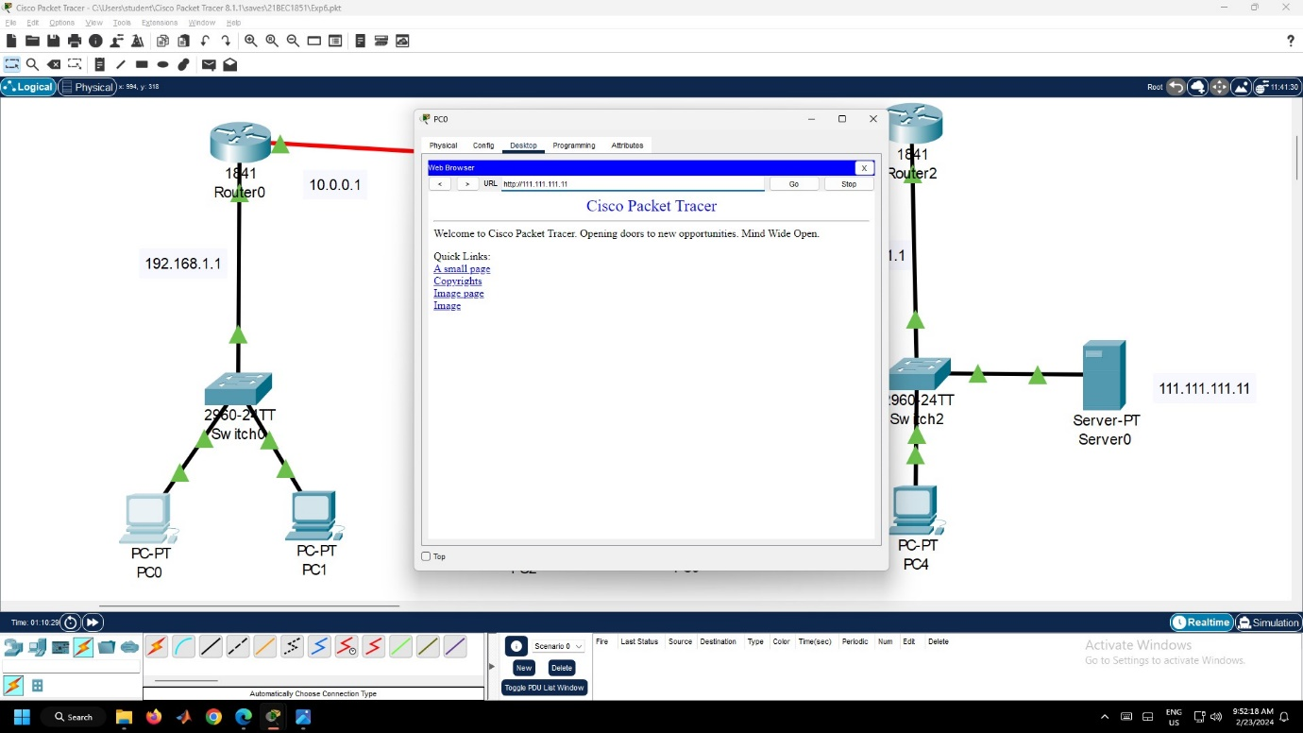

Figure 6.8 – Web Browser in PC0

**Result:**

Hence, the dynamic routing between two routers is configured and the devices can able to communicate between other devices connected in the network.



Figure 6.9 – Ping Successful

**Inference:**

1. In this network, three different local area networks are connected to three different routers.
2. The devices in different LANs are connected to different routers.
3. Dynamic routing is more complicated than static routing because it offers more ways to send packets through a network.
4. Default Gateway is used to identify the different Local Area Networks connected to the router and the hops are facilitated in this routing between the LANs.
5. Traffic can be effectively regulated here due to the numerous available options for packet transmission.

Experiment 7: Performance of TCP and UDP Protocol using NetSim

**Aim:**

To evaluate the performance of TCP and UDP protocols using NetSim.

**Procedure:**

1. Open NetSim. Then, click Internetworks (Base).
2. Get the L3 Switch and wired Node and Connect the Nodes to the L3 Switch using Wired/Wireless as given in Figure 7.1.

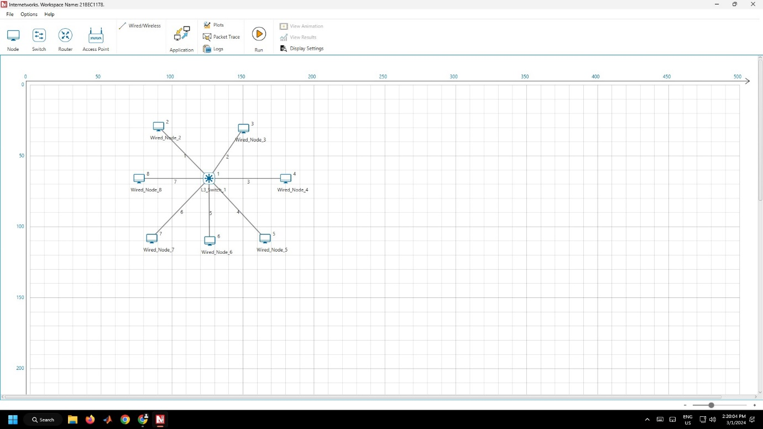

Figure 7.1 – Connection in NetSim

1. Now, go to the Applications Menu. Add the Application Type as CBR, Source ID, Destination ID, and Transport Protocol as TCP. Similarly, create three applications. Click OK as given in Figure 7.2.

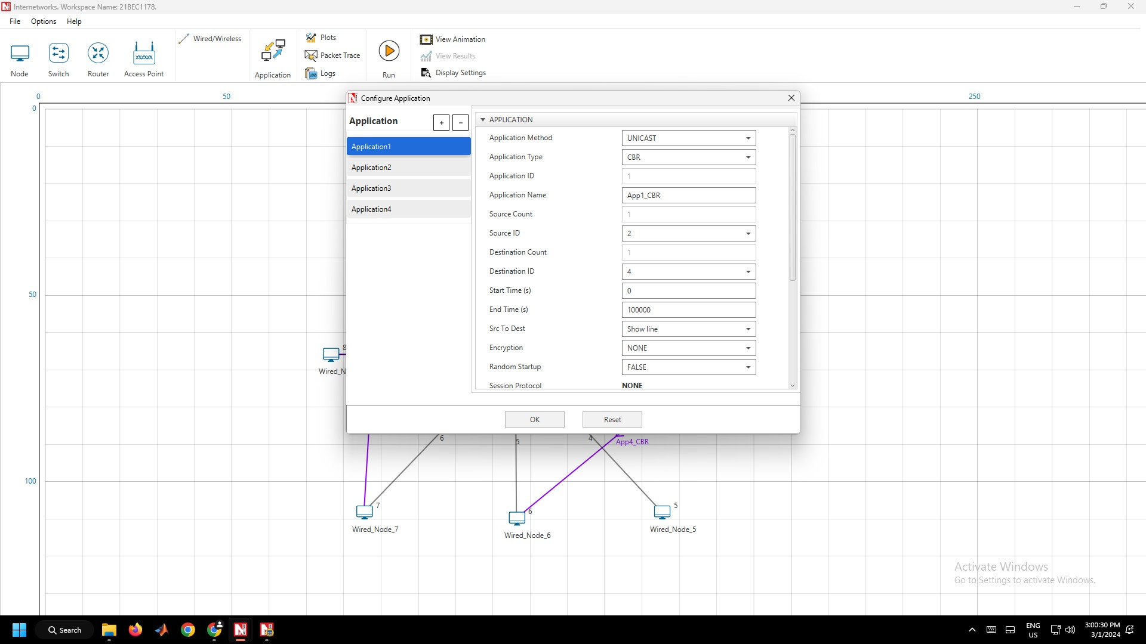

Figure 7.2 – Application Window

1. Now, click the Run Button and Click OK as given in Figure 7.3.

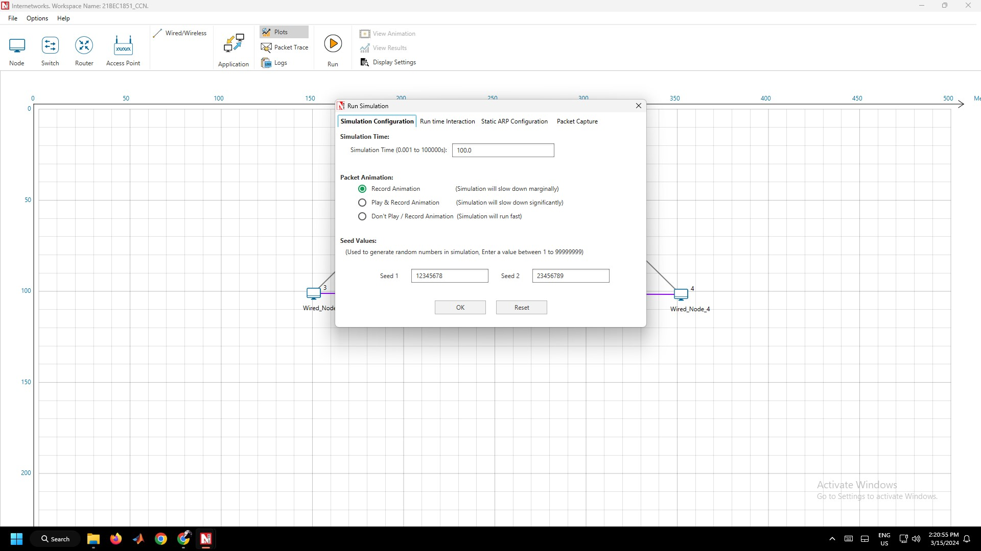

Figure 7.3 – Run Simulation Window

1. Follow Step 3 Again, but now use the Transport Protocol as UDP as given in Figure 7.4. Now run it again.

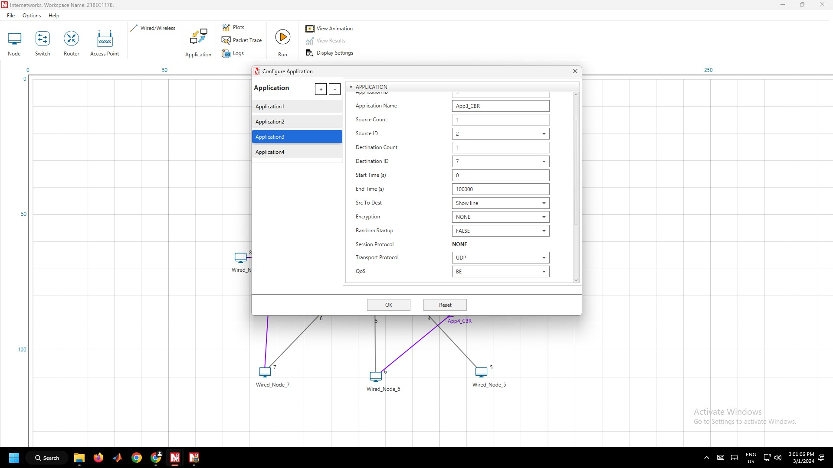

Figure 7.4 – Configuring UDP as Transport Protocol in Applications Window

1. Note down the Metrics Table for TCP and UDP.

**Result:**

Hence, the performance of TCP and UDP protocols was successfully evaluated using NetSim.

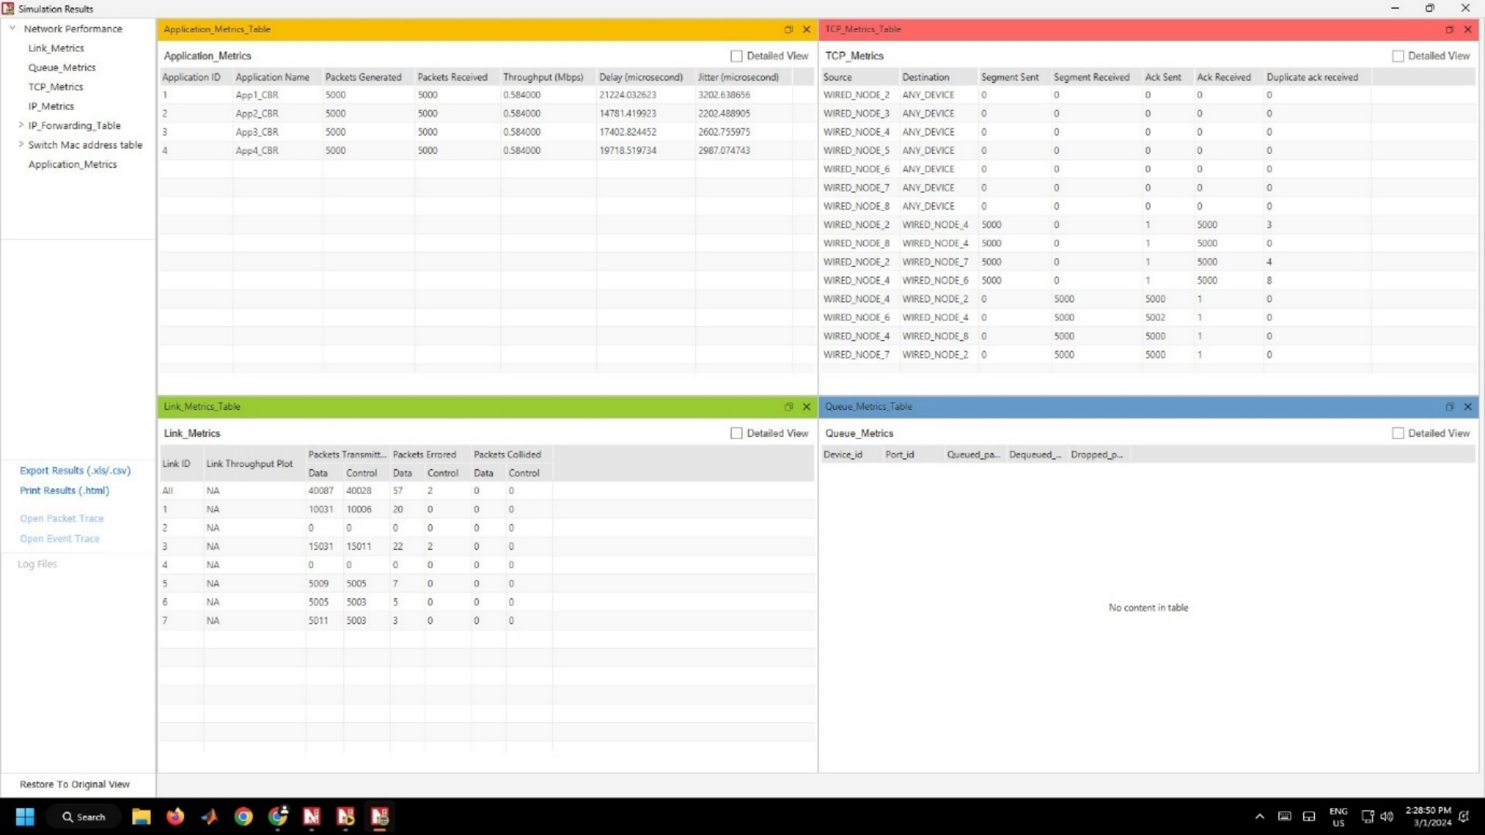

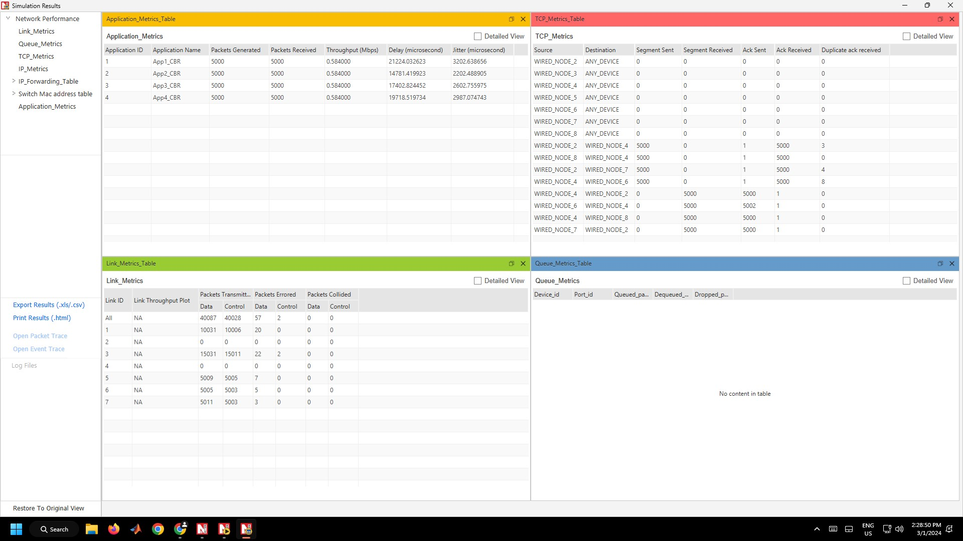

Figure 7.5 – Application Metrics and Link Metrics of TCP Protocol

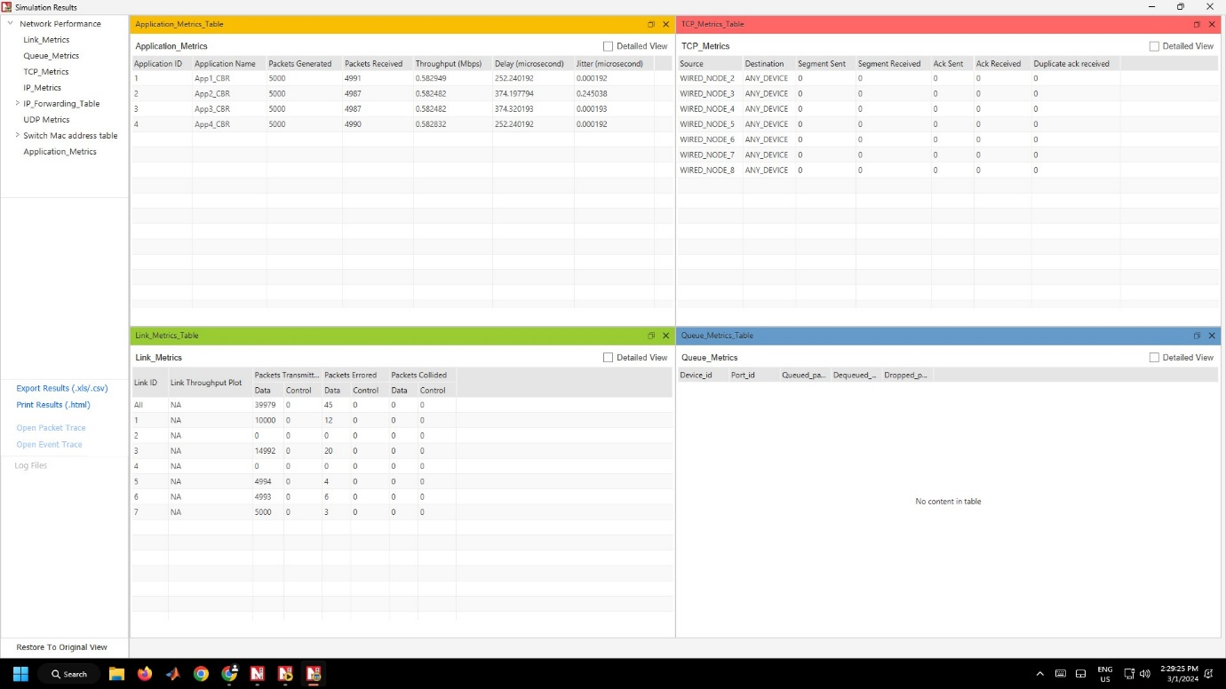

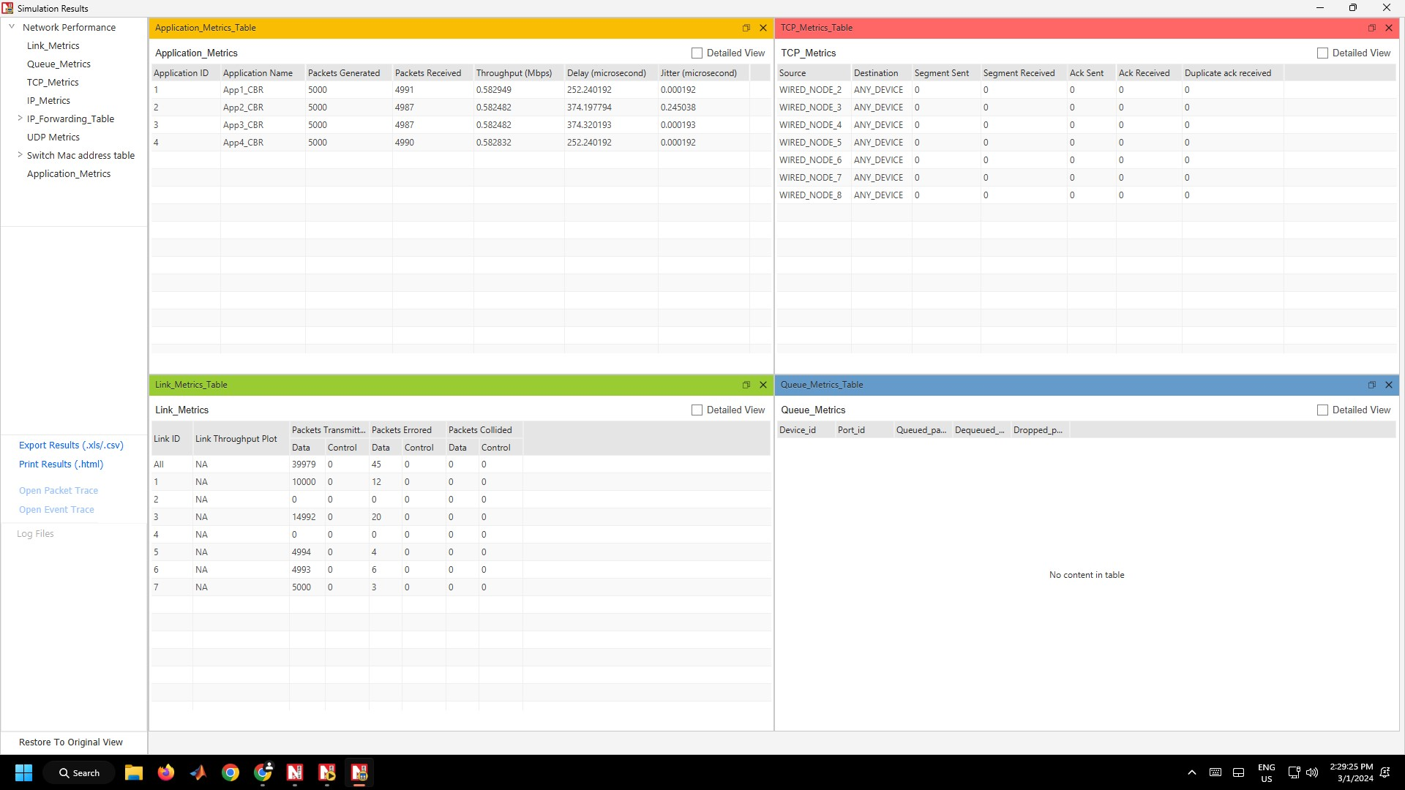

Figure 7.6 – Application Metrics and Link Metrics of UDP Protocol

**Conclusion:**

1. The data packets in TCP (Transmission Control Protocol) are delivered in order and without errors whereas in UDP (User Datagram Protocol), we can see that some packets have been lost.
2. The delay in TCP is significantly more than UDP.
3. TCP is connection-oriented, meaning it establishes a connection between the sender and receiver before data transfer, ensuring acknowledgement of data receipt. UDP is connectionless, allowing for faster transmission since it doesn't require connection setup and teardown.
4. TCP includes extensive error-checking mechanisms, including checksums and retransmission of lost packets, to ensure data integrity. UDP doesn’t have such error correction features, making it more susceptible to packet loss or corruption.
5. TCP has flow control mechanisms to regulate the rate of data transmission between sender and receiver, preventing overwhelming the receiver with data. UDP does not include built-in flow control, which can lead to potential congestion and packet loss in high-traffic situations.
6. TCP tends to have higher latency compared to UDP which has a lower latency.
7. TCP is used for applications that require reliable data transmission, such as web browsing, email, and file transfer. UDP is preferred for applications that require speed and efficiency over reliability, such as streaming media, online gaming, and VoIP calls.

Experiment 8: Impact of Link Failure on Network’s Performance Using NetSim

**Aim:**

To evaluate the impact of link failure on the network’s performance using NetSim.

**Procedure:**

1. Open NetSim. Then, click Internetworks (Base).
2. Get the Routers and Wired Nodes and connect using the Wired/Wireless as per Figure 8.1.

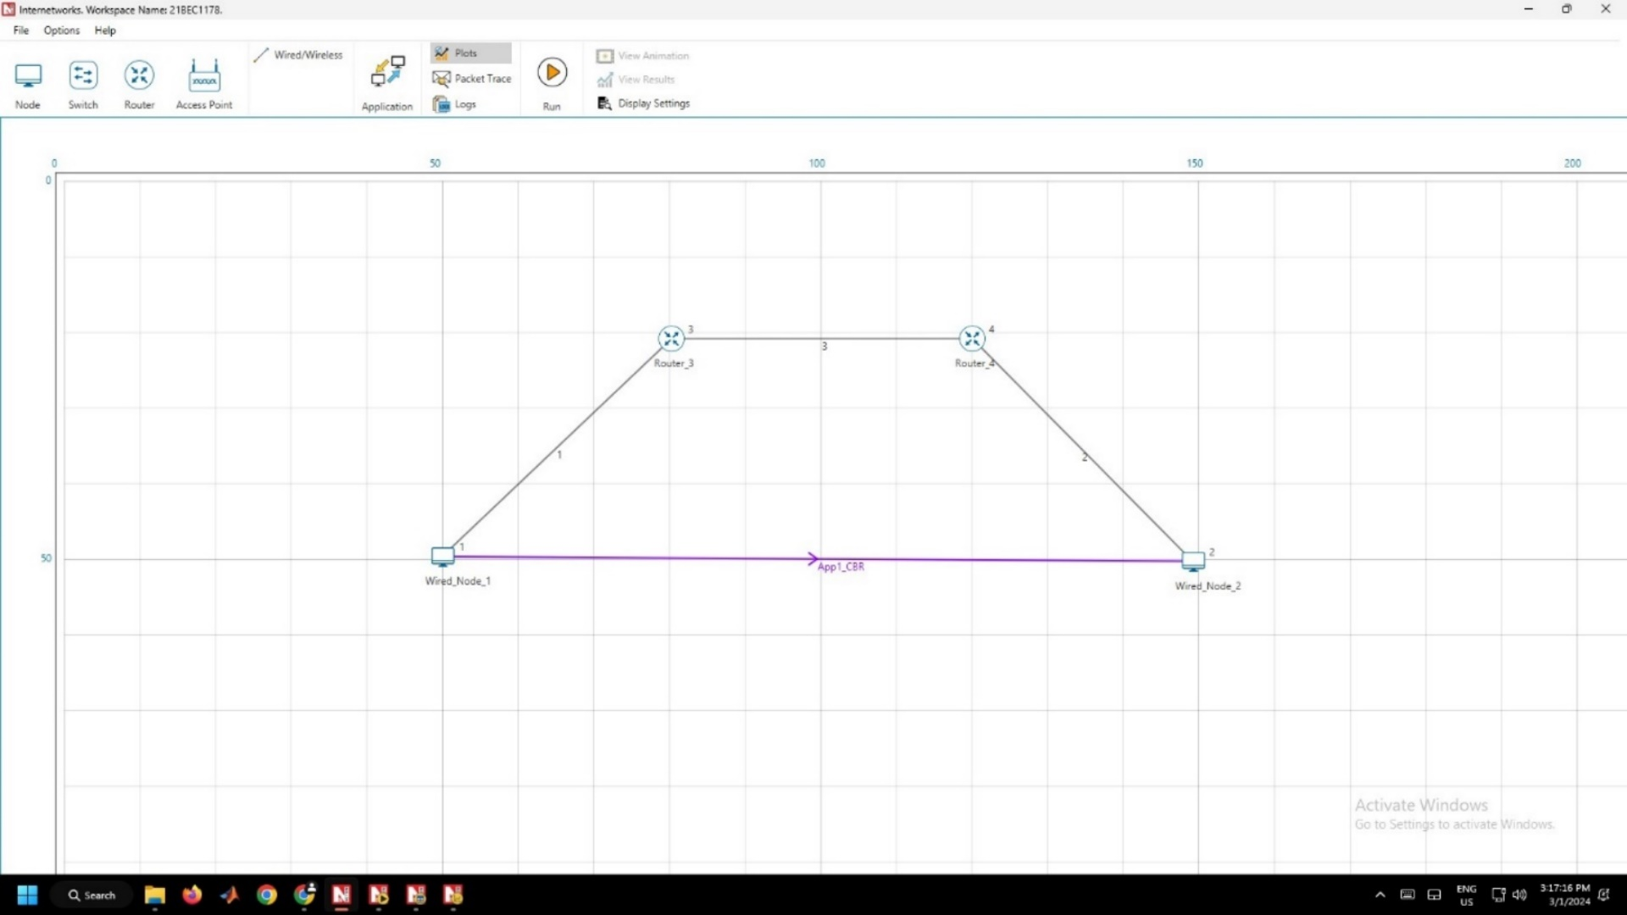

Figure 8.1 – Connection in NetSim

1. Now, go to the Applications Menu. Add the Application Type as CBR, Source ID, Destination ID, and Transport Protocol. Click OK. Follow the Figure 8.2.

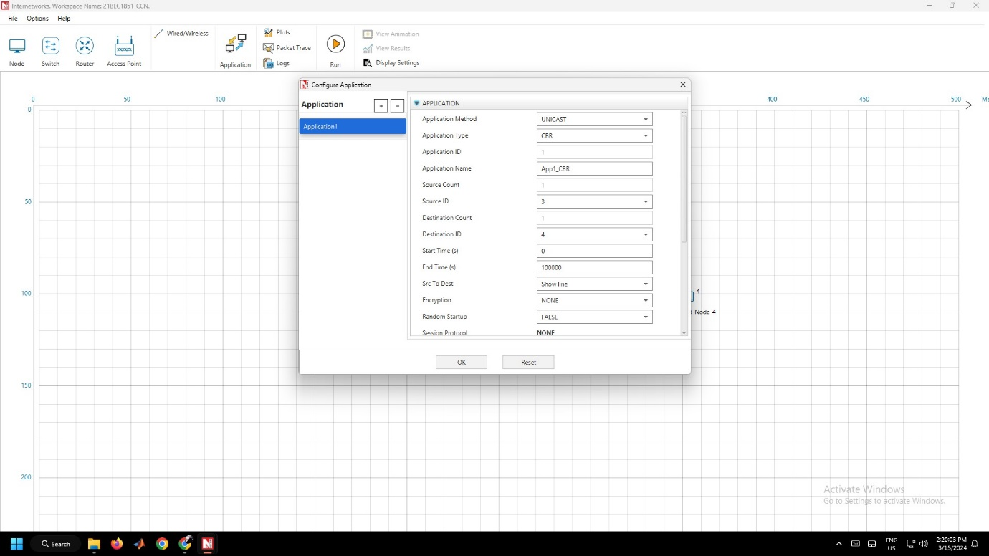

Figure 8.2 – Application Window

1. Now, go to Link 3 (Link Between 2 Routers) Properties and configure the Uptime and Downtime as 40,70 and 20,50 respectively as given in Figure 8.3. Then, Click OK.

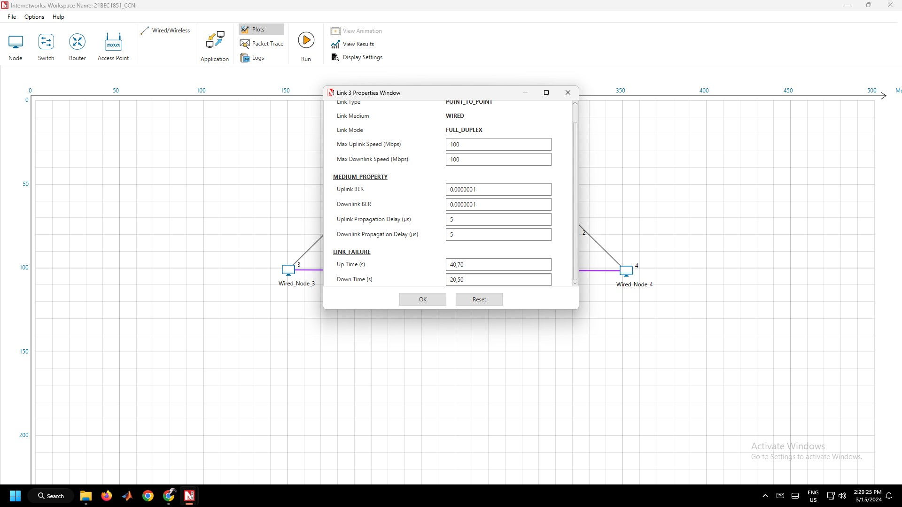

Figure 8.3 – Link Properties

1. Now, Click the Run Button and then click the OK Button as given in Figure 8.4.



Figure 8.4 – Run Simulation Window

**Result:**

Hence, the impact of link failure on the network’s performance is evaluated using NetSim.

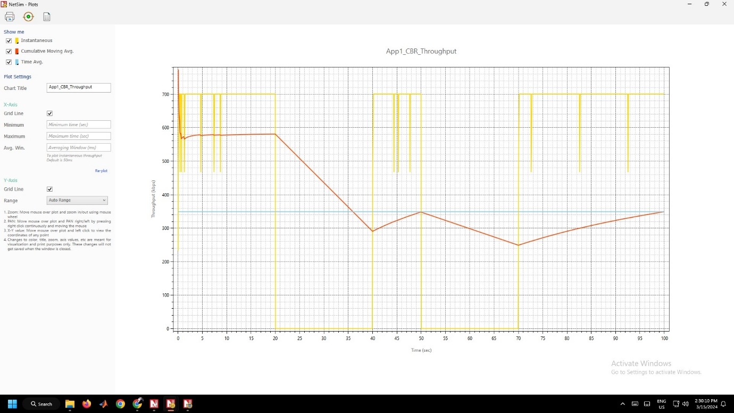

Figure 8.5 – Cumulative Throughput vs Time Graph

**Conclusion:**

1. Here, the downtime is configured at 20,50. It means the packets won’t be transferred during that time.
2. The Instantaneous throughput shows the throughput at a particular instantaneous of time.
3. The Cumulative throughput shows the throughput as a cumulative value instead of a particular time.
4. The Instantaneous throughput varies so much at a given instant of time.
5. The Cumulative throughput doesn’t vary and mostly it’ll be a constant.
6. From the Instantaneous throughput, we can observe that during the downtime the throughput value suddenly goes to 0.
7. From the Cumulative throughput, we can observe that during the downtime the throughput value suddenly decreases but not to 0.

Experiment 9: Working of RIP and OSPF Routing Protocol using NetSim

**Aim:**

To evaluate the working of RIP and OSPF routing protocols in NetSim.

**Procedure:**

1. Open NetSim. Then, click Internetworks (Base).
2. Get the L3 Switch, Routers and Wired Nodes and connect using the Wired/Wireless as per Figure 9.1.

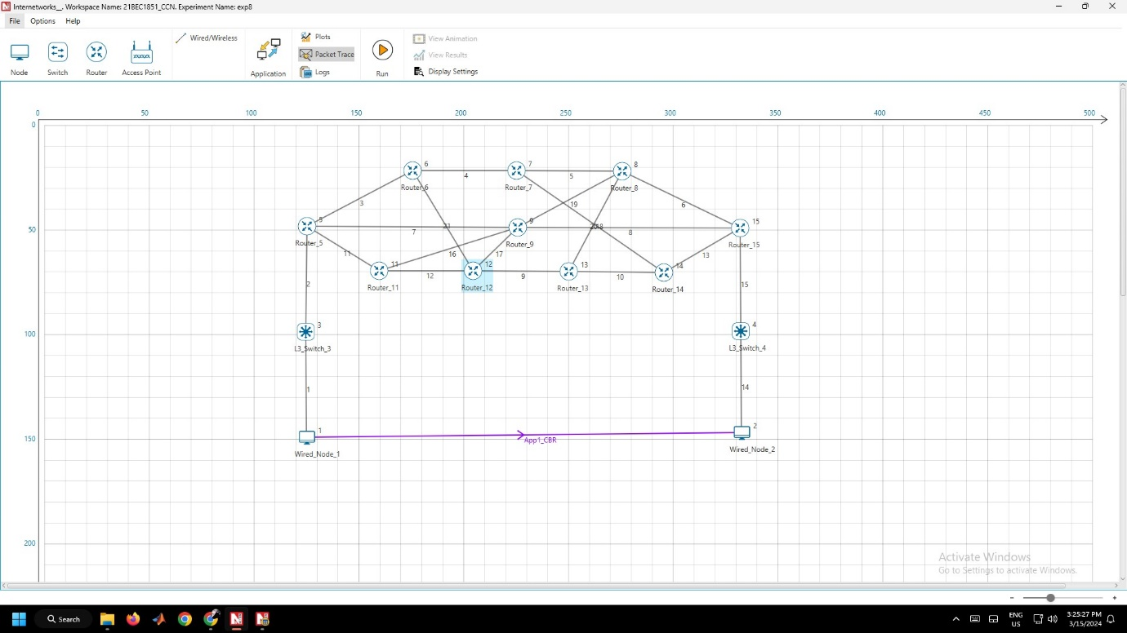

Figure 9.1 – Connection in NetSim

1. Assign the cost of each link randomly.
2. Now, go to the Applications Menu. Add the Application Type as CBR, Source ID, Destination ID, Transport Protocol, Start time and End time. Similarly, create three applications. Click OK as given in Figure 9.2

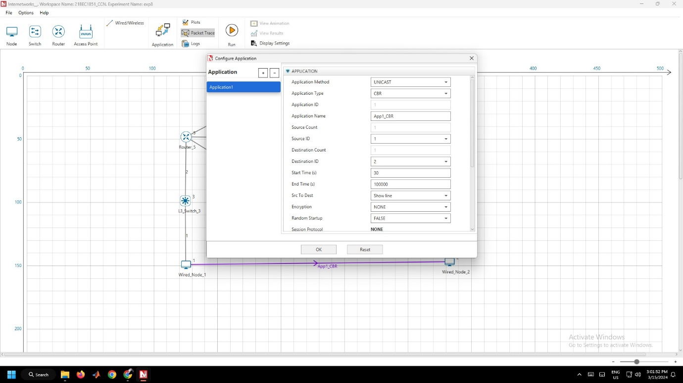

Figure 9.2 – Application Window

1. Configure the Router, go to the Application Layer and Configure the SDN Controller as RIP. Do this for all routers in the Network as given in Figure 9.3 and measure the metrics for the RIP Routing Protocol.

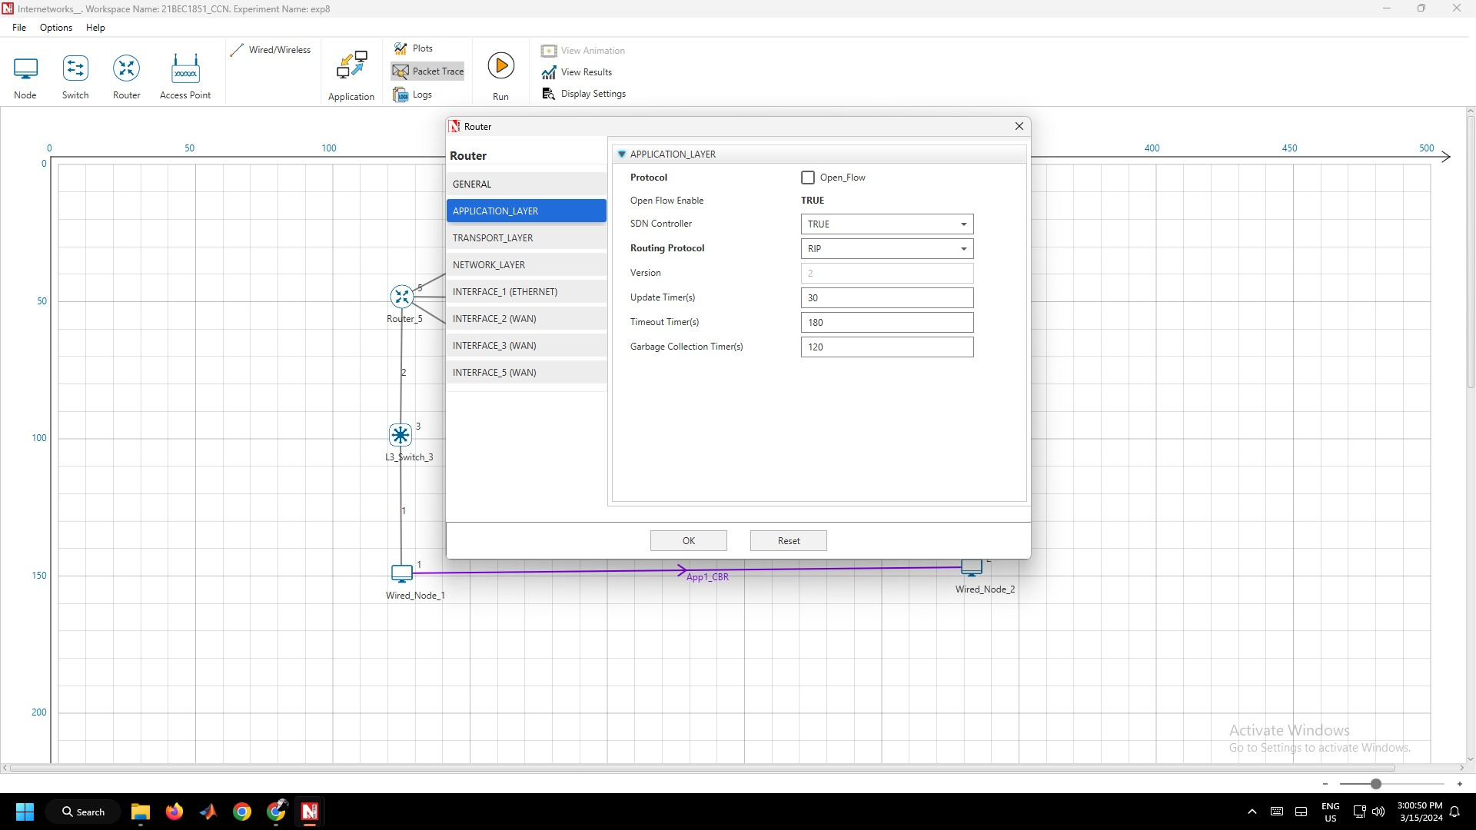

Figure 9.3 – RIP Configuration in Router

1. Now, change the SDN Controller to OSPF and measure the metrics for the OSPF routing protocol as given in Figure 9.4.

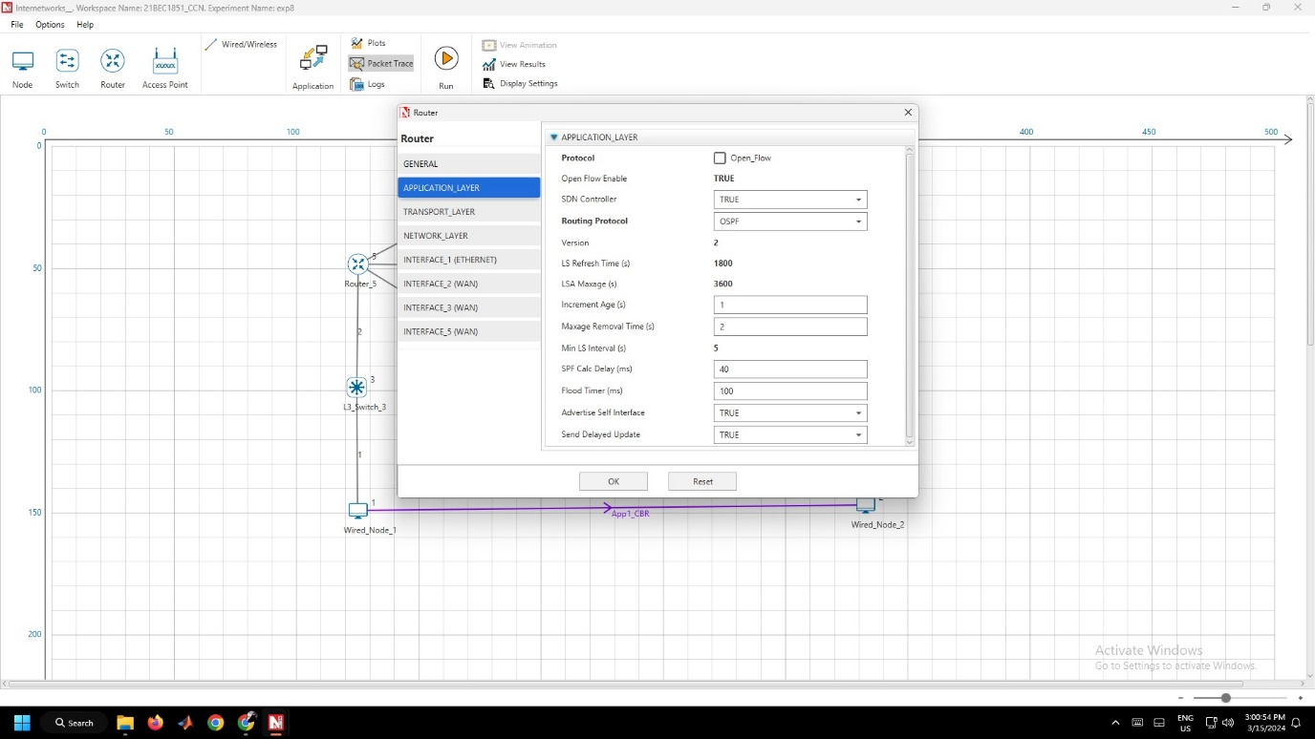

Figure 9.4 – OSPF Configuration in Router

**Result:**

Application Metrics – RIP:

|  |  |  |  |  |  |  |  |  |  |  |
| --- | --- | --- | --- | --- | --- | --- | --- | --- | --- | --- |
| **Application ID** | **Application Name** | **Source ID** | **Destination ID** | **Packets Generated** | **Packets Received** | **Payload generated (bytes)** | **Payload received (bytes)** | **Throughput (Mbps)** | **Delay (microsecond)** | **Jitter (microsecond)** |
| 1 | App1_CBR | 1 | 2 | 5000 | 4965 | 7300000 | 7248900 | 0.579912 | 752.589631 | 0.029637 |

Packet Trace – RIP:

|  |  |  |  |  |  |  |  |
| --- | --- | --- | --- | --- | --- | --- | --- |
| **PACKET_ID** | **SEGMENT_ID** | **PACKET_TYPE** | **CONTROL_PACKET_TYPE/APP_NAME** | **SOURCE_ID** | **DESTINATION_ID** | **TRANSMITTER_ID** | **RECEIVER_ID** |
| 1 | 0 | CBR | App1_CBR | NODE-1 | NODE-2 | NODE-1 | SWITCH-3 |
| 1 | 0 | CBR | App1_CBR | NODE-1 | NODE-2 | SWITCH-3 | ROUTER-5 |
| 1 | 0 | CBR | App1_CBR | NODE-1 | NODE-2 | ROUTER-5 | ROUTER-9 |
| 1 | 0 | CBR | App1_CBR | NODE-1 | NODE-2 | ROUTER-9 | ROUTER-15 |
| 1 | 0 | CBR | App1_CBR | NODE-1 | NODE-2 | ROUTER-15 | SWITCH-4 |
| 1 | 0 | CBR | App1_CBR | NODE-1 | NODE-2 | SWITCH-4 | NODE-2 |

Application Metrics – OSPF:

|  |  |  |  |  |  |  |  |  |  |  |
| --- | --- | --- | --- | --- | --- | --- | --- | --- | --- | --- |
| **Application ID** | **Application Name** | **Source ID** | **Destination ID** | **Packets Generated** | **Packets Received** | **Payload generated (bytes)** | **Payload received (bytes)** | **Throughput (Mbps)** | **Delay (microsecond)** | **Jitter (microsecond)** |
| 1 | App1_CBR | 1 | 2 | 3500 | 3467 | 5110000 | 5061820 | 0.578494 | 1000.64 | 0 |

Packet Trace OSPF:

|  |  |  |  |  |  |  |  |
| --- | --- | --- | --- | --- | --- | --- | --- |
| **PACKET_ID** | **SEGMENT_ID** | **PACKET_TYPE** | **CONTROL_PACKET_TYPE/APP_NAME** | **SOURCE_ID** | **DESTINATION_ID** | **TRANSMITTER_ID** | **RECEIVER_ID** |
| 1 | 0 | CBR | App1_CBR | NODE-1 | NODE-2 | NODE-1 | SWITCH-3 |
| 1 | 0 | CBR | App1_CBR | NODE-1 | NODE-2 | SWITCH-3 | ROUTER-5 |
| 1 | 0 | CBR | App1_CBR | NODE-1 | NODE-2 | ROUTER-5 | ROUTER-6 |
| 1 | 0 | CBR | App1_CBR | NODE-1 | NODE-2 | ROUTER-6 | ROUTER-7 |
| 1 | 0 | CBR | App1_CBR | NODE-1 | NODE-2 | ROUTER-7 | ROUTER-8 |
| 1 | 0 | CBR | App1_CBR | NODE-1 | NODE-2 | ROUTER-8 | ROUTER-15 |
| 1 | 0 | CBR | App1_CBR | NODE-1 | NODE-2 | ROUTER-15 | SWITCH-4 |
| 1 | 0 | CBR | App1_CBR | NODE-1 | NODE-2 | SWITCH-4 | NODE-2 |

**Conclusion:**

1. RIP uses hop count for path selection, whereas OSPF uses path based on cost of the link.
2. The throughput in RIP and OSPF is the same.
3. OSPF is generally faster than RIP due to its more efficient routing algorithm and support for hierarchical routing, which reduces the convergence time in medium and large networks.
4. OSPF generally incurs higher administrative overhead compared to RIP due to its more complex configuration requirements and the need for careful network planning.
5. RIP is suitable for small to medium-sized networks with simpler topologies and lower scalability requirements, while OSPF is better suited for larger networks with complex topologies and higher scalability demands.

Experiment 10: Subnetting Using Cisco Packet Tracer

**Aim:**

To set up a network with Subnetting using Cisco Packet Tracer.

**Procedure:**

1. Open Cisco Packet Tracer. Then, get the following components and connect the components using the connection cables as given in Figure 10.1.
   1. Six PCs from the End Devices Section
   2. One 2960 Switch from Switches Section
   3. One 2911 Router from Router Section

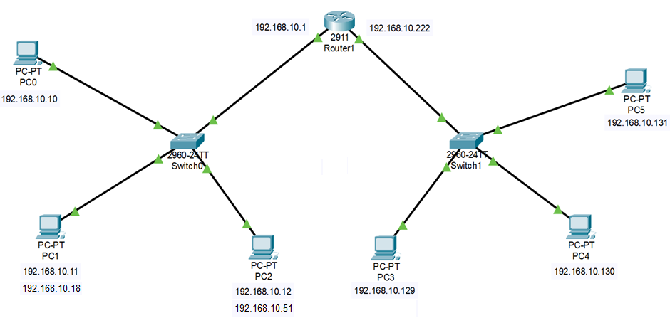

Figure 10.1 – Subnetting Connections

1. Click on PC, go to Desktop Tab $→$ IP Configuration, then enter the following as given in Figure 10.2.
   1. PC0:
      1. IP Address – 192.168.10.10
      2. Subnet Mask – 255.255.255.128
      3. Default Gateway – 192.168.10.1
   2. PC1:
      1. IP Address – 192.168.10.11
      2. Subnet Mask – 255.255.255.128
      3. Default Gateway – 192.168.10.1
   3. PC2:
      1. IP Address – 192.168.10.12
      2. Subnet Mask – 255.255.255.128
      3. Default Gateway – 192.168.10.1
   4. PC3:
      1. IP Address – 192.168.10.129
      2. Subnet Mask – 192.168.10.128
      3. Default Gateway – 192.168.10.222
   5. PC4:
      1. IP Address – 192.168.10.130
      2. Subnet Mask – 192.168.10.128
      3. Default Gateway – 192.168.10.222
   6. PC5:
      1. IP Address – 192.168.10.131
      2. Subnet Mask – 192.168.10.128
      3. Default Gateway – 192.168.10.222

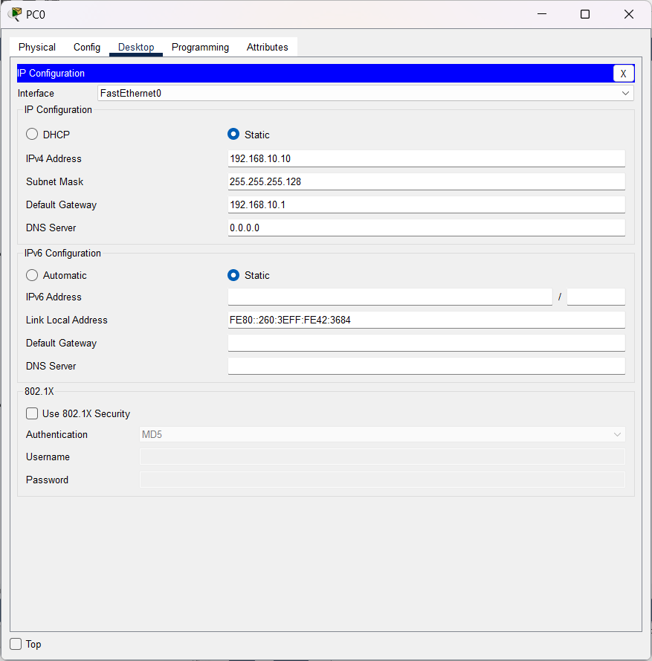

Figure 10.2 – PC0 Configuration

1. Click Router1, turn on the Port Status and configure the following as given in Figure 10.3.
   1. Configure the GigabitEthernet/0/0/0, IPv4 address as 192.168.10.1 and Subnet Mask as 255.255.255.128.
   2. Configure the GigabitEthernet/0/0/1, IPv4 address as 192.168.10.222 and Subnet Mask as 255.255.255.128.

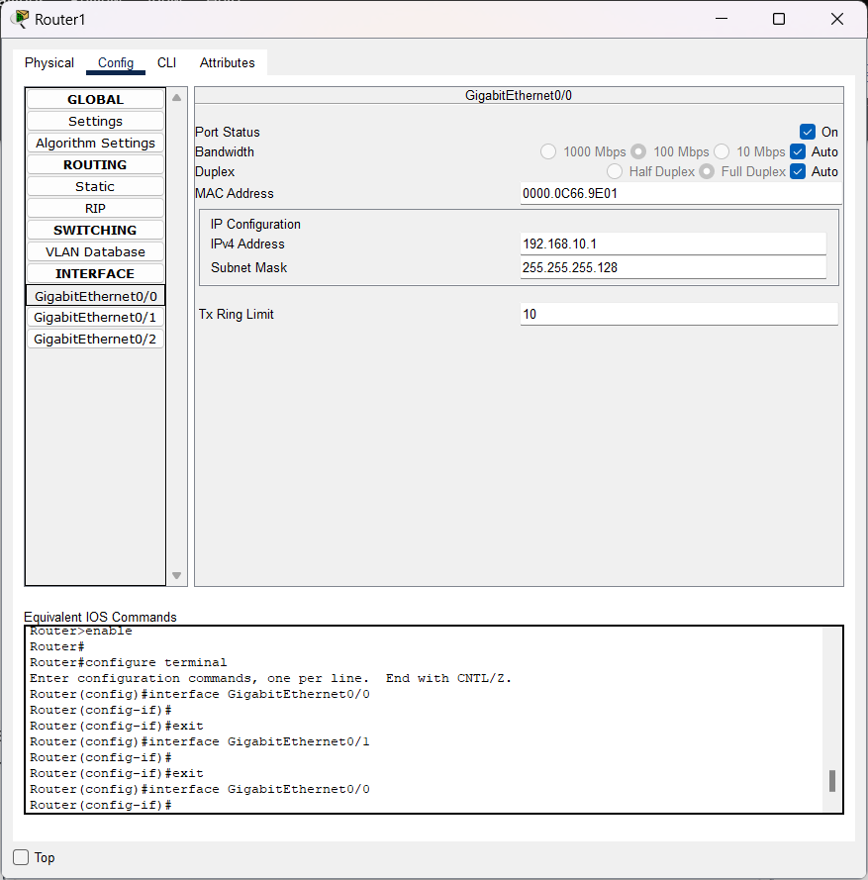

Figure 10.3 – Router1 Configuration

1. Verify the connection between the PCs by going to Desktop $→$ Command Prompt of PC0. Then type, ping 192.168.10.129 as given in Figure 10.4.

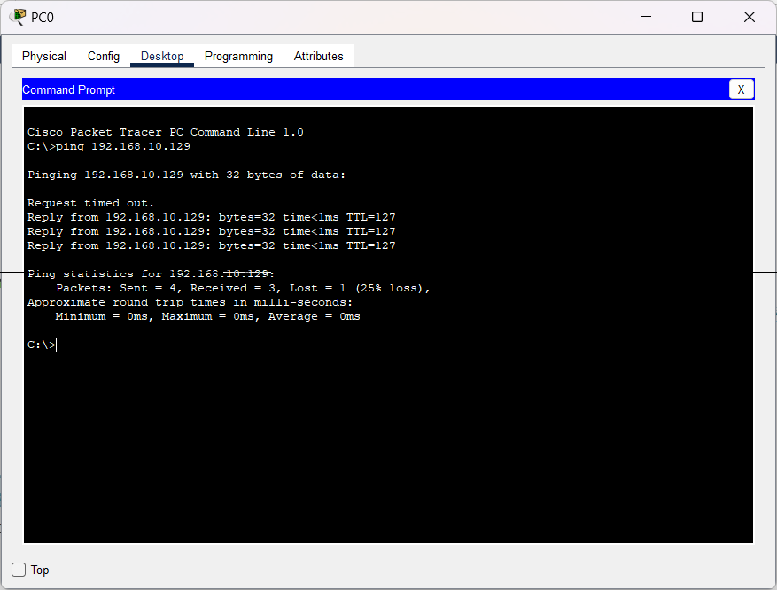

Figure 10.4 – Ping Command

1. Now, add PCs, Switches and Routers and connect as given in the Figure 10.5.

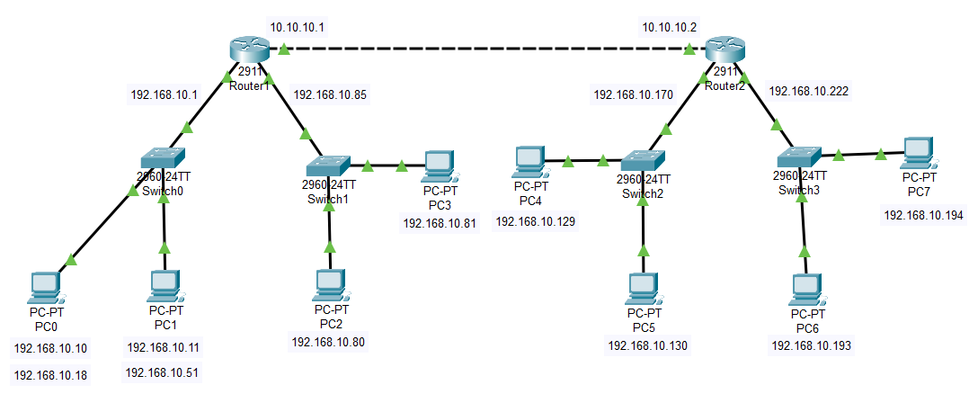

Figure 10.5 – Subnetting Connections with Routing

1. Click on PC, go to Desktop Tab $→$ IP Configuration, then enter the following as given in Figure 10.6.
   1. PC0:
      1. IP Address – 192.168.10.10
      2. Subnet Mask – 255.255.255.192
      3. Default Gateway – 192.168.10.1
   2. PC1:
      1. IP Address – 192.168.10.11
      2. Subnet Mask – 255.255.255.192
      3. Default Gateway – 192.168.10.1
   3. PC2:
      1. IP Address – 192.168.10.80
      2. Subnet Mask – 255.255.255.192
      3. Default Gateway – 192.168.10.85
   4. PC3:
      1. IP Address – 192.168.10.81
      2. Subnet Mask – 192.168.10.192
      3. Default Gateway – 192.168.10.85
   5. PC4:
      1. IP Address – 192.168.10.129
      2. Subnet Mask – 192.168.10.192
      3. Default Gateway – 192.168.10.170
   6. PC5:
      1. IP Address – 192.168.10.130
      2. Subnet Mask – 192.168.10.192
      3. Default Gateway – 192.168.10.170
   7. PC6:
      1. IP Address – 192.168.10.194
      2. Subnet Mask – 192.168.10.192
      3. Default Gateway – 192.168.10.222
   8. PC7:
      1. IP Address – 192.168.10.194
      2. Subnet Mask – 192.168.10.192
      3. Default Gateway – 192.168.10.222

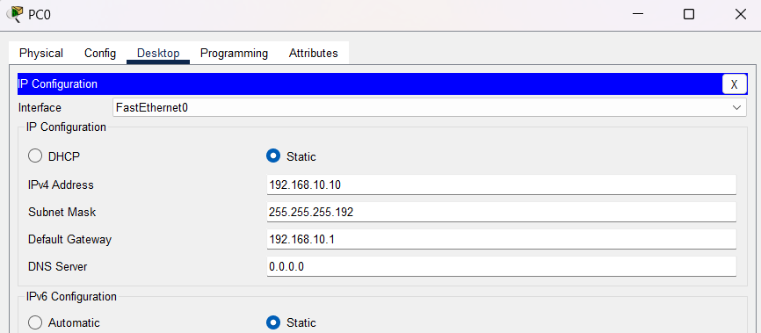

Figure 10.6 – PC0 Configuration

1. Click Routers, turn on the Port Status and configure the following as given in Figure 10.7.
   1. Router1:
      1. GigabitEthernet/0/0/0, IPv4 address as 192.168.10.1 and Subnet Mask as 255.255.255.192.
      2. GigabitEthernet/0/0/1, IPv4 address as 192.168.10.85 and Subnet Mask as 255.255.255.192.
      3. GigabitEthernet/0/0/2, IPv4 address at 10.10.10.1.
   2. Router2:
      1. GigabitEthernet/0/0/0, IPv4 address as 192.168.10.170 and Subnet Mask as 255.255.255.192.
      2. GigabitEthernet/0/0/1, IPv4 address as 192.168.10.222 and Subnet Mask as 255.255.255.192.
      3. GigabitEthernet/0/0/2, IPv4 address at 10.10.10.2.

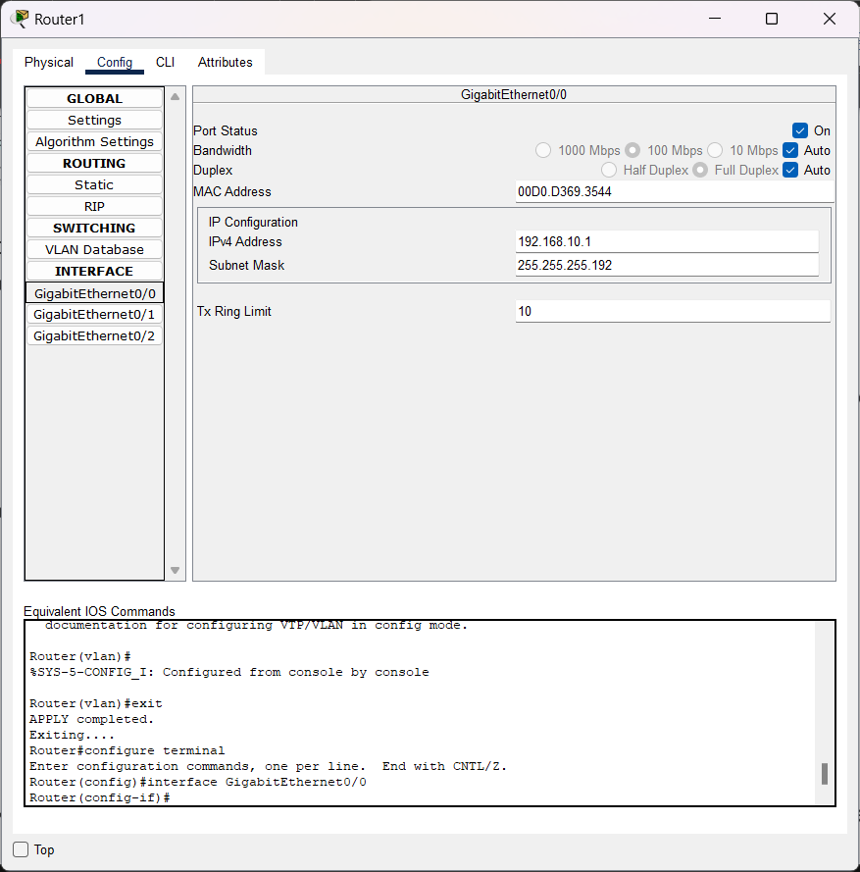

Figure 10.7 – Router1 Configuration

1. Now, Click the Router and go to Config tab. Go to Static under Routing section. Under the Network, enter the IP Address of the different LAN connected to the different router, it’s Mask and Next Hop Address and click the Add button as given in Figure 10.8.
   1. Router1:
      1. Network: 192.168.10.0; Mask: 255.255.255.192; Next Hop: 10.10.10.2
      2. Network: 192.168.10.64; Mask: 255.255.255.192; Next Hop: 10.10.10.2
      3. Network: 192.168.10.128; Mask: 255.255.255.192; Next Hop: 10.10.10.2
      4. Network: 192.168.10.192; Mask: 255.255.255.192; Next Hop: 10.10.10.2
   2. Router2:
      1. Network: 192.168.10.0; Mask: 255.255.255.192; Next Hop: 10.10.10.1
      2. Network: 192.168.10.64; Mask: 255.255.255.192; Next Hop: 10.10.10.1
      3. Network: 192.168.10.128; Mask: 255.255.255.192; Next Hop: 10.10.10.1
      4. Network: 192.168.10.192; Mask: 255.255.255.192; Next Hop: 10.10.10.1

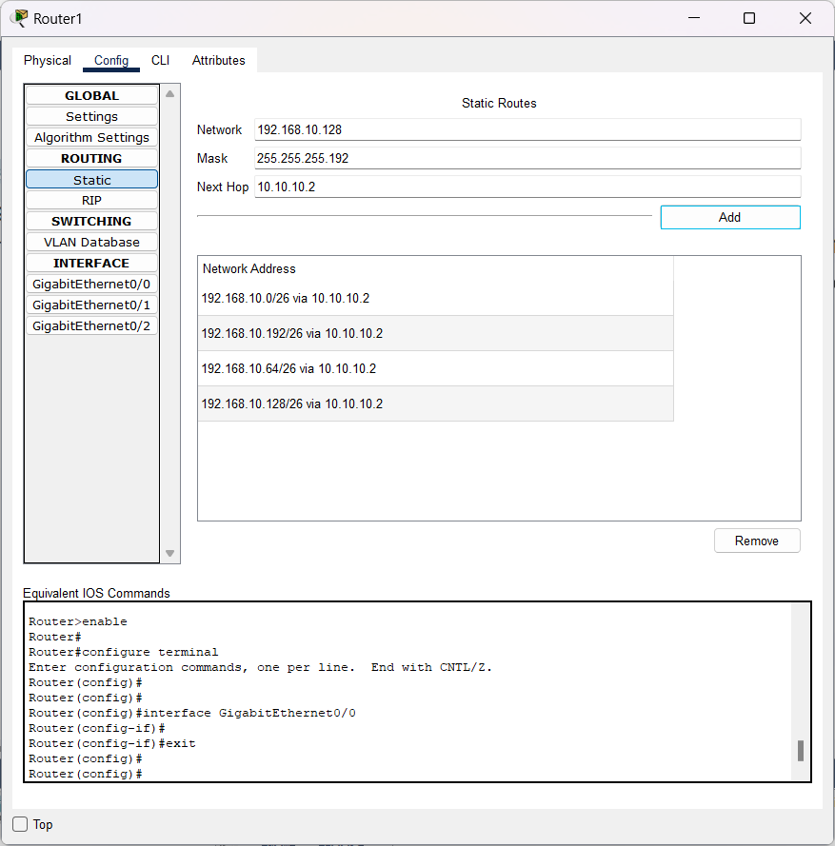

Figure 10.8 – Static Routing Configuration of Router1

1. Now, verify the connection between the PCs by going to Desktop $→$ Command Prompt of PC0. Then type, ping 192.168.1.2 as given in Figure 10.9.

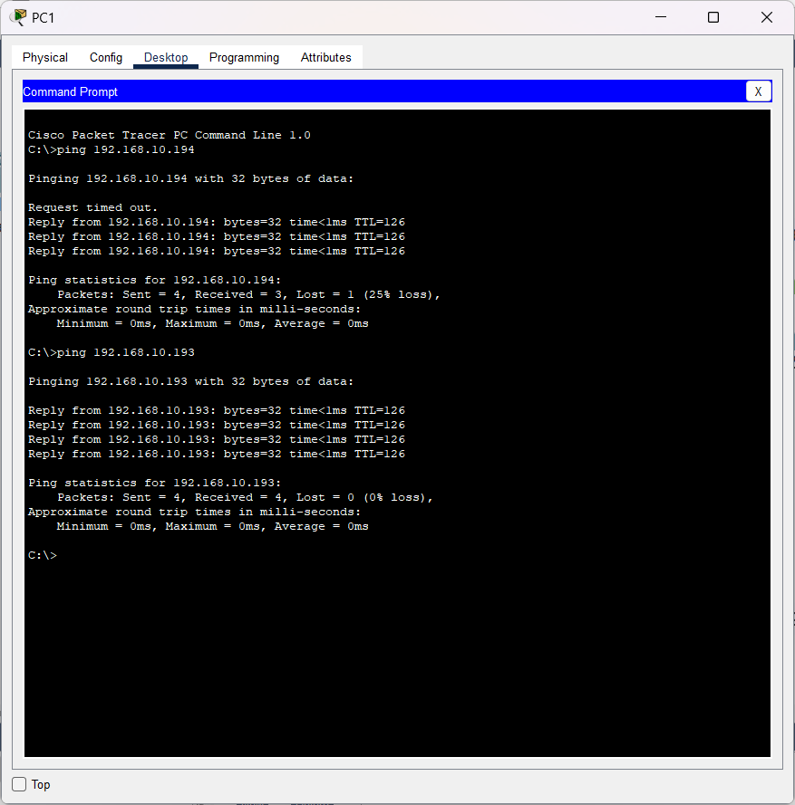

Figure 10.9 – Ping Command

**Result:**

Hence, a network is set up with subnetting using Cisco Packet Tracer.



Figure 10.10 – Ping Successful

**Conclusion:**

1. Subnetting is the process of creating a subnetwork (also known as a subnet) within a network. Network interfaces and devices within a subnet can communicate with each other directly. Routers facilitate communication between different subnets.
2. Subnetting allows for efficient utilization of IP addresses by breaking down a large network into smaller, manageable sub-networks. This helps in conserving IPv4 addresses, which are finite.
3. By segmenting a large network into smaller subnets, network traffic can be localized within each subnet, reducing congestion and improving overall network performance.
4. Subnetting provides scalability by allowing networks to grow and adapt to changing requirements without the need for the entire network infrastructure. New subnets can be easily added to accommodate additional devices or services.
5. Subnetting offers flexibility in IP address allocation, allowing organizations to customize their addressing schemes according to their specific needs. This flexibility is particularly useful for multi-tenant environments or organizations with complex network architectures.
6. The Subnet Mask is changed according to the number of subnets and the class of the IP Address.
7. While configuring the Static Routing, the Default Gateway of each subnet needs to be added even though it belongs to the same IP Address Family.

Experiment 11: Perform Cyclic Redundancy Check Using MATLAB

**Aim:**

To perform a Cyclic Redundancy Check using MATLAB.

**Procedure:**

1. Open MATLAB. Start defining the variables for the message, polynomial divisor, message length, and divisor degree. Represent the message and divisor as binary strings.
2. Initialize the remainder with the message bits shifted to the left to make room for the remainder.
3. Use a for-loop to iterate through each bit of the message. At each iteration, perform the CRC division step by XORing the remainder with the divisor if the leftmost bit of the remainder is 1.
4. After the division is complete, the check value is the remainder.
5. To check the integrity of a message, add the check value to the remainder bits and introduce an error into the message. Then, repeat the CRC division operation and check if the result is zero.

**Code:**

clc;

clear all;

close all;

m = 0b1101100111011010u32;

mlen = 16;

d = 0b1111u32;

dDegree = 3;

d = bitshift(d,mlen-dDegree-1);

dec2bin(d)

d = bitshift(d,dDegree);

rem = bitshift(m,dDegree);

dec2bin(d)

dec2bin(rem)

for k = 1:mlen

if bitget(rem,mlen+dDegree)

rem = bitxor(rem,d);

end

rem = bitshift(rem,1);

end

CRCCheckVal = bitshift(rem,-mlen);

dec2bin(CRCCheckVal)

rem = bitshift(m,dDegree);

rem = bitor(rem,CRCCheckVal);

rem = bitset(rem,6);

dec2bin(rem)

for k = 1:mlen

if bitget(rem,mlen+dDegree)

rem = bitxor(rem,d);

end

rem = bitshift(rem,1);

end

if rem == 0

disp('Message is error free.')

else

disp('Message contains errors.')

end

**Output:**

Message contains errors.

**Result:**

Hence, the Cyclic Redundancy Check is performed using MATLAB.

**Inference:**

1. CRC is a commonly used error detection technique in Computer Networks. It verifies the integrity of transmitted data by calculating a checksum based on the data and appending it to the message.
2. CRC operates by performing polynomial division on the message using a predetermined polynomial divisor. This divisor is typically represented as a binary number, and the division is carried out using bitwise XOR operations.
3. The result of the polynomial division, known as the remainder or CRC check value, is appended to the original message. This check value is used at the receiver's end to verify whether the message has been corrupted during transmission.
4. CRC is highly efficient in detecting errors, including single-bit errors, burst errors, and most random errors. It can detect a large percentage of errors with a relatively small number of redundant bits added to the message.
5. Several standardized CRC algorithms exist, each with its polynomial divisor. These standards ensure interoperability between different systems and devices that utilize CRC for error detection.
6. The length of the CRC checksum, determined by the degree of the polynomial divisor, affects the error detection capability. Longer checksums provide better error detection but require more overhead in terms of additional bits added to the message.
7. CRC can detect errors but it does not provide error correction capabilities.
8. CRC can be adapted to different scenarios by selecting appropriate polynomial divisors and checksum lengths based on the specific requirements of the system, such as the expected error rate and the size of the data being transmitted.